CAMRA Pub Heritage Group update – July
14/07/2026 by Tom Chapman
Campaign

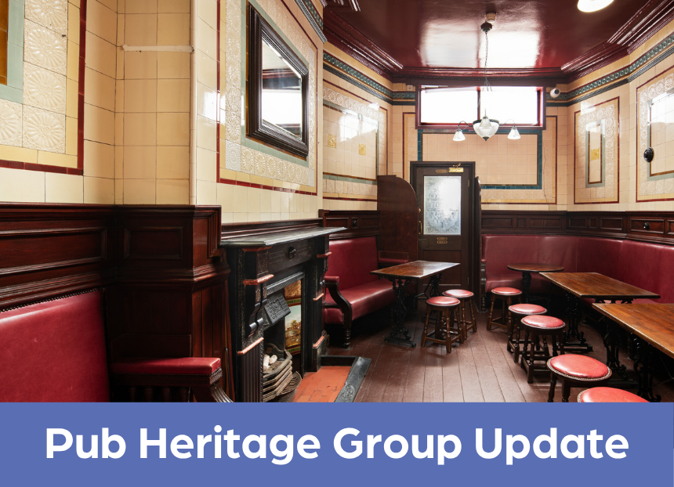

CAMRA’s Pub Heritage Group shares news and updates about pubs with historically significant interiors across the UK. For further news see the Pub Heritage Group webpage. Pub Design Awards CAMRA announced the winners of the annual Pub Design Awards at the Woodman (above, photo by Historic England) in Birmingham. Run in collaboration with Historic England, the Pub Design Awards recognise the highest standards of architecture in the refurbishment and conservation of existing pubs as well as the construction of new pubs. Two National Inventory pubs received awards this year:
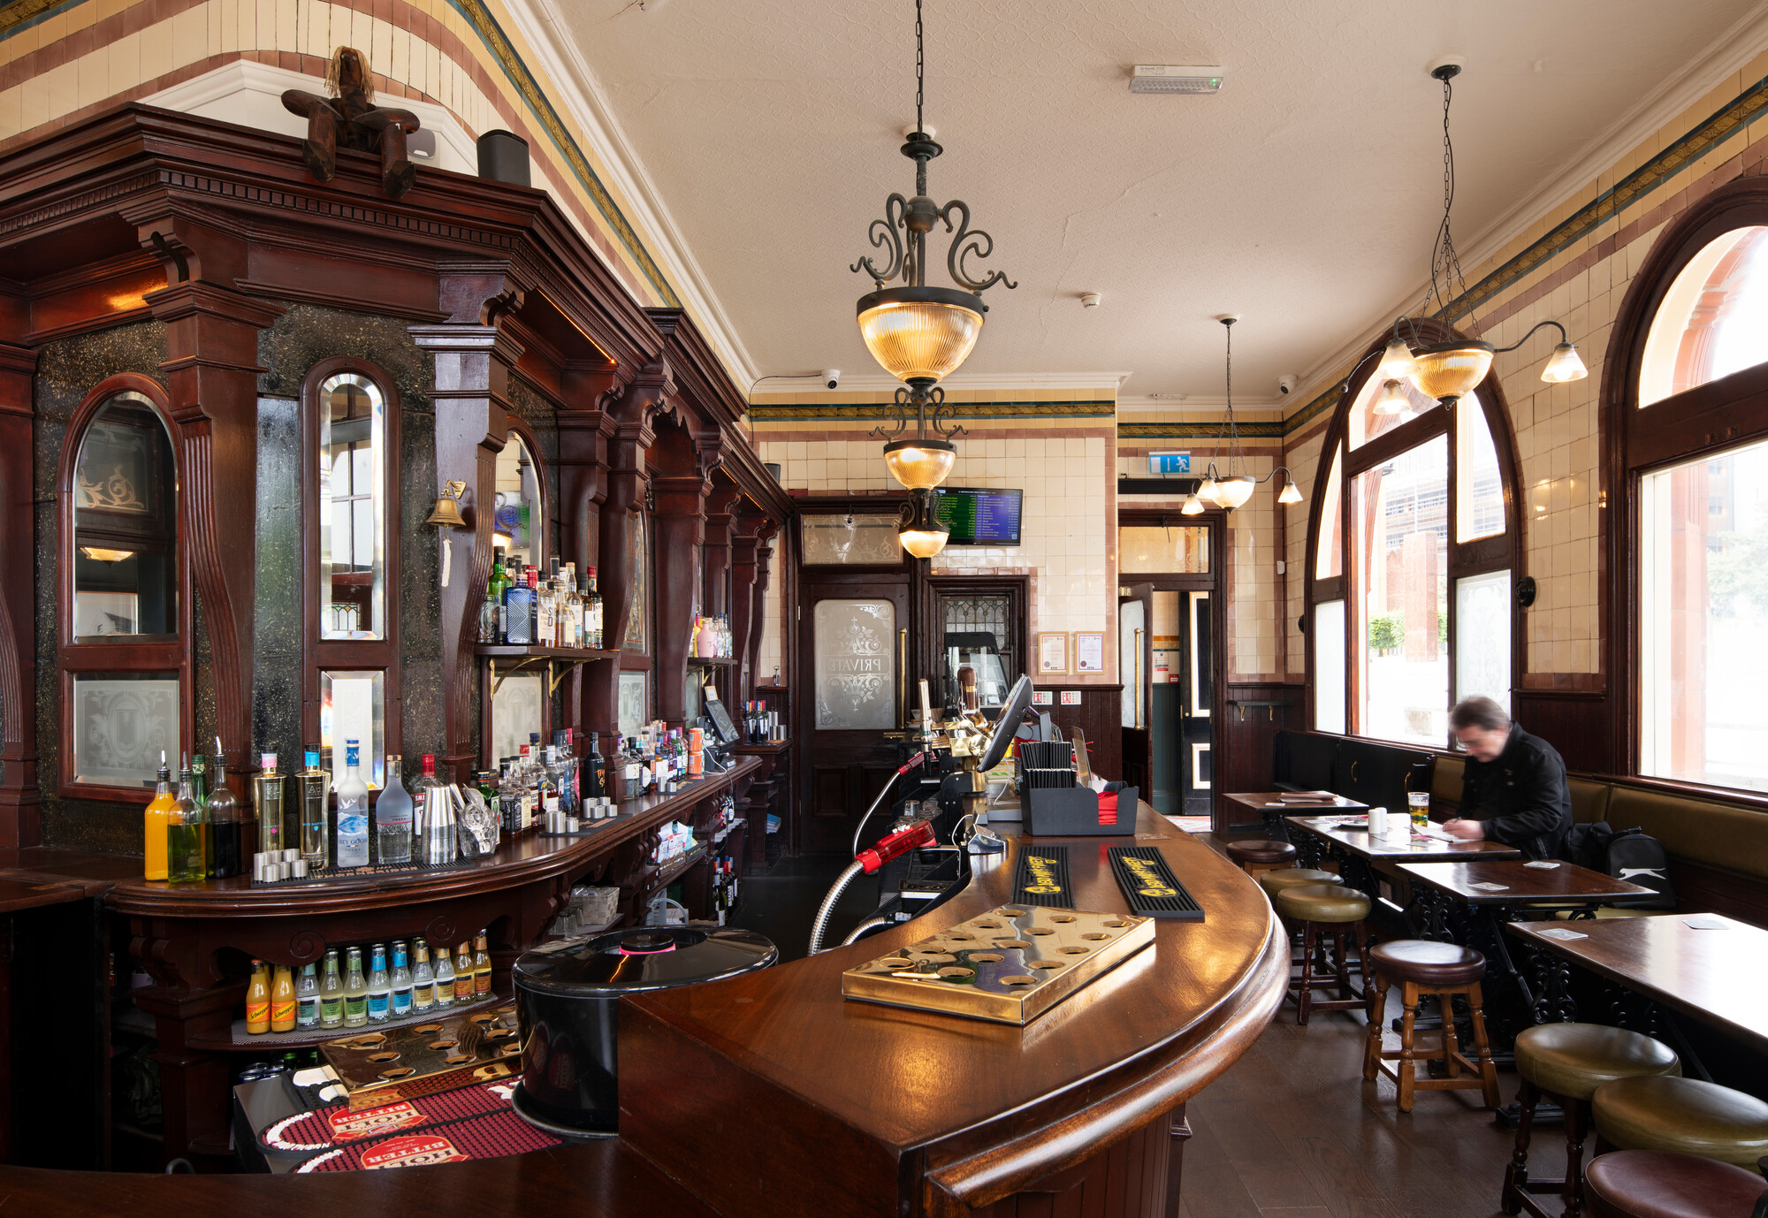
Woodman, Birmingham, West Midlands (above) The Woodman won the Historic England Conservation category. Union Inns took on the lease of this classic Three Star Victorian, brick-and-terracotta pub and reopened it in September 2024, after careful restoration of the internal Minton tiling and woodwork, as well as replacing the timber flooring.
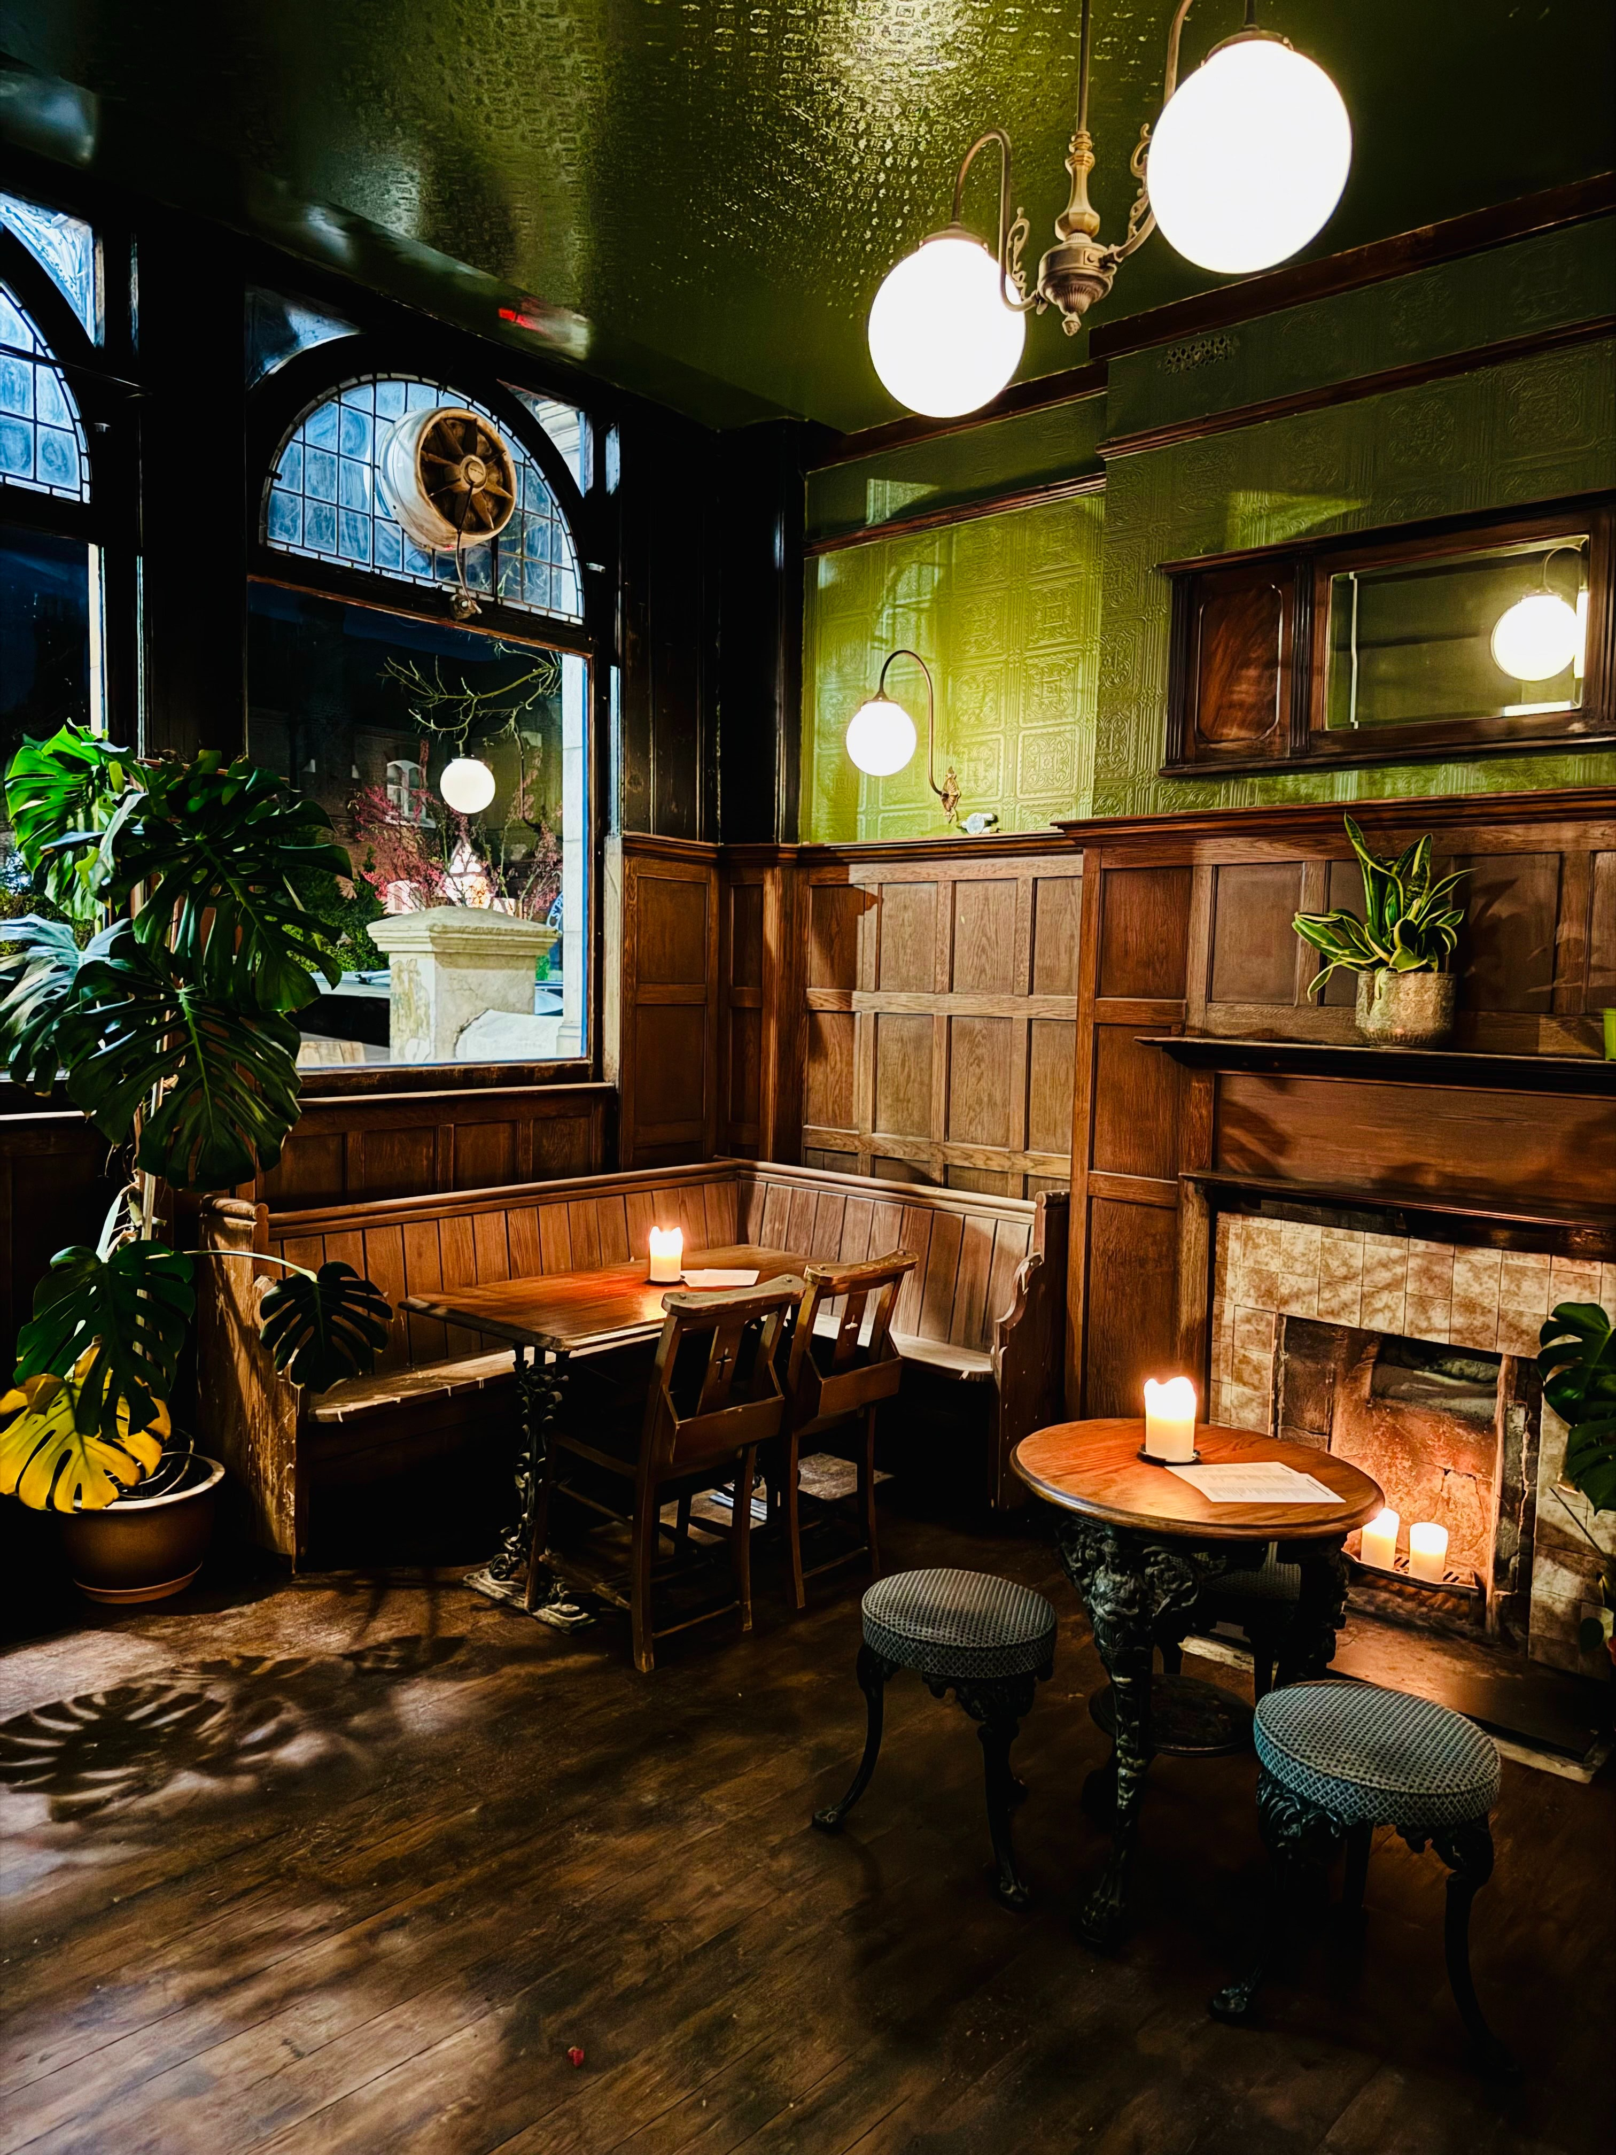
Lord Southampton, Kentish Town, Greater London North West (above) Also recognised in the Pub Design Awards was the Lord Southampton, a One Star heritage pub in Kentish Town, which won the Community Local category. The pub was built in the 1850s and was subject to a major refit in the inter-war period. It was in a near derelict state and could easily have been lost to development. Licensees Aimee Brown and Phil Harrington took on the lease in 2024, undertaking a high-quality refurbishment that conserved the inter-war interior. The pub is revitalised and is now successfully serving its local community once again. Read more in the Camden New Journal. Three Star heritage pubs
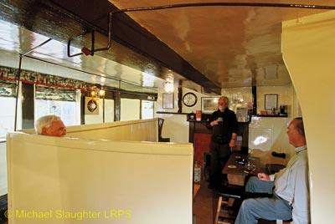
North Star, Steventon, Oxfordshire (above) The North Star has reopened after being shut since September last year, as reported in the March bulletin, for essential repairs to prevent penetrating damp. Following an inspection by the Pub Heritage Group, no changes to the historic interior have been made. The North Star is one of only seven traditional pubs in the UK without a bar counter, with the drinks served via a stable door from the ground floor cellar. The main room consists of a snug formed from high-back settles centred on the fireplace – one of only a handful of such pub rooms left in the UK. Two Star heritage pubs
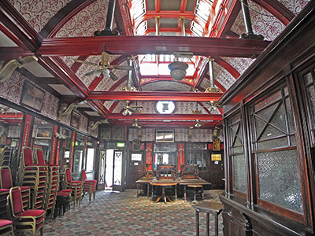
Denmark Arms, East Ham, Central London East (above) The Pub Heritage Group is pleased to report that a planning application to convert the Denmark Arms into a casino has been rejected by Newham Council. Councillors refused the application due to the proposed loss of the pub, with insufficient evidence being submitted to demonstrate its lack of viability. It was felt the proposals would also cause harm to the significance of this Grade II-listed building, whose star attraction is the magnificent first-floor billiard room. Built around 1890, the Denmark Arms closed in January last year, as reported in February 2025, and was sold later that year. Read more about the planning rejection on Newham Voices.
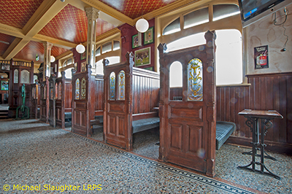
Rock Bar, Belfast, Northern Ireland (above) After closing in June, the Rock Bar has now reopened with local businessman Conor Connolly taking on this famous pub. Located on the Falls Road, the Rock Bar has five surviving timber snugs facing the servery – a characteristic feature of Northern Ireland pubs. Read more about the reopening on Belfast Media.
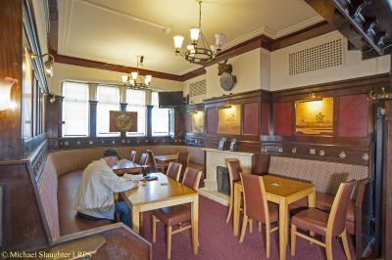
Ramsden Arms Hotel, Blackpool, Lancashire (above) The Pub Heritage Group last reported on the Ramsden Arms in December 2025, following it reopening after a refurbishment without any changes to the historic interior. However, a new lease is now being advertised by owner Star Pubs with a £240,000 investment planned. The investment includes a proposal to redesign the main bar and snug, in order to transform the Ramsden Arms into a modern community pub. Star has been contacted by Pub Heritage Group chairman, Paul Ainsworth, for clarification on the planned changes and their impact on the interior. A reply has not yet been received. The pub, which is not listed, was built in 1939 in Brewers Tudor style and retains an interior of the period with a still discernible multi-room layout, despite a degree of opening up. Read more about the plans on Blackpool Gazette. One Star heritage pubs
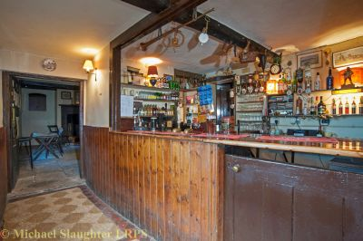
Berkeley Arms, Purton, Gloucestershire (above) Having been closed since 2020 following the retirement of the licensee, the Berkeley Arms finally reopened in June. It was previously included on the National Inventory at Three Star status for its unspoilt interior. Tragically, owners Berkeley Castle Estate has ripped out the traditional fittings before Historic England could assess the pub for statutory listing (hence its current One Star rating). Initial reports now confirm the interior has been remodelled with few, if any, of the historic fittings remaining. The Pub Heritage Group will reassess the Berkeley Arms to decide if it needs to be removed from the National Inventory.
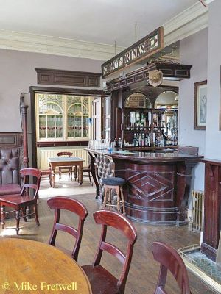
Central Station Hotel, Dewsbury, West Yorkshire (above) Built in 1903, the Central Railway Hotel has been closed since August 2025 and is now in a state of disrepair and is deteriorating. The pub features an original curved bar counter with good-quality fixed seating and glazing. The Heavy Woollen District CAMRA branch is investigating. Other news Heritage Pub Revival Award CAMRA’s new Heritage Pub Revival Award is still open for nominations. The award recognises heritage pubs that have been revived in some way, including: reopened after a protracted period of closure been restored to their former glory been shown loving care and attention to detail in refurbishment or restoration instigated community initiatives, festivals or events introduced services of benefit to the community, such as a shop or post office been re-energised by becoming a cask beer haven. The award is open to pubs that are included on the National Inventory of Historic Pub Interiors at Three, Two or One Star status. Nominations are open until 12 August 2026. Nomination form and eligibility criteria is here. Humphrey Smith Humphrey Smith, the controversial owner of the Tadcaster-based brewery Samuel Smith’s, has died at the age of 81. Samuel Smith’s has featured in the Pub Heritage Group update on numerous occasions due to the significant number of heritage pubs owned by the brewery, many of which have been conserved and restored over the years to a high standard. In more recent years, however, the strict behavioural rules imposed on the pubs and transgressions have led to long and seemingly inexplicable periods of closure. The Pub Heritage Group will wait to see what impact his death will have on Samuel Smith’s pub estate going forward. If you have any news on heritage pubs, send to: info@pubheritage.camra.org.uk Feel free to forward this bulletin to your friends who are also interested in visiting pubs like these. If you wish to receive the bulletins directly, sign up by sending an email to bulletin@pubheritage.camra.org.uk with the word “subscribe” as the subject or “unsubscribe” if you wish to stop receiving bulletins. Photos by Michael Slaughter, James O Davies (Historic England), Aimee Brown, Michael Croxford and Mike Fretwell

