CAMRA calls for UK beer market investigation
06/07/2026 by WB Reporter
Campaign

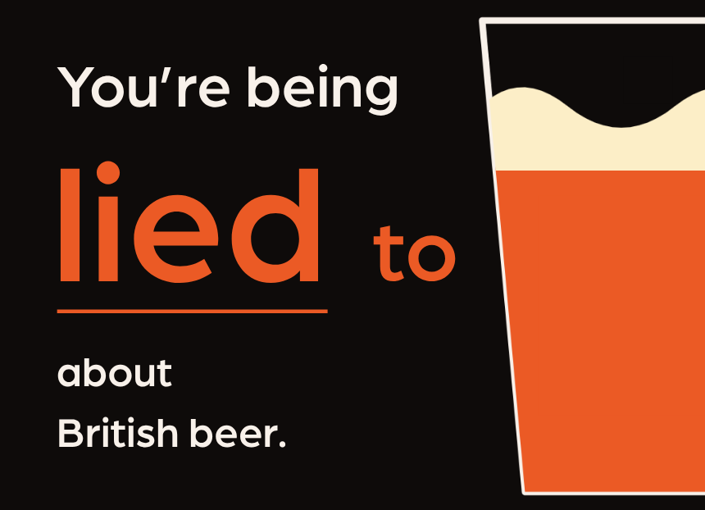

A new report, published today by CAMRA, shows how independent brewers are being excluded from bars across the UK, and sets out the case for Competition and Markets Authority action. Beer in the UK is the authoritative consumer view on how the UK beer scene actually works, or doesn’t, for drinkers and independent brewers. The report lays bare the stark state of British brewing – dominated by four international conglomerates with little affinity with our brewing heritage, or what beer drinkers want. It also found: seven of the top 10 selling “craft beers” in the UK are made by just four global brewing conglomerates

many of the UK’s favourite “continental” and “imported” lagers are brewed in the UK

data from the Society of Independent Brewers and Associates (SIBA) shows demand for independent beer is 280 per cent higher than its share of the pub market CAMRA chairman Ash Corbett-Collins said: “Ordinary drinkers are being short changed when it comes to choice and quality at the bar. Our report proves how the global players are exploiting the status quo to squeeze out independent brewers, to the detriment of ordinary publicans and beer drinkers. “The government needs to step up, start taking the issue seriously, and take action that matches up to its statements about supporting pubs and the communities they serve. “Andy Burnham recently said that ‘people need to be able to look forward to a night out’. The best way he can deliver on that is by ordering a proper market investigation to sort this mess out and deliver a fair deal for publicans and drinkers, and the independent brewers that they want to support. “If this report makes you as angry as it makes me, that’s good. CAMRA is fighting for changes to the status quo, and I hope you’ll join us and get involved.” Report editor Tim Webb said: “The fact that a narrow clique of multinational corporations dominates the UK brewing industry is a national embarrassment. They only make beers that suit their production facilities, ignoring the types that beer lovers want to drink. They do not know how to reverse beer’s downward spiral, make little profit, and brew nothing worth exporting. They cannot grow the UK economy. “The way that better, independent, brewers are excluded from the on-trade beer market is scandalous. Brewing is a business that competition authorities need to investigate, take apart, and reassemble, so the UK can return to playing a leading role in the world of beer.” The full report can be read here.

