Cumbrian homecoming
04/07/2026 by Roger Protz
Opinion

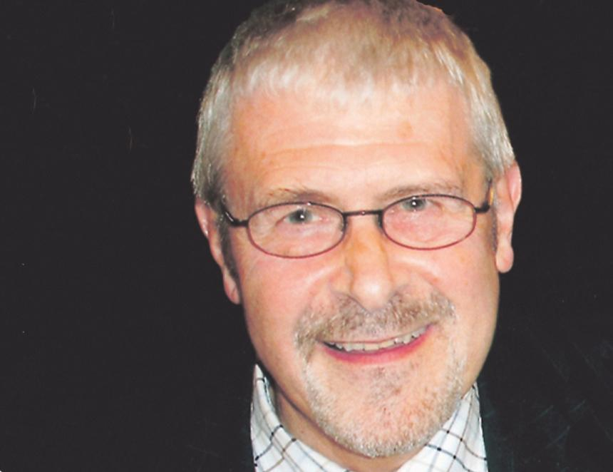

Jennings brewery is back yam – that’s Cumbrian dialect for back home. The last weekend in June saw Jenningsfest, a celebration that marked the rescue of the brewery in Cockermouth and proof that it’s been saved for the local community. If you think it was a small event of no particular importance, think again, for it marked the start of a fight back against the overweening power of global lager brewers and their disdain for our cask beer heritage. Jennings was closed in 2022 when the short-lived Carlsberg Marston’s Brewing Company (CMBC) went on the rampage. The Danish brewer was the majority shareholder in CMBC, and it chaired the company. It used its power to close in short order Jennings, Banks’s, Ringwood and Wychwood on the completely specious grounds that the cask beer sector was in terminal decline. This flew in the face of the evidence that cask beer was recovering following the challenges created by the Covid pandemic and pub lockdowns. CMBC soon disappeared, replaced by Carlsberg Britvic following the takeover of the soft drinks company. Marston’s, once one of the great Burton brewers responsible for Pedigree pale ale, is now a pub company. The scale of the CMBC closures is breathtaking. Banks’s in Wolverhampton was especially horrific. It was the giant brewery of the Black Country, with a capacity of 100,000 barrels a year, producing such iconic beers as Bank’s Mild and Bitter. Also feeling the madman’s axe were Wychwood in Oxfordshire and Ringwood in Hampshire. Both produced award-winning brews, including the Brakspear beers originally from Henley-on-Thames, fermented in a double-drop system similar to the Burton unions and transferred to Wychwood. Not to be outdone, Heineken closed the historic Caledonian brewery in Edinburgh. The Dutch giant had taken over Scottish and Newcastle and owned, among others, Deuchars IPA, brewed at Caledonian and a former Champion Beer of Britain. Deuchars has now been hived off to Greene King’s Belhaven brewery in Dunbar on the coast, overlooked by – and I love the fortuitous geography – the Bass Rock. One brewery escaped the mayhem. In Cockermouth, two locals Kurt and Rebecca Canfield were determined to save Jennings for the local community. Kurt runs an engineering firm while Rebecca has a wine shop, now moved on to the Jennings site. CMBC wanted £75m for Jennings but Kurt says he and Rebecca paid nothing like that – though he won’t mention the actual sum. They have thrown themselves into restoring the brewery and making it, once again, a pillar of Cockermouth. The company dates from 1828 and became part of Marston’s in 2005. The Canfields hired a top brewer, Buster Grant, most recently at Bateman’s in Lincolnshire. He set about improving beer quality, replacing cheaper grains and hops with the finest Maris Otter malting barley and Fuggles and Goldings traditional hops. He had the good fortune to find the original Jennings' recipes and brought back such main brands as Cocker Hoop and Sneck Lifter. A taproom has been developed at the brewery that’s open seven days a week and has rapidly become a community hub. It was the central scene of Jenningsfest, with food, drink and music and games for children. Saving and restoring Jennings brings joy to my heart. It comes at a time when Timothy Taylor in Yorkshire reports it’s selling more cask beer – mainly Landlord – than before Covid. Neighbouring Theakston says it had its best year ever in 2025. It will celebrate 200 years of brewing in 2027, and it knows good years from bad. In Stockport, Robinsons, founded in 1838, for the first time ever saw sales exceed £100m in 2025. MD Oliver Robinson says sales of cask beers are “outperforming the market”. All the good news about cask is lost on Carlsberg and Heineken but, remarkably, it has been noted by the world’s biggest brewer AB InBev, which produces 30 per cent of all the world’s beer and is best known for the likes of American Budweiser, Corona and Stella Artois. When Bass left brewing in 2000, Draught Bass ended in the hands of AB InBev. It was once Britain’s premium cask beer, producing some 800,000 barrels a year. In the hands of the global giant, production slipped to just 30,000 barrels and the beer became difficult to find away from its Midlands heartland. Then beer lovers stepped in. A Drink Bass Day was organised every year and a list of outlets serving the beer was made available online. The campaign was so successful that AB InBev has bowed to consumer demand. It has launched a promotion for the beer, with glasses, beer mats and pump handles displaying the famous Red Triangle symbol. AB InBev makes much of the fact that the symbol was the first registered trademark in England, recorded in 1876. It would be good if Carlsberg and Heineken followed in AB InBev’s footsteps, but I fear they are too dominated by their lacklustre lagers to restore the beers they have axed. In the meantime, congratulations to Kurt and Rebecca Canfield and Buster Grant for saving Jennings. For the Jenningsfest they brewed a special beer, Back Yam. Welcome home.

