CAMRA raffle update – July
03/07/2026 by Matthew Rogers
Campaign

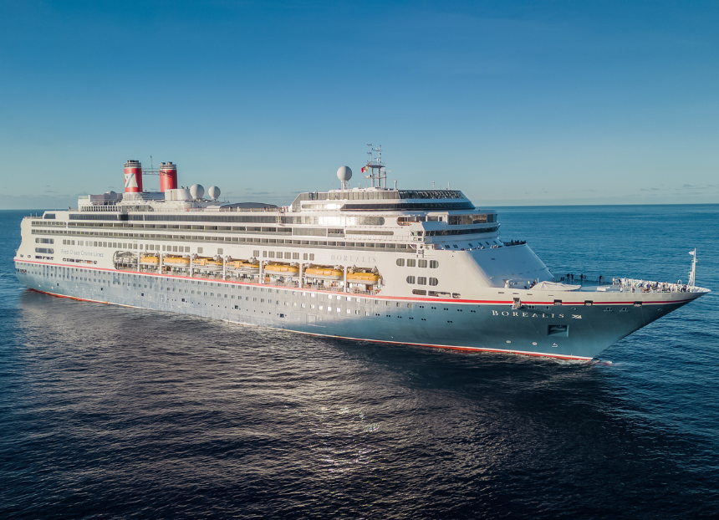

Congratulations to all the winners of CAMRA’s Beer Day Britain Bonanza Raffle! To celebrate Beer Day Britain, CAMRA put on its largest raffle to date with special prizes including a five-night cruise with Fred. Olsen Cruise Lines as well as the regular big cash jackpot. Who won what: Ralph Beeby won a five-night cruise to Northern Spain for two, courtesy of CAMRA’s long-standing partners at Fred. Olsen Cruise Lines (above), including a tempting itinerary

Stephen Gillen took home an Instax Mini Evo camera – the perfect companion for a festival or pub garden

Ken Shearer is now the proud owner of a limited-edition, Trooper-themed Pinter, an all-in-one brew and draught machine that makes it easy to make and pour pints of award-winning beer at home

Chris Johnson claimed the big prize of £1,000, Michael Collins won £500, while Andrew Tucker, Chris Woolaston and Ian Johnson all won £100. Taking part in the CAMRA Monthly Raffle is a fun way to support CAMRA. By entering you’ll be supporting vital campaigning work to protect pubs, breweries and cask beer across the UK. Every £1 entry gives you a chance to win a fantastic prize and you can play up to £20 a draw for more chances to win. You can even join by Direct Debit to ensure you never miss a draw. There’s no need to claim your prize, CAMRA will pay any winnings directly into your account and post or email your prizes to you. Take part in the Monthly Raffle today to be in with a chance to win big money prizes: First – £1,000

Second – £500

Third – £100 (three winners)

Fourth – case of beer made up of six bottles or cans (25 winners)

Fifth – £5 money-off voucher redeemable in the official CAMRA Shop and Book Store (50 winners) The raffle draws will take place on the second Friday of every month. Make sure to sign up before 10 July for Direct Debits to be entered into our August draw: raffle.camra.org.uk Full raffle terms and conditions are here. GambleAware Campaign for Real Ale, Unit 9, Finway, Dallow Road, Luton, LU1 1TR, company number 1270286, is licensed and regulated in Great Britain by the Gambling Commission under account number 4827; a society lottery which raises funds to support CAMRA’s aims and objectives. The responsible person is Tony Lewis.

