Sponsors revealed for flagship pub award
01/07/2026 by WB Reporter
Campaign

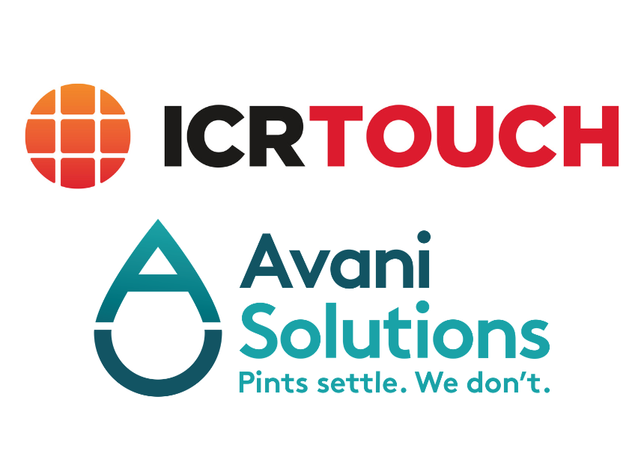

Avani Solutions and ICRTouch will sponsor the Campaign’s Pub of the Year competition for 2026. The former is coming on board as a beer quality partner, and the latter as a technology partner. The announcement comes as judging in the 2026 race hots up with the regional winners set to be announced in late August. The sponsorship is purely supportive, and partners have no influence in the independent judging process, which remains with CAMRA members. Avani Solutions is a trusted supplier to pubs across the UK, helping deliver profitable pints by protecting beer quality, raising hygiene standards and providing data that supports fact-based decision-making creating better experiences for customers and teams alike. Founded in 2012, Avani works at the heart of the licensed trade to ensure every pint is served clean, consistent and at its best, while providing the insights needed to support both quality and profitability in a sustainable way. Avani Solutions MD Amanda Thomson said: “We’re proud to be sponsoring CAMRA’s Pub of the Year competition and to be supporting the awards as beer quality partner. Across the industry, there is a growing recognition that exceptional beer quality doesn’t happen by chance – it is the result of consistent standards, expert cellar management and a commitment to maintaining dispense systems to the highest level. “At Avani Solutions, we work with pubs, breweries and hospitality operators throughout the UK to help ensure that every pint reaches the consumer exactly as the brewer intended. That’s why we’re delighted to support a competition that celebrates not only great pubs, but the dedication, professionalism and attention to detail that underpin a truly outstanding beer experience. “CAMRA’s Pub of the Year competition highlights the very best of Britain’s pub sector, and we look forward to recognising and championing those venues that continue to set the benchmark for beer quality and customer satisfaction.” For more than 30 years, ICRTouch has worked alongside the hospitality industry, providing electronic point of sale (EPoS) solutions to pubs, bars, clubs and hospitality venues across the UK. The ICRTouch ecosystem is designed to help streamline every step of service and the customer journey, with the aim for businesses to be able to reduce operational costs, increase revenue and build meaningful relationships with their customers. The partnership between ICRTouch and CAMRA brings together two organisations with a shared commitment to supporting a thriving pub sector and ensuring the long-term sustainability of hospitality businesses. ICRTouch said: “Pubs remain at the heart of communities throughout the country, and partnerships such as this help to continue championing great hospitality businesses. We are thrilled about our partnership and look forward to working with the team at CAMRA.” For more information on Avani Solutions see: camra.org.uk/about/partner-with-camra/avani-solutions and for ICRTouch: camra.org.uk/about/partner-with-camra/icr-touch This article supports CAMRA’s agreed work with the award partners.

