Sir Ian Rankin pens foreword to our top guide
26/06/2026 by WB Reporter
Campaign

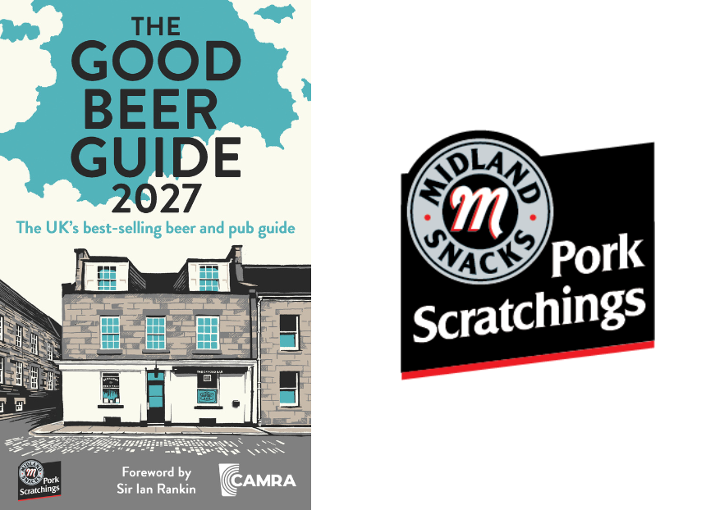

The creator of DI John Rebus has written the foreword to the Good Beer Guide 2027 (pictured left), which is now available to pre-order. Sir Ian Rankin, the best-known patron of the Oxford Bar in Edinburgh, writes about what makes the perfect pub and reflects on his links to “the Ox”, which is on the guide’s cover illustrated by David Wardle. The new edition is the UK’s definitive guide to great pubs that serve top-quality cask beer. It is independent with listings based entirely on evaluation by CAMRA members and volunteers. It is sponsored by Midlands Snacks Traditional Scratchings (pictured right), which has stayed true to the original recipe and method of cooking that has earned it a Great Taste Award. There’s no better snack pairing for that perfect pint of cask beer! The guide is also endorsed by Cask Marque, a hallmark of beer quality and consistency. Released 24 September, the Guide can be pre-ordered here: shop1.camra.org.uk/product/the-good-beer-guide-2027

