CAMRA’s grand designs in the spotlight
23/06/2026 by WB Reporter
Campaign

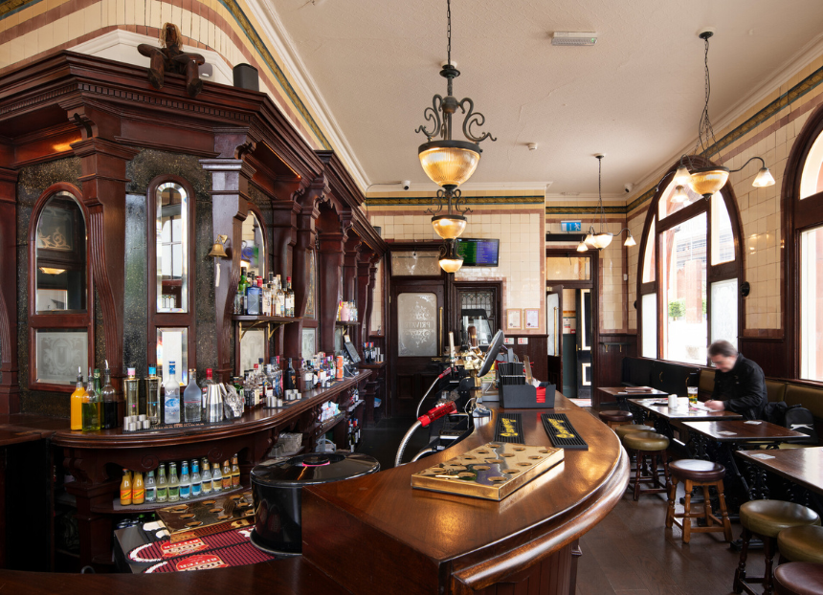

A former church and a restored historic pub are among the winners revealed in the latest CAMRA Pub Design Awards. The awards celebrate not only the UK’s best-looking pubs, but those which have been lovingly refurbished, converted or have made a major difference to their community. Run in collaboration with Historic England, the competition is judged by a panel of design and conservation experts. Panel chair Andrew Davison said: “Despite the increasing pressure on the hospitality industry, people are still prepared to invest time, money and energy into pubs and bars. The Pub Design Awards recognise the extraordinary amount of effort, the imagination and design, plus high-quality craftsmanship which have gone into all of these projects. In these troubled times, the pub still has a key role to play in our communities, and those who are working to conserve, repair and renovate them should rightfully be applauded.” CAMRA awards committee chair Shelly Bentley added: “From striking Art Deco wonders to inviting street-corner locals, there are some beautiful pubs across the UK. Next time you are enjoying a pint, take a second to marvel at the skill involved in making these stunning spaces. In these difficult times for the industry, it is always heartening to see just how much people care about pubs. From volunteering to help renovate your local, to architects undergoing full-on conservation projects, it all means future generations can enjoy them too.” Historic England co-chief executive officers Claudia Kenyatta and Emma Squire said: “Pubs continue to be cherished historic spaces for people across the country. Each pub is distinct telling the story of the community they stand within and continue to serve. This year’s Historic England Conservation Award winner, the Woodman in Birmingham, is an outstanding example of how thoughtful conservation can allow historic buildings to live on, securing them for future generations to enjoy. We are proud to partner with CAMRA to celebrate the skill, dedication and passion of everyone involved in preserving these special places.” Who won what? Historic England Conservation: Given for “constructive conservation”, carefully preserving a pub’s historical architectural features, whilst updating and evolving its facilities to improve the viability of the building, securing it for future generations to enjoy. Winner: Woodman, Birmingham (pictured) Dating back to 1897 and falling into disrepair, owner Union Inns set out to carefully restore and protect the pub’s heritage features and multi-roomed layout. A new wooden floor has been laid, the historic Minton tiling walls (which culminate in the wonderful tiled rear Smoke Room) have been carefully cleaned and conserved, and the beautiful, ornate woodwork has been restored. Standing next to the Old Curzon Street station, set to be reopened as part of HS2, the pub will be an impressive first port of call for passengers. Conversion to Pub Use: awarded to a building which previously was not a pub. It centres on the building’s character and historic features to capture a pub’s atmosphere and ambience.
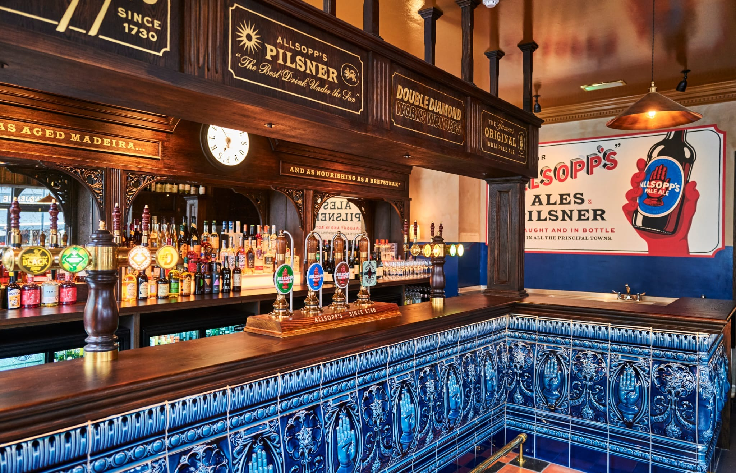
Joint winner: Blue Stoops, London (above) A conversion of the former Kensington Wine Rooms by Relic Interiors and Box Construction, commissioned by owner Jamie Allsopp, has transformed the building. The interior has been re-imagined with half-height partitions and glazed screening, plus new fixed seating, along with a revamp of the exterior with new signage and lighting. The striking new ceramic bar front featuring the historic Allsopp’s trademark is a major highlight to this latest addition of West London’s pub scene.
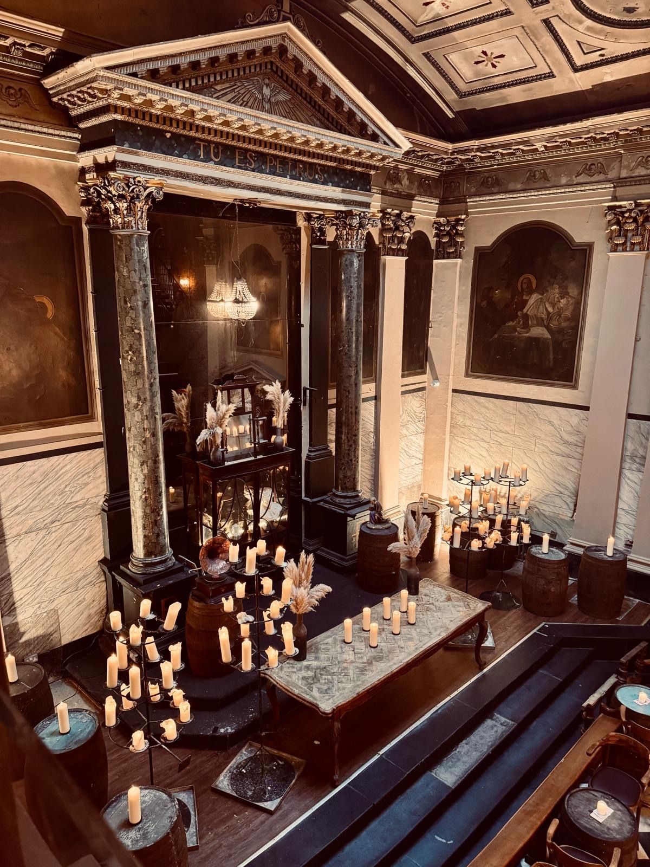
Joint winner: St Peter’s Tavern, Liverpool (above) Formerly a Roman Catholic church built in 1788, owner 1936 Pubco described the impressive conversion as its greatest challenge. It involved opening up the spectacular galleried interior and restoring historic features and façade, along with the introduction of an impressive 20-metre-long bar counter formed from recycled courthouse furniture. New pew seating, glazing and bespoke mirrors have been added along with the creation of a courtyard garden.
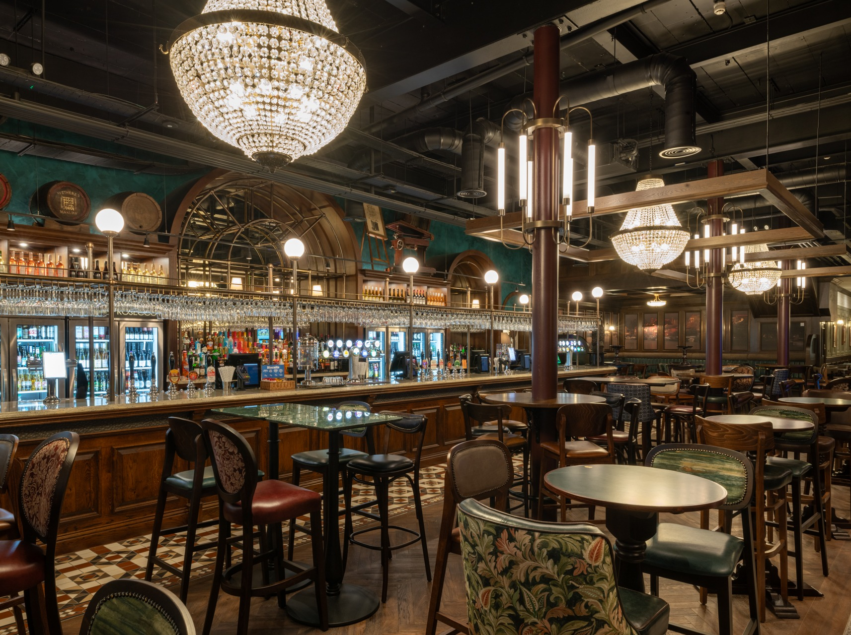
Commended: Grand Assembly, Marlow (above) A conversion of a former retail unit into a pub by architects kdpa commissioned by JD Wetherspoon. Inspired by pubs and grand assembly halls of the Victorian era, but with a modern-industrial twist, the interior has been broken up into discrete areas with Victorian-styled screening, featuring bespoke, embellished tiling and huge empire chandeliers. The lighting, choice of colours and carpets have all been inspired by Marlow’s links to the Thames and rowing heritage. Refurbishment: best refurbishment of an existing pub building, ranging from a complete gutting to enhancing the design of what was originally in the pub. Judges are looking for originality and imagination in the way the building is treated.
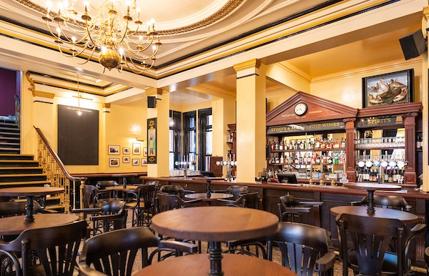
Winner: Leyton Engineer, London (above) Originally Leyton Town Hall, it was converted to a pub some years ago and has undergone an extensive refurbishment by Remarkable Pubs. With the restoration of historic features such as glazed screens and the mosaic and terrazzo floors, plus the installation of a new bar back and brass chandeliers have helped to create one of the most impressive pub interiors in East London.
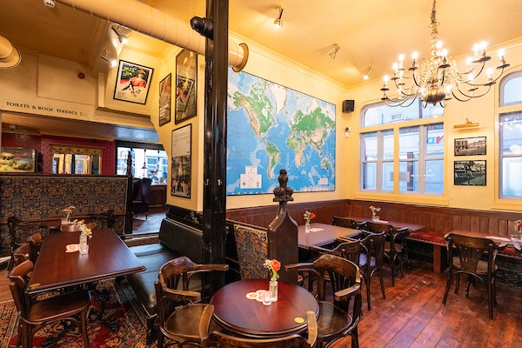
Highly Commended: European, London (above) Remarkable Pubs aimed to bring back the feel of a welcoming traditional pub to a building which had been stripped of most of its original features. The introduction of a traditional bar back, bespoke upholstered pew seating and the careful choice of the paint scheme both inside and outside have helped restore the aesthetic of a traditional Victorian pub, while the creation of an open kitchen on the ground floor has introduced a new focal point.
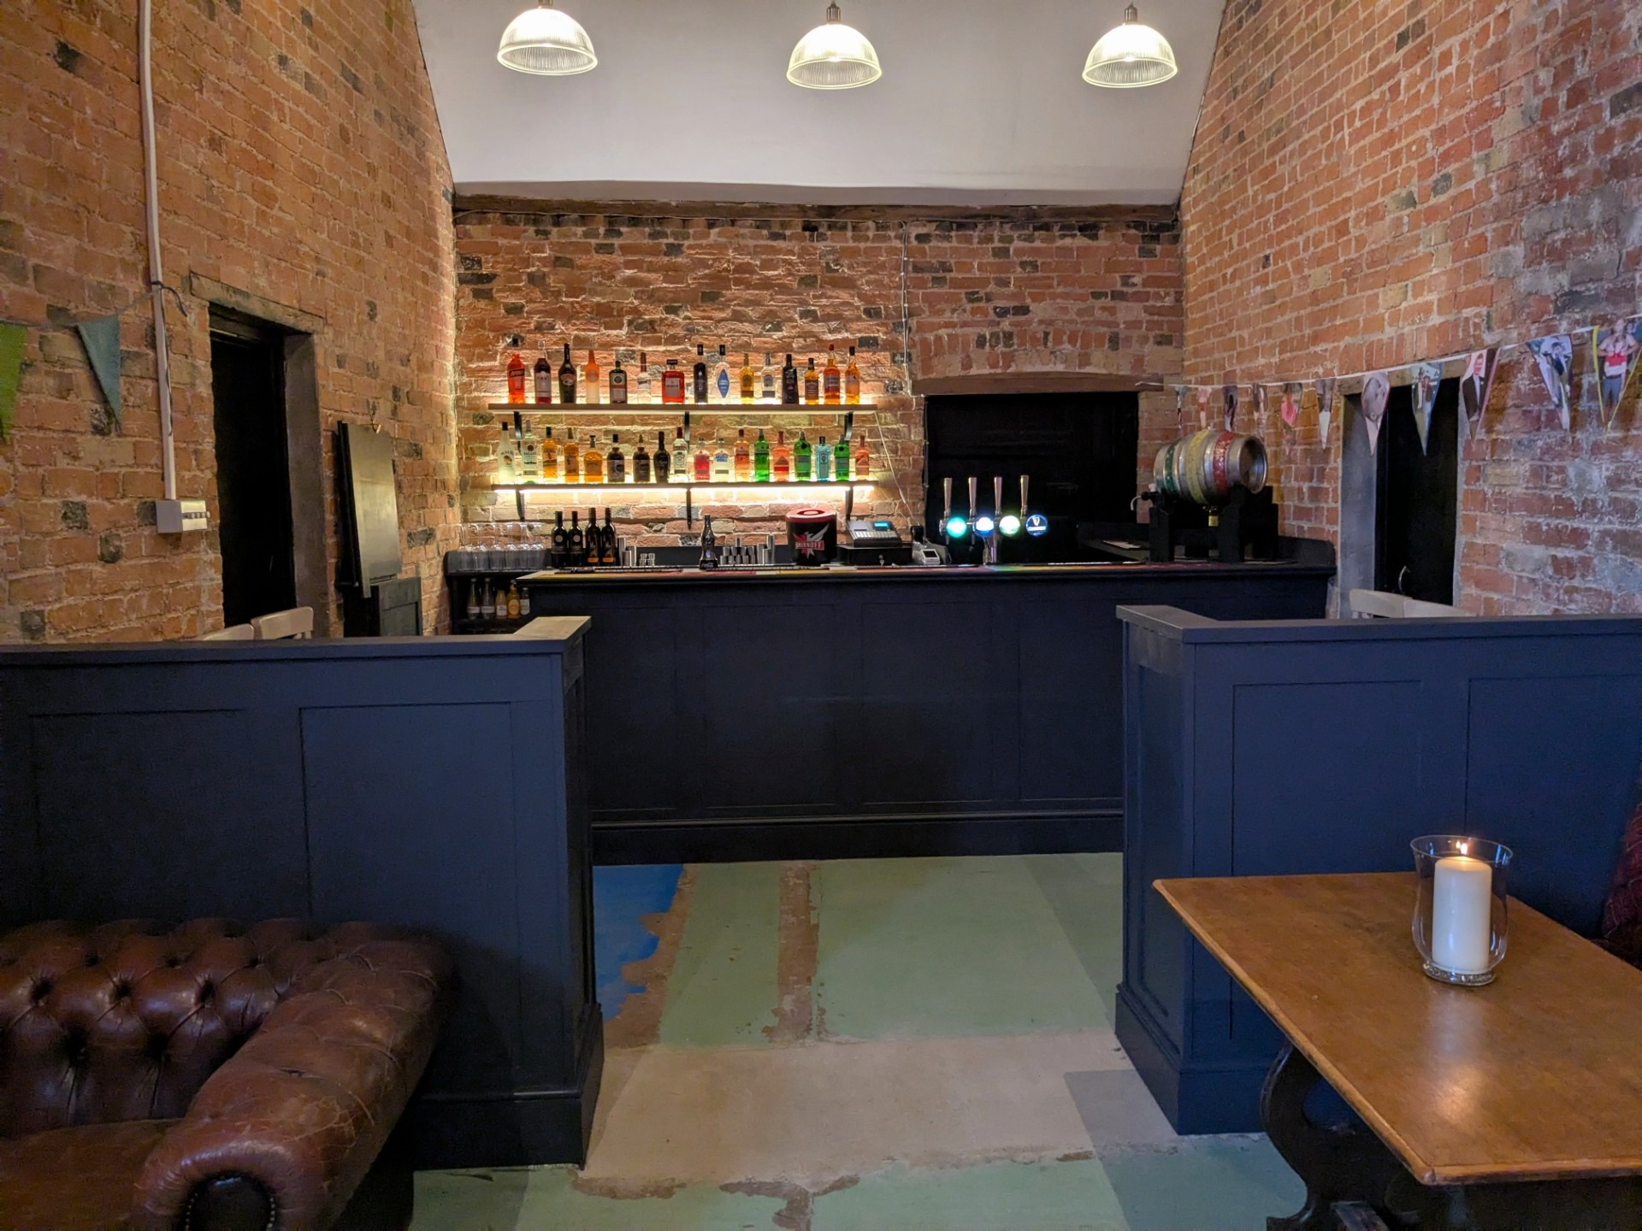
Highly Commended: Green Man, Huntington (above) Owners Andy and Lizzie Langridge took over a run-down building and have transformed it into a focal point for the village. The pub was in such poor condition, with many fixtures covered in mould, almost all the fittings had to be replaced, including flooring, installing new lighting, seating and bar shelving. An entirely self-funded renovation project, the owners did as much of the work as possible independently, even painstakingly building the new oak panelling from scratch.
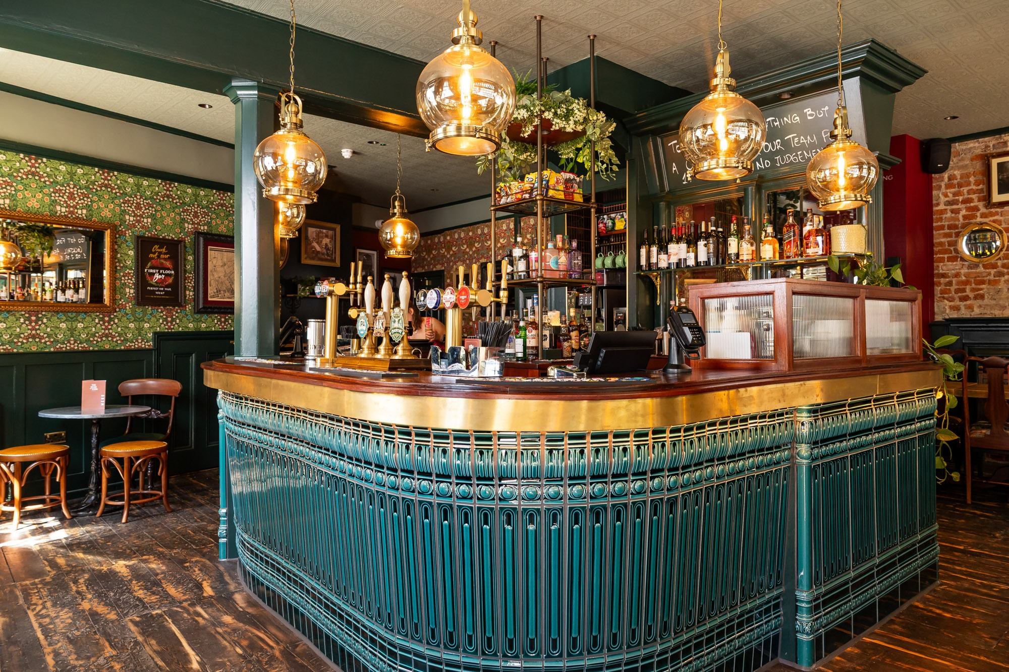
Commended: Duke of York, London (above) McMullen’s brewery stripped the building back to its bare bones and fully refurbished it, including repairs to fix the pavement from falling into the cellar! The outstanding feature of the pub’s refurbishment is the highly impressive ceramic tiled bar counter, which acts as the main focus in the ground-floor bar. Community Local: Reserved for outstanding conservation or refurbishment of street-corner pubs at the centre of the local community.
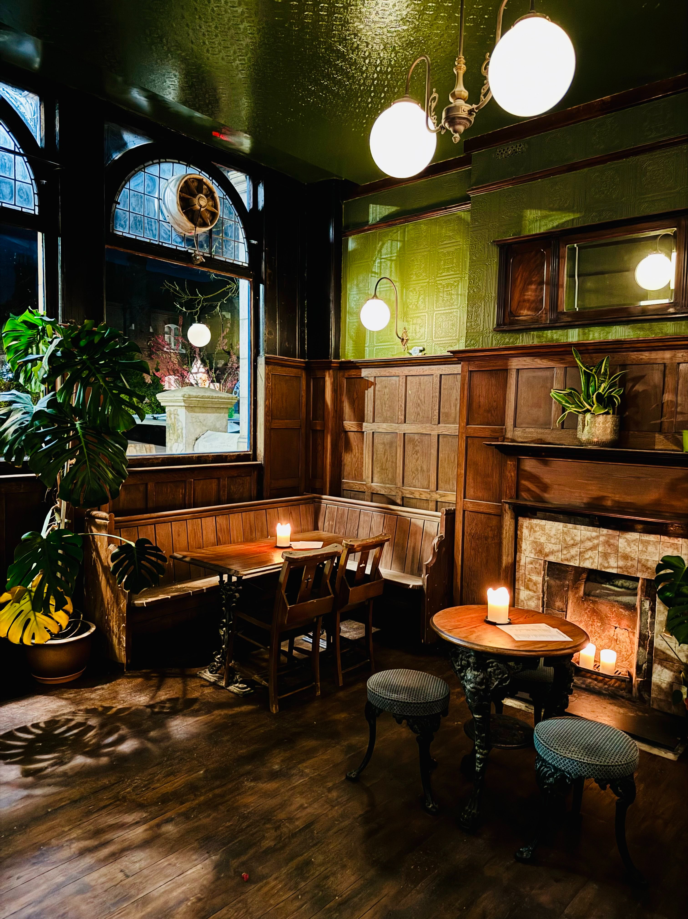
Winner: Lord Southampton, London After being closed for a long time and in near-derelict condition, owners Aimee Brown and Phil Harrington took on the lease of the pub and underwent extensive repairs. The original floorboards and damaged wall-panelling were restored, the bar area was upgraded, and a new hand painted sign was commissioned. It now offers spaces for local groups to meet and is at the heart of its local community.

