CAMRA urges government to back bid to protect pub treasures
17/06/2026 by WB Reporter
Campaign

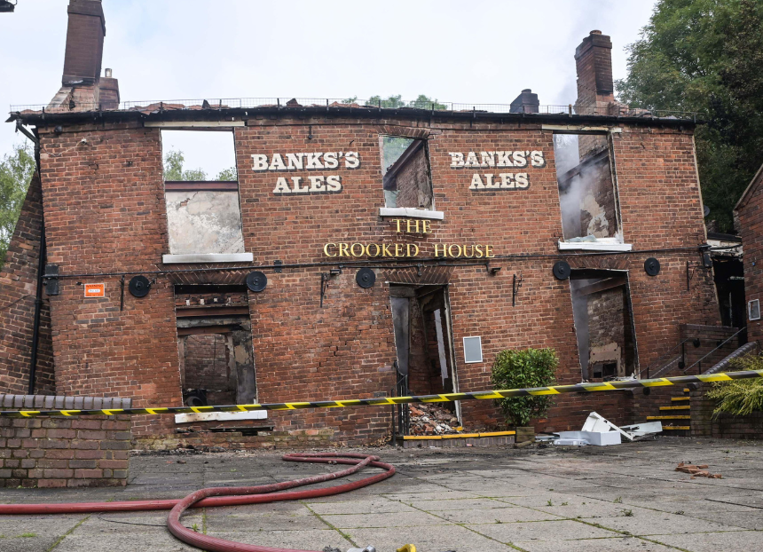

CAMRA has called on MPs and ministers to back a new law to stop heritage pubs being lost. The Campaign is throwing its weight behind legislation introduced to the House of Commons today which would give extra legal protection for historic and outstanding pubs in England. The Heritage Public Houses Bill would better protect historic locals from being lost to demolition or conversion. The bill has been introduced by Conservative MP Mike Wood, who came third in the Private Members Bill ballot, which means he has a high chance of getting his proposals into law, but only if political parties and the government give their support. Mike Wood is the MP for Kingswinford and South Staffordshire constituency where the Crooked House pub (pictured) in Himley was demolished following a fire back in 2023. CAMRA joined campaigners and communities across the country in calling for the Crooked House pub to be rebuilt brick-by-brick. The future of the pub is dependent on an ongoing police investigation before South Staffordshire Council can force the owner of the pub to rebuild it. The new bill would give stronger protections in law to prevent pubs listed as a heritage pub being demolished or converted into houses or other uses where the community wants to save the building as a pub. CAMRA chairman Ash Corbett-Collins said: “CAMRA and our 145,000 members are giving our full backing to this desperately needed bill that will give better protections for pubs, which are a vital part of our heritage and of community life up and down the country. “The public’s reaction to the scandal of the Crooked House in Himley being destroyed showed just how much the nation values historic and unique pubs, and why better protections are needed to stop them being lost forever to demolition or converted into houses, shops or takeaways. “A huge thank you to Mike Wood for standing up to save and safeguard outstanding pubs that hold such a special place in our national story in the past, present and – if the government and MPs back this legislation – the future too.” Photo by Alamy. Do not reshare.

