Members’ Weekend 2026 round up – AGM resolutions
14/06/2026 by Harri Knight-Davis
Campaign

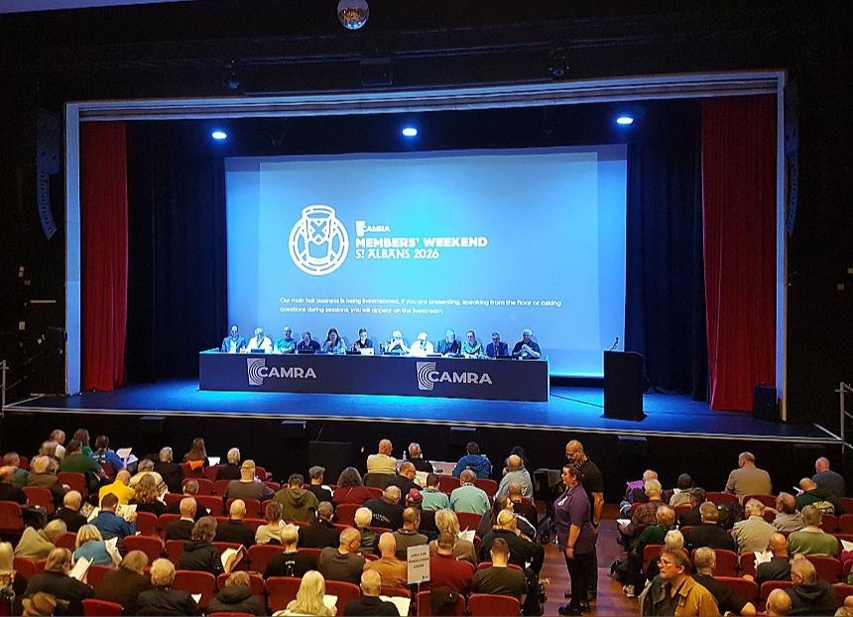

What’s Brewing is highlighting key moments from Members’ Weekend 2026 in St Albans. Watch the Ordinary and Special Resolutions at CAMRA’s AGM from Members’ Weekend 2026 below.

