Is AI leaving a bad taste?
13/06/2026 by Matthew Curtis
Opinion

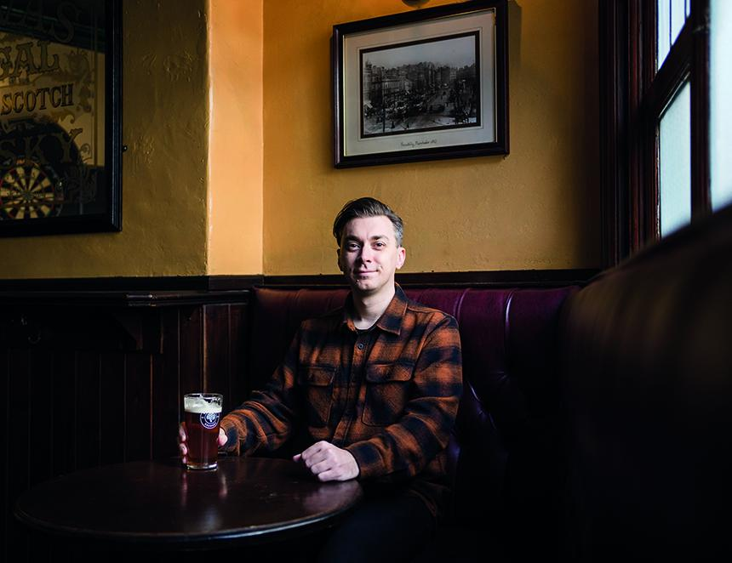

Standing at the bar in Sheffield’s Rutland Arms, I scan the beer list before deciding what to order. Settling on a pint of pale ale from Derbyshire’s Pentrich Brewing Company, I watch as the bartender takes a pint pot from the shelf above their head before bringing it down to the swan neck spout in front of them. Just before they grip the handpull I notice the pump clip and something about its artwork immediately feels a little off. Asking the bartender to pause for a second, I lean in, at which point my suspicions are confirmed – the art is generated by a large language model (LLM) more commonly referred to as generative AI. It might sound extreme, but I immediately tell the bartender I’d rather order something else. I care about the beer I drink and how much effort and care goes into its production. I deeply value the level of care that takes place in the production of creative work, which includes pumpclip and beer label design. I consider that if I can’t trust that this basic level of care has gone into producing said artwork, then I can’t trust the beer, either. Settling instead for a pint of Hillfoot Best by local favourites Blue Bee, the bartender then tells me something surprising – I’m not the only customer they’ve served that got the AI-ick when spotting this particular pump clip. Could it be that breweries cutting corners with AI artwork are actually putting customers off from buying their beer? There are a few reasons why a brewery might opt to use AI-generated artwork instead of hiring an illustrator or graphic designer. Chief among these is cost. Good art and indeed artists deserve fair remuneration for their work but aren’t cheap. LLMs often let you use them for free, or access premium features for a small monthly subscription. It also gives you a pretty much infinite well of ideas to choose from, seeing that LLMs are trained on vast amounts of art that already exists. The drawbacks, however, feel like they massively outweigh any potential savings. For starters, none of the work AI generates is actually original, and in many cases it is trained on material that is copyrighted, effectively making any artwork produced using it tantamount to theft. Using AI is also woefully bad for the environment. The data centres in which LLMs are housed not only require massive amounts of energy to run, but a vast volume of water to keep them from overheating. For example, asking ChatGPT a single question uses 10 times the amount of water as a single Google search. If it needs that for just a few lines of text, imagine how much generating reams of images then requires… But there’s more to the anti-AI argument than simply the fact it’s stolen work that’s rapidly progressing climate change (okay, there shouldn’t be, but here we are). The other drawback is that, even with the latest advances in technology, there’s always something a little off about the images. The human brain is a clever thing and if something doesn’t look right, it can cause those feelings of discomfort that might put them off purchasing whatever uses it. People value authenticity, especially when it comes to the beer they drink. Generative AI has none. Those savings you might have made by not hiring an artist in the first place may well be lost in sales as a direct result. As it happens, I’m not the only person who has decided to give breweries that rely on AI artwork the boot. In Newcastle, pubs the Mean Eyed Cat and Free Trade Inn have publicly announced their intention to cease stocking beer from breweries that use generative AI to make their artwork. Speaking to the BBC, the Mean Eyed Cat’s Simon Willard commented on his fears that its use might put artists out of work, and how he hopes the policy might cause a few breweries to rethink using LLMs to create their label art. While this might hopefully inspire a few breweries to actually invest in original creative work to use on their labels and pump clips, in turn investing in the authenticity of their products, some breweries continue to rely on generative AI. Most recently, Hampshire’s Vibrant Forest brewery has worked with production company Treacle7 to produce an AI-generated television commercial. The 30-second advertisement features four of the brewery’s core range beers, depicted in a forest, hanging from trees, with one even blooming from a water lily. The only thing is that none of it is actually real… Instead of using the nearby New Forest National Park from which the brewery takes its name, it uses a fake, AI-generated woodland. I find it baffling why a company that celebrates the fact it is near such a stunning area of natural beauty would invest in technology that is fundamentally detrimental to its existence. The video itself feels unsettling – a simulacrum completely ungrounded in reality, which, for me at least, does little to make me actually want to try the beers. Ultimately, customers will decide what beer they choose to drink with their wallets. For those that value authenticity and social conscience as core brand values, it’s unlikely they’ll be spending with breweries that invest in the use of generative AI. It’s called real ale, after all, not artificial ale.

