Branch celebrates half century with 50-pub ale trail
11/06/2026 by WB Reporter
Campaign

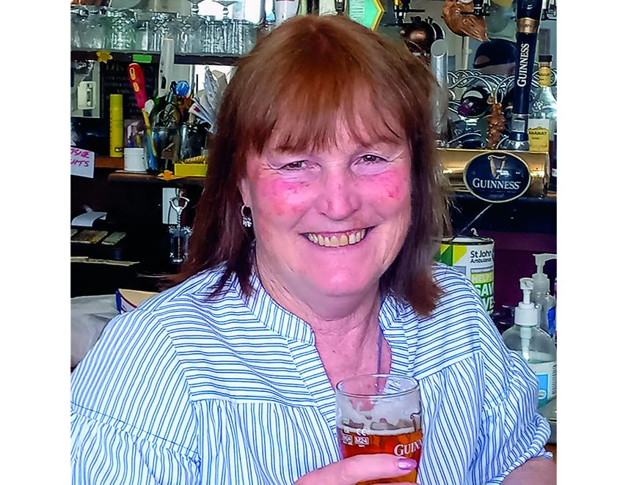

As part of the West Dorset’s branch’s 50th anniversary celebrations, a local ale trail was launched in early April which is encouraging people to visit pubs and also highlighting the 50 local pubs that have appeared most often in the Good Beer Guide since the branch was founded. Trail co-ordinator Mandy Priest (above) said: “Potential participating publicans were initially asked if they wished to take part, once the 50 pubs were listed they were given a stamp to show a customer had visited the pub. In the recent addition of the Giant’s Pint publication (which is available in most West Dorset pubs), the centre piece shows the five trails for participants to visit. “On ordering any drink they receive a stamp; there are 10 pubs on each trail and prizes on completion with full details in the Giant’s Pint. “So far we have had very good feedback from the participating pubs and people taking part in the trail. I am now looking forward to visiting all of the trails by the close at the end of August and celebrate a successful event.” Janine Ryan of the Giant Inn, Cerne Abbas said: “Every shift someone comes in on the ale trail it’s definitely brought in extra trade”. Lucy Orton from the Chetnole Inn, Chetnole added: “Some people have already nearly completed the trail, people seem to love it and not just cask ale drinkers, it’s boosted our trade." Landlady Geraldine Baker of the Ropemakers, Bridport said: “We have had customers in the pub we have never seen; I think the ale trail is a really good idea and I would love to do a trail myself.” West Dorset CAMRA spokesperson Rich Gabe said: “When the trail was launched we had never done anything like this before. The whole point of the trail is to encourage trade in the participating pubs but also encourage support for other pubs within the vicinity. “With the summer months ahead of us this is the perfect time to visit a pub and take advantage of the gardens or go somewhere you would normally not visit.”

