Members’ Weekend 2026 round up – beer scoring review
10/06/2026 by Harri Knight-Davis
Campaign

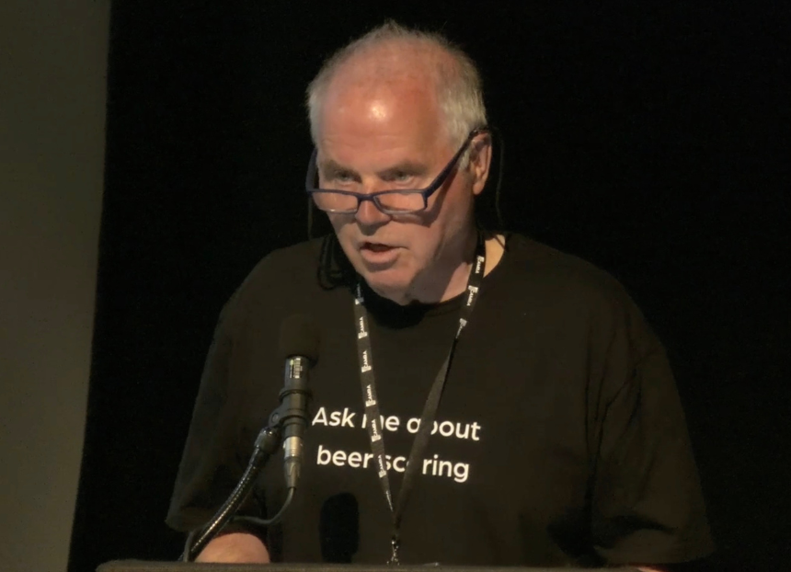

What’s Brewing is highlighting key moments from Members’ Weekend 2026 in St Albans. Watch National Beer Scoring System (NBSS) coordinator Brett Laniosh (above) give an overview of the beer scoring review and explanation of the new beer scoring system, covering why it has been changed and its new features. Find out more about the revamped beer scoring system here.

