Boom time for lower-strength beer
09/06/2026 by Timothy Hampson
Industry

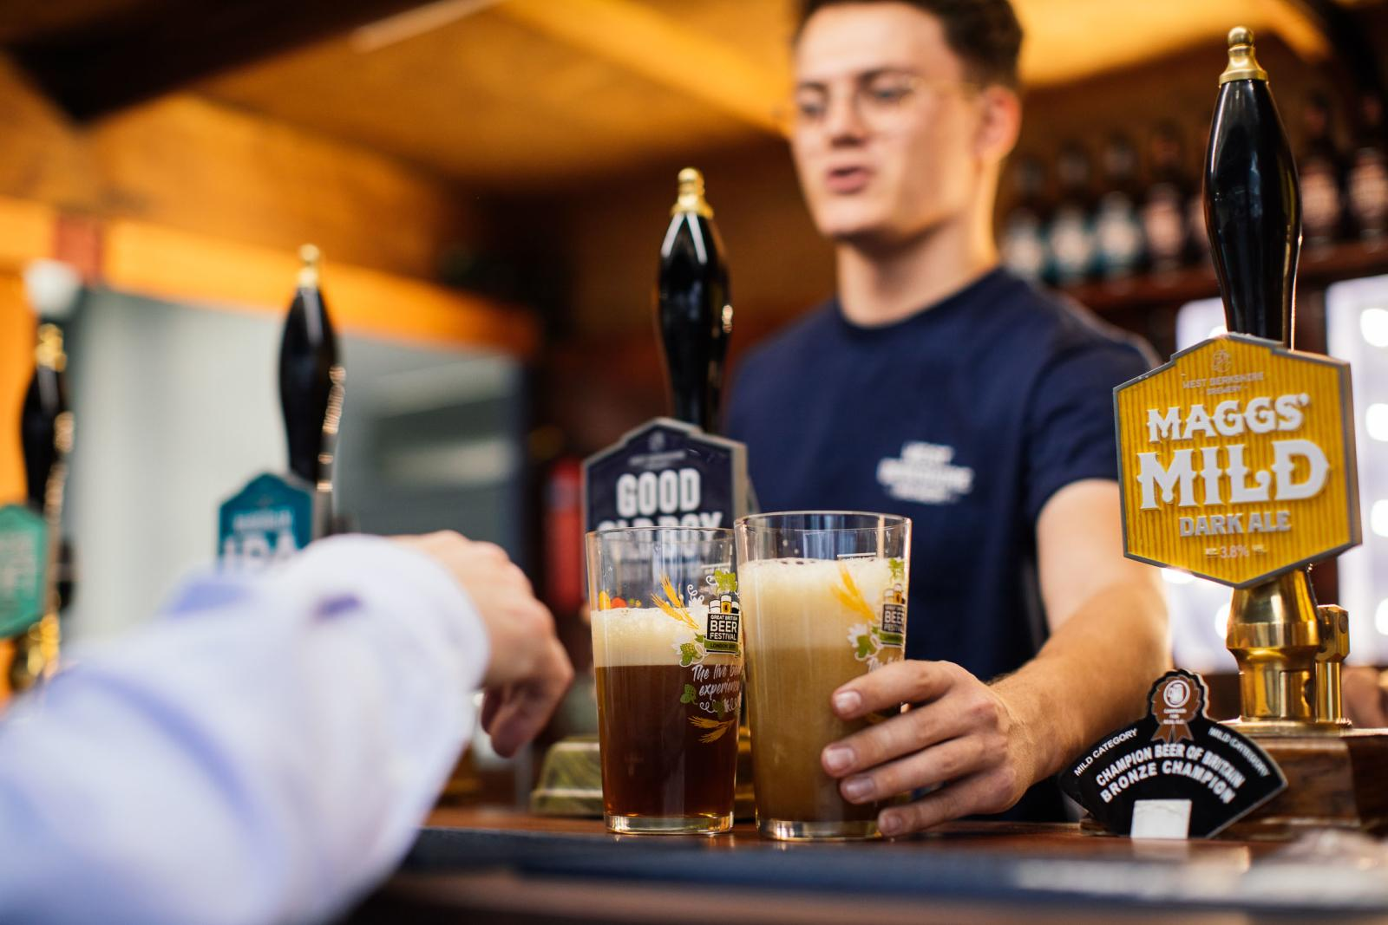

Alcohol duty regime change has led to a boom in lower-strength pint sales, new research has revealed. The British Beer and Pub Association (BBPA), which commissioned the research from Oxford Economics with the Brewers of Europe, said: “The results are proof that when government supports business, business can boost the economy and help people choose lower strength options.” In the Alcohol Duty Review (ADR) in August 2023, drinks of 3.4 per cent ABV and under were granted a lower tax rate, along with a new draught duty relief to support pubs. Since this came into effect, 200m units of alcohol have been removed every year up until 2025. Sales of lower strength beers – classed as between 1.3 per cent and 3.4 per cent – have boomed since the ADR, with brewers investing in a new range of products, the BBPA said. The subsector was only 0.4 per cent of the market – the equivalent of 35m pints – in 2022 but, since the tax changes, this has grown rapidly to more than 12 per cent of the market or 912m pints, the trade body said. BBPA chief executive Emma McClarkin said: “It is clear that a progressive alcohol duty regime that incentivises lower-strength products can help grow the economy, give people more options, and support public health goals. “Beer is already a low-strength alcohol beverage, but brewers have come up with an incredible choice of lower-strength products, which means more people than ever before can moderate and pubs can give people a great choice. “However, UK beer drinkers continue to pay among the highest duty rates in Europe and brewers and pubs face eye-watering increases in the cost of doing business. “This is why we need to go further and cut beer duty to support our brewers and pubs, ensure a pint remains affordable for all, and help give consumers more choice.” The analysis said the changes to the duty regime have helped businesses make firm progress towards meeting the key objectives the government set out. It pointed to significant innovation through the reformulation of products to below 3.5 per cent and increased consumption of lower-strength alcohol drinks. The research, which looked at sales up until the end of 2025, said academic literature suggests a reduction in alcohol units consumed of this scale would result in health benefits at a population level. CAMRA chairman Ash Corbett-Collins said: “Ensuring lower-strength beers are served on the bar is essential so consumers have more choice, however, that doesn’t mean consumers want brewers to lower the ABVs of their existing beers. Global brewers are changing the recipes of their brands, not for customer choice, but for lower tax – charging pubgoers the same price for watered-down beer. Alcohol duties rose across the bar in February, so some breweries have had to lower the ABV in beers to make ends meet. “The UK has incredible independent breweries that make a variety of quality beer styles with varying levels of alcohol. But they barely stand a chance against global brewers who have a stranglehold over bars in pubs. The government must cut alcohol duties, so consumers have better, quality choice and use their recent independent Access to Market Review to make room for beers by independent, local producers.”

