Members’ Weekend 2026 round up – marketing for growth
08/06/2026 by Harri Knight-Davis
Campaign

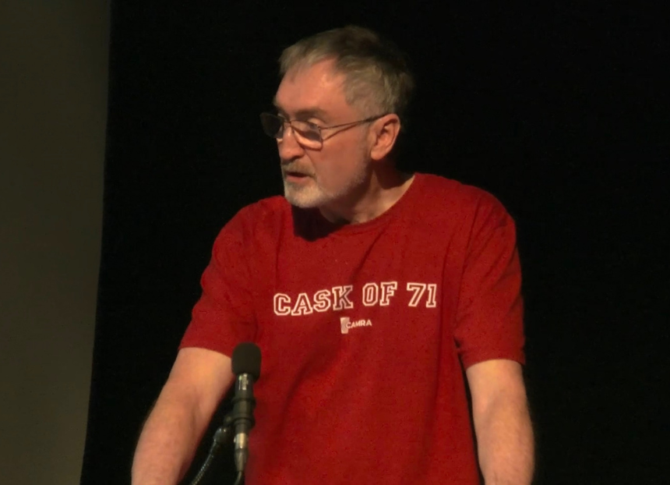

What’s Brewing is highlighting key moments from Members’ Weekend 2026, in St Albans. Watch commercial director Dean Barrett lay out CAMRA’s marketing plan to grow membership.

