Intuitive beer scoring system launched
01/06/2026 by Nick Yarwood
Campaign

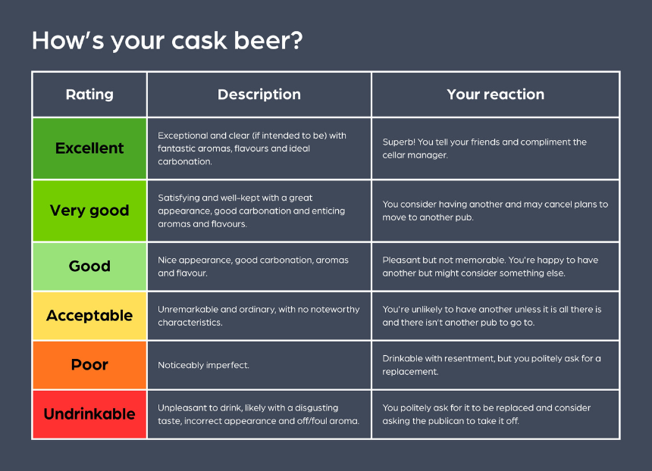

CAMRA has revamped its beer scoring system, bringing in a new intuitive rating scheme making one of the key factors in selecting pubs for the Good Beer Guide easier to use. For lovers of a decent pint, it’s important to be able to find them. CAMRA’s Good Beer Guide has been the bible for finding the very best since 1974 and continues to be relied upon by thousands of cask lovers. CAMRA’s online pub guide camra.org.uk/pubs can also help because beer quality is indicated by the 3 Pints symbols that members see when logged in. Pubs and clubs that consistently serve excellent pints are candidates for the Good Beer Guide. To help identify them, CAMRA members score their pints whenever they have the opportunity. Their scores help branches determine entries for the guide, and these can change year on year as the standards are high. Competition for a place is stiff because only 4,500 are available. Up to now, the scoring system has used a 0-to-5 system. But there are problems as it requires memorising the criteria for each score and using them consistently. Some people struggle with numbers, so they don’t take part. It becomes open to individual interpretation with resulting inconsistency between scorers. There’s also the potential for individual bias and a reluctance to award high scores. We all know a good pint that’s been well-kept, and if it is very good or excellent plus when it is simply okay or, hopefully not often, undrinkable. To make things easier, a new rating system is being introduced, which is more descriptive (pictured). Each of the new ratings has a description and a likely reaction to help you pin down the most appropriate rating. Ratings can be recorded on CAMRA’s online pub guide camra.org.uk/pubs by all members, so start rating your beer now. If you’re not a member but would like to rate your beers, then head over to camra.org.uk/membership.

