Killer Peculiar collab
29/05/2026 by Timothy Hampson
Industry

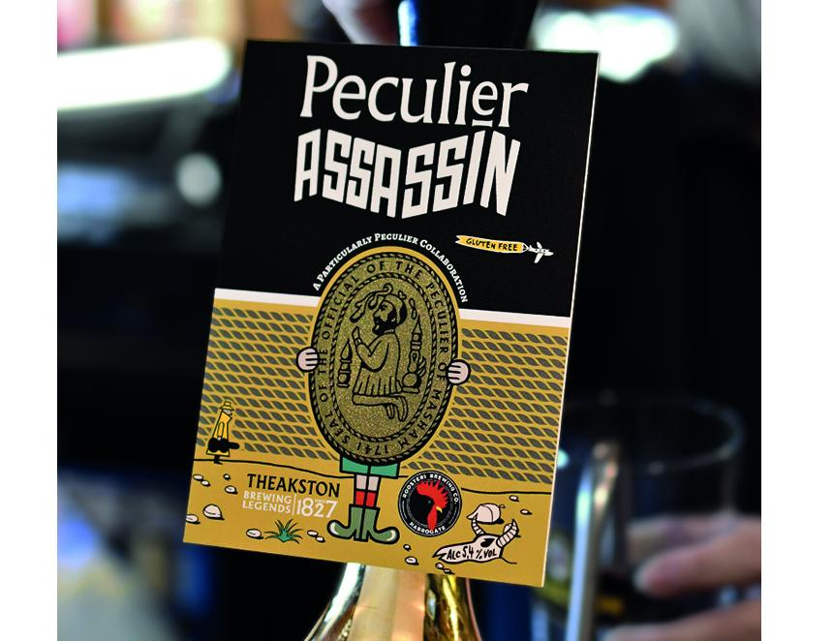

T&R Theakston and Rooster’s Brewing have come together to create Peculier Assassin, a gluten-free beer that fuses the character of Old Peculier with the hop-charged attitude of Baby-Faced Assassin. Launching at the end of May in cask, keg and can, the limited-edition 5.4 per cent ABV release will debut at Theakston's flagship pub, the Black Bull In Paradise and Rooster's Taproom in Harrogate before rolling out to pubs, bars and retailers across the UK. Peculier Assassin is what happens when two distinctive Yorkshire beers collide. Rich, dark and fruit-laden Old Peculier meets the tropical punch and resinous hop hit of Baby-Faced Assassin to create something entirely new. A smooth, deep ruby-brown beer layered with roasted malt sweetness, juicy citrus and pine notes, balanced by vibrant bitterness and a long, effortlessly drinkable finish. The collaboration brings together two independent Yorkshire breweries, united by a shared passion for characterful beer, innovation and doing things their own way. Old Peculier is the flagship beer of T&R Theakston and one of the most distinctive strong beers in British brewing. Dark, ruby red in colour, it is instantly recognisable for its deep dark cherry fruit character, soft banana esters and rich malt backbone, layered with gentle roasted complexity. Baby-Faced Assassin, a 100 per cent Citra-hopped American-style IPA was initially conceived as a 25-litre batch homebrew recipe before forming part of Rooster’s core range in 2013. First canned in 2014, the beer has since won countless awards competitions and beer festivals. The connection between the breweries stretches back decades, with Rooster’s chairman Ian Fozard involved in the 1980s CAMRA campaign that supported Theakston’s return to independent ownership. The beer has been jointly developed by Theakston head brewer Mark Slater and Rooster’s head brewer Oliver Fozard. Fozard said: “Mark and I have known each other within the industry for over 10 years, so it's been great fun to work with him on this project. From our initial meetings there was only one beer we were both keen to explore, so I’m delighted with how both breweries have come together to create Peculier Assassin.” Slater added: “Working with Oliver on Peculier Assassin has been a really enjoyable process. We both came to the table with a clear idea of what we wanted to achieve — bringing together the richness and depth of Old Peculier with the bright, modern hop character Rooster’s is known for. It's been a genuine collaboration throughout, and I'm really pleased with how the beer has come together — it feels balanced, distinctive and full of character.” Theakston has brewed the cask version while Rooster's has produced the keg and can releases.

