Tring Toad tapped in Stranger’s bar
28/05/2026 by Timothy Hampson
Industry

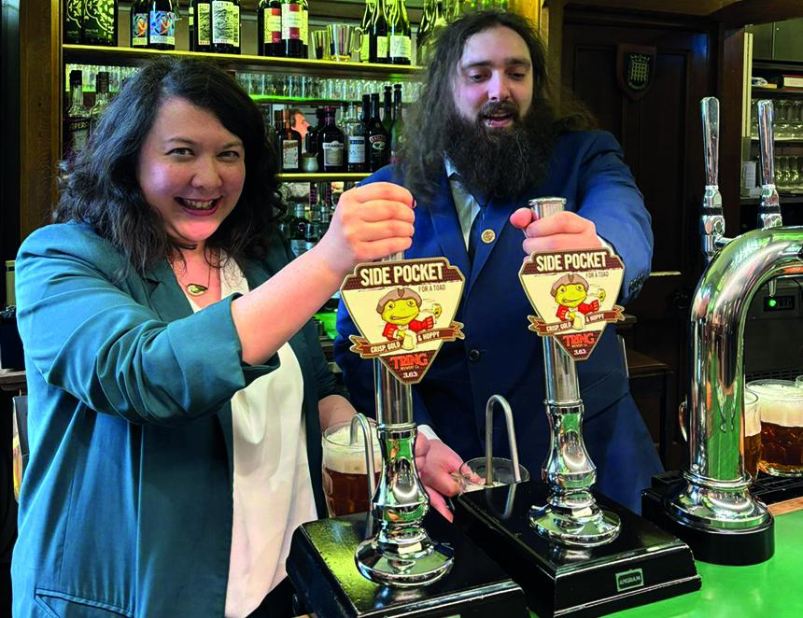

One of Hertfordshire’s best-selling beers has been served at Strangers’ Bar in the Houses of Parliament, with MPs enjoying the local brew. Side Pocket for a Toad at 3.6 per cent, Tring brewery’s flagship beer, was nominated through the parliamentary guest beer initiative by Harpenden and Berkhamsted MP Victoria Collins. As part of the nomination, Tring beer sommelier Jared Ward was invited to parliament for a tour, and a tipple of Toad at Strangers’ Bar – parliament’s private pub. Named following Tring’s theme of local legends, Side Pocket for a Toad takes its title from an old-Hertfordshire saying for uselessness, akin to a “chocolate teapot”. Far from useless as a beverage, Side Pocket celebrated a quarter-century of production last year and was Hertfordshire Beer of the Year at the St Albans Beer and Cider Festival in November. Strangers' Bar and its Thameside terrace are located within the Houses of Parliament, restricted to MPs, officers of Parliament and parliamentary staff. Members of the public may be admitted as guests of officials only. Ward said: “To have Side Pocket for a Toad nominated for service at Westminster is truly historic. “What started as an unconventional name and playful mascot 25 years ago soon morphed into the brewery’s champion ale and remains top of the pack after all these years. “We’d like to thank Victoria Collins for her work in getting Tring ale into Strangers' Bar. We relished the opportunity to tour the hallowed halls and chambers, and to prop up the bar at one the country’s most exclusive pubs. To have our local representative give us this platform is a very special moment indeed for Tring brewery.” LibDem MP Collins said: “It has been great to be able to champion a brewery within the Harpenden and Berkhamsted constituency. It was such fun to pour a pint of Side Pocket for a Toad in Strangers’ Bar. Here’s to supporting local.” Pictured: Toad tipplers – Victoria Collins and Jared Ward

