Plan your next festival trip
27/05/2026 by Matthew Rogers
Campaign

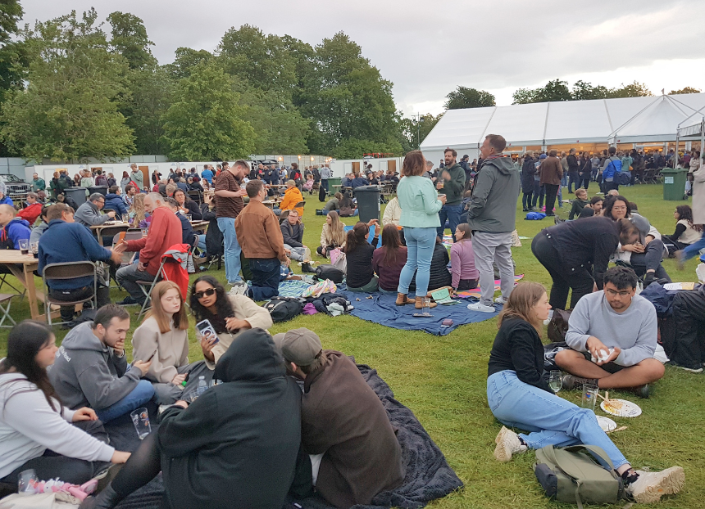

The sun is shining so make the most of it and head to a CAMRA festival this summer! Members can now enjoy free entry to many CAMRA festivals (not including souvenir glass and programmes) when booking tickets in advance. For more information and to see all upcoming CAMRA events visit the events webpage. Colchester Real Ale and Cider Festival, 27-30 May Colchester Arts Centre, Church Street, Colchester, CO1 1NF colchesterbeerfestivals.co.uk Thurrock Beer and Cider Festival, 2-6 June Civic Hall, Blackshots Lane, Grays, RM16 2JU thurrock.camra.org.uk/viewnode.php?id=242456 Hitchin Beer and Cider Festival, 4-6 June Hitchin Rugby Club, Old Hale Way, Hitchin, SG5 1XL hitchinbeerciderfestival.org.uk Stratford Upon Avon Beer and Cider Festival, 5-6 June Stratford On Avon Racecourse, Luddington Road, Stratford-upon-Avon, CV37 9SE shakespeare.camra.org.uk/festival Chester Beer Festival, 5-6 June Chester Town Hall, Town Hall Square, Chester, CH1 2HQ westcheshire.camra.org.uk/beerfestival KESR Railway Real Ale and Cider Festival, 5-6 June KESR Railway, Tenterden, TN30 6HE afrm.camra.org.uk/viewnode.php?id=278100 Kingston Beer Festival, 11-13 June Kingston Workmen’s Club and Institute, 25 Old London Road, Kingston-upon-Thames, KT2 6ND facebook.com/KingstonBeerFest Barnsley Beer Festival, 11-13 June Barnsley Civic, 46 Eldon Street, Barnsley, S70 2JL barnsleycivic.co.uk/event/barnsley-beer-festival Winchester Beer and Cider Festival, 12-13 June University of Winchester Student Union, Sparkford Road, Winchester, SO22 4NR winchesterbeerfestival.camra.org.uk GWR Ale and Steam Weekend Festival, 12-14 June Winchcombe and Toddington GWR Stations, Winchcombe and Toddington, GL54 5LD gwsr.com/whats-on/rail-ale-festival Leicester Beer Festival, 18-20 June Abbey Pumping Station, Corporation Road, Leicester, LE4 5PX leicester.camra.org.uk/events/leicester-beer-festival-2026 Stockport Beer and Cider Festival, 18-20 June Masonic Guildhall, 169-171 Wellington Road South, Stockport, SK1 3UA stockportfestival.org.uk CAMRA Cricket Tent Kent v Middlesex, 19-22 June Kent County Cricket Club, Old Dover Road, Canterbury, CT1 3NZ kent.camra.org.uk/viewnode.php?id=281836 Rutland CAMRA Beer Festival, 26-28 June County Museum, Catmos Street, Oakham, LE15 6HW rutland.camra.org.uk/viewnode.php?id=279309 Totnes Beer and Cider Festival, 2-4 July Totnes Civic Hall, Market Square, Totnes, TQ9 5SF southdevon.camra.org.uk/viewnode.php?id=231333 Maidenhead Beer and Cider Festival, 3-4 July The Sports Bar, Summerleaze Park, Off Summerleaze Road, SL6 8SP maidenheadbeerfest.camra.org.uk Ealing Beer Festival, 8-11 July Walpole Park, Mattock Lane, London, W5 5BS ebf.camra.org.uk Beer on the Wye XlX, 10-12 July Hereford Rowing Club, Greyfriars Avenue, Hereford, HR4 0BE beeronthewye.wixsite.com/beeronthewye Chelmsford Beer and Cider Festival, 13-18 July Admirals Park, Rainsford Road, Chelmsford, CM1 2PL cbcf.camra.org.uk Hemel Old Town Beer Festival, 17-19 July St Mary's Church, High Street, Hemel Hempstead, HP1 3AE hemeloldtownbeerfestival.co.uk Glasgow Real Ale Festival (G-RAF), 6-8 August The Briggait, 141 Bridgegate, Glasgow, G1 5HZ g-raf.camra.org.uk Worcester Beer, Cider and Perry Festival, 13-15 August The Grandstand, Worcester Racecourse, Worcester, WR1 3EJ festival.worcester.camra.org.uk East Anglian Beer and Cider Festival, 26-31 August St Edmundsbury Cathedral, Angel Hill, Bury St Edmunds, IP33 1LS burystedmundsbeerfestival.com Clacton Beer and Cider Festival, 26-29 August St James Hall, 56 Tower Road, Clacton-on-Sea, CO15 1LE tendring.camra.org.uk/clacton-on-sea-real-ale-cider-festival Harbury Beer and Cider Festival, 4-5 September Harbury Village Hall, South Parade, Leamington Spa, CV33 9JE how.camra.org.uk/?page_id=79 CAMRA Bar at Faversham Hop Festival, 5-8 September East Street, Faversham, ME13 8AF kent.camra.org.uk/viewnode.php?id=282070 Calderdale Beer and Cider Festival 2026, 24-26 September Arden Road Social, Arden Road, Halifax, HX1 3AG hxcalderdale.camra.org.uk/2026-calderdale-beer-and-cider-festival Nottingham Robin Hood Beer and Cider Festival, 7-10 October Trent Bridge Cricket Ground, Bridgford Road, West Bridgford, NG2 6AG nottinghambf.camra.org.uk Steel City Beer & Cider Festival, 21-24 October Kelham Island Museum, Alma Street, Sheffield, S3 8RY sheffield.camra.org.uk/scbf Redhill Beer Festival, 29-31 October Merstham Village Hall, Station Road North, Merstham, RH1 3ED ems.camra.org.uk/festival

