Old and new combine for Spring
26/05/2026 by Timothy Hampson
Industry

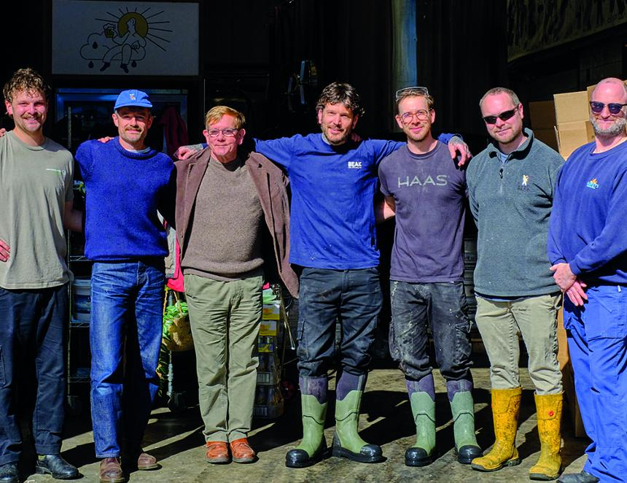

Two Sussex breweries, one with more than 230 years of brewing heritage and the other one of the UK’s most exciting modern craft breweries, have come together to create a collaborative beer. Harvey’s and Beak breweries have launched Spring, a limited-edition 4.5 per cent ABV golden ale brewed at the latter’s site in Lewes (above). Brewed with a blend of Harvey’s and Beak’s yeast, it opens with fresh grapefruit and bright citrus notes before soft tropical character builds from a generous dry hop of New Zealand Cascade hops. UK Harlequin and Cascade hops provide a clean, zesty bitterness, while heritage Plumage Archer malt from Warminster lends a light bready sweetness and smooth, rounded body. Slightly hazy and highly drinkable, Spring bridges traditional Sussex brewing with contemporary hop-forward character. The beer’s pump clip features illustrations of Harvey’s joint MD Miles Jenner alongside Beak’s distinctive Beak Man character, reflecting the collaboration. Jenner said: “It has been great fun combining thoughts and resources with Danny, Mark and all the team at Beak. “We have broken new ground with our first, intentionally, slightly hazy beer. It contains a wealth of flavours derived from Sussex and New World hops, offset by a marriage of yeasts from both breweries. A heritage, Sussex-grown barley forms the backbone of the brew, as is befitting for a beer produced by two county town brewers." Beak’s Danny Tapper said: “We’re huge cask beer fans here at Beak and Harvey’s has always been a brewery we’ve looked up to. Not just because of its incredible heritage and the consistency and quality of its beers, but because of the role it plays in the community. It is woven into the fabric of Lewes life in a way that feels increasingly rare and special, and it has been hugely supportive of Beak since the very beginning. “For us, this collaboration felt genuinely meaningful. It was an opportunity to spend time brewing alongside Miles and the Harvey’s team, sharing ideas, techniques and ingredients, and finding a balance between our two approaches to brewing. “The result is a beer that really reflects both breweries, rooted in cask tradition but with a vibrancy that feels very Beak. It’s a real honour to have worked together on something that celebrates both where we come from and the kind of beer we love to drink.”

