Brewer to open shipping container taproom
25/05/2026 by Timothy Hampson
Industry

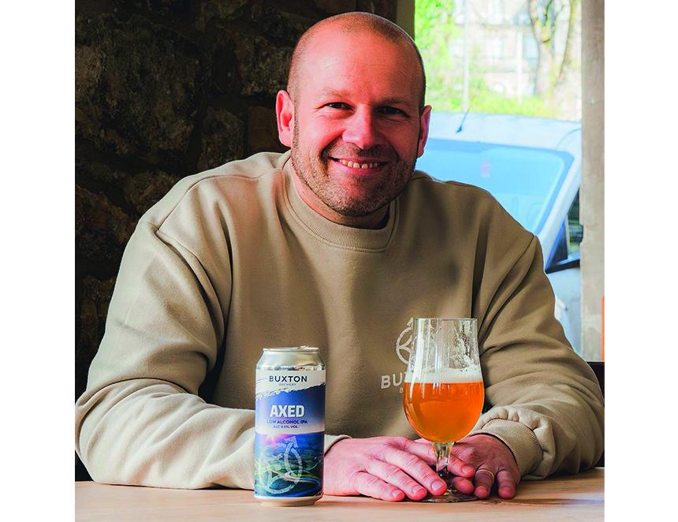

Derbyshire brewer Buxton is opening a new taproom at Bustler’s upcoming St James Yard development in Derby city centre. Dubbed Dukes, the venue will become part of Bustler’s street food and leisure concept, which is being created from around 20 shipping containers arranged over two levels. The taproom will feature three cask lines, eight keg fonts and a rotating range of canned beers, including small-batch brews produced on Buxton’s forthcoming pilot brewing system. Limited-edition beers will only be available at the brewer’s taprooms in Buxton and Derby. Bustler MD Olivia Pritchard said: “Dukes will be a key part of the overall destination adding another layer to what we’re building at St James Yard and giving people even more reason to spend time there.” Buxton MD Dom Metcalfe (above) said: “Derby is a fantastic beer city with a real appreciation for both traditional and modern styles, so it feels incredibly important for us to have a proper presence here. “The taproom will be treated exactly like our bars in Buxton, with the same range, the same standards and the same attention to detail. We want people to walk in and feel like they’re experiencing a genuine Buxton taproom." The upstairs space at Dukes is also expected to host beer masterclasses, events and potential brewery tours linking Derby with Buxton’s Peak District base. Bustler originally launched as a street food market in Derby before expanding into permanent food hall operations in the city and Nottingham. Buxton brewery already operates several venues in its home town including Sock and Buskin cocktail bar, Tap House, Spring Gardens retail venue and its brewery taproom.

