Hen’s Damm switch
22/05/2026 by Timothy Hampson
Industry

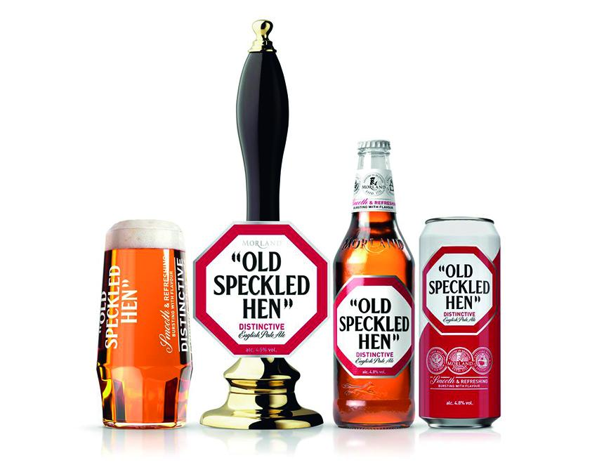

The Old Speckled Hen beer range has been sold to Damm UK despite owner Greene King saying it would be the cornerstone of a new cask sales initiative in 2023. The beer, which dates from the late 1970s, has been brewed at Greene King's base in Bury St Edmunds, Suffolk, for the past 25 years after it took over the Morland brewery in Abingdon, Oxfordshire. The beer will eventually be made at the Damm Eagle brewery in Bedford. Damm UK, the British arm of Barcelona-based family brewer SA Damm and owner of the Estrella Damm brand, said it had acquired the Old Speckled Hen, Old Golden Hen, Old Crafty Hen, Old Master Hen and Low Alcohol Old Speckled Hen brands. During a “transition process” it will continue to be brewed at Greene King’s Westgate brewery, before moving to Bedford. Following completion of the purchase, the Old Speckled Hen brands will continue to be available in the off-trade, including major supermarkets across the UK as well as Greene King’s vast network of pubs. Damm UK MD Luke White said: “Old Speckled Hen is an iconic British ale brand with a rich heritage and loyal following, and we are proud that Greene King has chosen Damm UK to take the brand forward into its next chapter. “We have great respect for the history Greene King has built around Old Speckled Hen over the last 25 years and look forward to working closely together throughout the transition period to ensure continued success for the brand, customers and consumers alike. “The brand not only complements the current portfolio range by adding another category to our offering but it also reconnects the Damm Eagle brewery to its historic British beer and ale production roots.” Greene King CEO Nick Mackenzie said: “We are proud to have built Old Speckled Hen into one of the nation’s favourite ales over the last 25 years and are delighted to have secured a partner in Estrella Damm who will continue to brew the ales in the UK. We look forward to working closely in partnership with Damm and seeing Old Speckled Hen’s future success under their ownership.” The acquisition reinforces Damm’s long-term commitment to the UK market following the purchase of the Eagle brewery in 2022 and subsequent investment in the site. Greene King is planning to build a new £40m brewery that will see it move from its current site in Bury St Edmunds, where it has had a town-centre presence since 1799. It could relocate next to its distribution centre at Suffolk Park in the Moreton Hall area of the Suffolk town. Old Speckled Hen brands account for more than half of Greene King’s beers sold in UK retailers. Greene King, which runs 2,500 pubs, restaurants and hotels, will continue to make cask and keg beer including Greene King IPA and Abbot Ale but will focus on selling these in pub venues.

