Community pub ownership update – May
21/05/2026 by Paul Ainsworth
Campaign

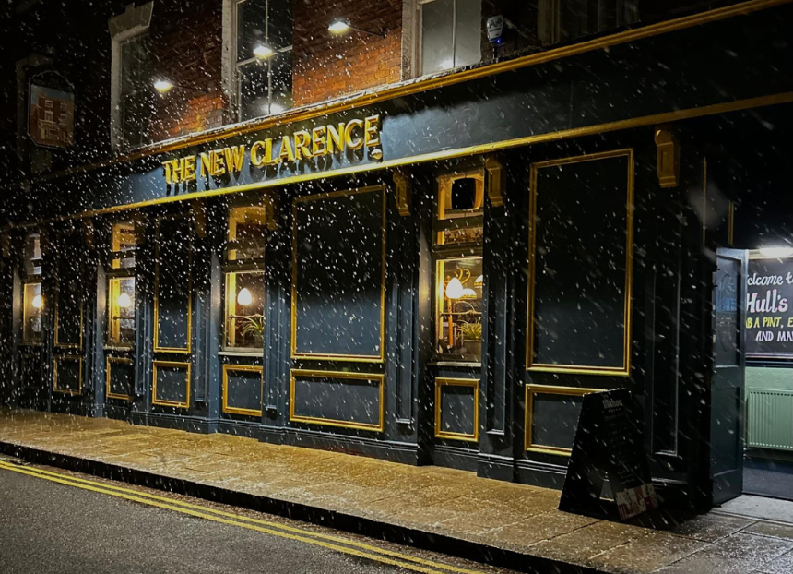

Since December’s bulletin, the number of community-owned pubs (COPs) has increased from 227 to 234. Those not owned but run by the community are up two at 31. There has been a noticeable slowdown over the last year or so, no doubt connected to the demise of the Community Ownership Fund (COF). The number of active campaigns has gone up from 90 to 96, so enthusiasm for community ownership clearly remains plentiful. CAMRA supports the community-ownership model and is keen to help those interested in going down this route. The community pubs webpage of CAMRA’s website contains advice and guidance as well as regularly updated information about existing and planned projects. Community Right to Buy At the end of April, parliament passed the English Devolution and Community Empowerment Act, which includes the new Community Right to Buy. However, these provisions will not come into force until the accompanying regulations and guidance are issued. CAMRA will be keeping in touch with officials at the Ministry of Housing, Communities and Local Government about this and it also expects a review of the Asset of Community Value process to follow as part of these changes. The new Community Right to Buy gives groups first refusal on the purchase of ACV-listed assets that are put up for sale. If a deal cannot be agreed, an independent valuer, appointed by the council concerned, will set the price based on market value. The moratorium period is also extended from six to 12 months, and ACV-nominating groups now have a right of appeal against council refusal. The legislation applies to existing ACVs as well as new ones. However, the effectiveness of these new powers is severely compromised by the absence of supporting funding. The COF, which over the past five years enabled many community purchases to go ahead, was wound up by government in 2024 and has not been directly replaced. The Pride in Place programme announced last year is unlikely to result in many, if any, pubs coming into community ownership. CAMRA will continue to press for reinstatement of the COF or a similar replacement. Campaign news New Clarence, Hull This renowned music pub was bought by a developer in 2023 who intended to convert it into a large house of multiple occupation (HMO). Two planning applications and two appeals were fought off, and the Save the New Clarence group then successfully raised funds to buy and reopen it in September 2025 as Hull’s first community-owned pub. The group went on to win CAMRA’s prestigious Pub Saving Award 2025. Plough, Fadmoor, North Yorkshire Once a well-known village pub and restaurant, the Plough closed in 2011. Attempts by the owner to achieve a change of use were successfully resisted and the Fadmoor Community Pub Ltd was established. A significant grant from the COF helped enable the group to purchase the pub in September 2024, but the building was in a terrible state and renovation works have been in progress since. The four-part TV series Our Yorkshire Pub Rescue on More4 has documented the pub’s progress. A reopening later this year is planned. Punch Bowl, Burton-in-Lonsdale, Yorkshire In 2024, when the future of the pub looked uncertain, the community came together with the goal of saving it. With the help of a COF grant, purchase was finalised last June and the pub reopened in December after a refurbishment. The pub now regularly hosts community events including quiz nights, music, games evenings plus poetry and craft clubs. Hare and Hounds, Wadsworth, Yorkshire Owner Timothy Taylor recently sold the pub to a developer which planned a residential conversion. Community benefit society Wadsworth Area Community Assets (WACA) is campaigning to buy the pub and will launch a community share offer. There are also “constructive and positive” discussions with the new owner about a sale. St Dunstan Inn, Langley, Cheshire When the owner of this 200-year-old village pub put it up for sale last year, local residents and the Langley Community Society Ltd launched a community buyout. An anonymous buyer has now agreed to purchase the freehold, allowing the community group to focus on running the pub and raising funds to buy the freehold in the long term. Bell Inn, Iden, East Sussex The Bell Inn Community Ltd was set up when the pub closed its doors in June 2023 and a community share offer raised £312,000. Purchase was completed in March with the focus now turning to the refurbishment work needed to bring the building back into pub use as soon as possible. Oakbank Inn, Sandbank, Argyll, Scotland After the Oakbank Inn closed in 2022, locals began a long campaign to buy and reopen the pub. The Scottish Land Grant provided £150,000 which covered most of the purchase price with local fundraising and thousands of volunteer hours enabling the pub to reopen in December. Ferry Lane Social Club, Kings Lynn, Norfolk Despite being West Norfolk CAMRA’s Club of the Year for the past five years, the Ferry Lane Social Club faces an uncertain future with the freeholder planning to sell the building. A community purchase scheme has been launched. The Club has more than 400 members and a recent call for support raised £30,000 in just a few weeks. If you have information about community ownership developments in your area, particularly new campaigns, send updates to info@communitypubs.camra.org.uk If your pub has closed or is under threat, CAMRA’s website has in-depth guides and resources, including those about community pub ownership, to help save your local here. Pictured: New Clarence, Hull by Simon Berry

