More help for Scottish community pubs
20/05/2026 by Timothy Hampson
Industry

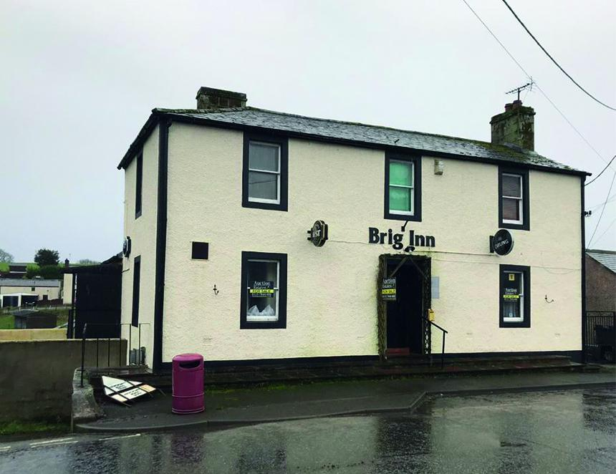

Charity Plunkett UK has secured a further year of government support for the Scottish Rural Network which helps communities bring pubs into local ownership sparking wider community action in areas with few alternatives. The renewed investment reflects continued confidence in community ownership as a practical, proven way of strengthening rural economies, improving wellbeing and sustaining services. Plunkett’s figures show that three community-owned pubs began trading during the past year, with a further local purchased by its community and preparing to open. The number of rural community-owned pubs in Scotland now stands at 19, having more than tripled in the last five years. Alongside this, 30 more rural and island communities are currently exploring or developing plans to bring their pub into community ownership. Plunkett’s programme provides tailored business advice, peer learning and practical support to groups navigating the complex process of community ownership. Ten of the supported communities are categorised as Very Remote Rural, with a further 15 classed as Remote, many with limited public transport and few remaining social spaces. As part of the programme, 59 people from community groups across Scotland benefitted from peer support, shared learning and access to more than 35 free training and information sessions. During the funding period, three pubs began trading as community-owned businesses: Crosswater (formerly the Trout Inn) in Barrhill, Ayrshire Oakbank Community Inn in Sandbank, Argyll & Bute Templehall Hotel in Morebattle, Scottish Borders In addition, the Brig Inn in Brydekirk, (pictured) Dumfries and Galloway was purchased by the community and is now undergoing renovation, with plans to open as a pub alongside a cafe, essentials shop and social rented accommodation demonstrating how community ownership can unlock wider local benefit.

