Pub’s key role in CAMRA history celebrated
14/05/2026 by Timothy Hampson
Campaign

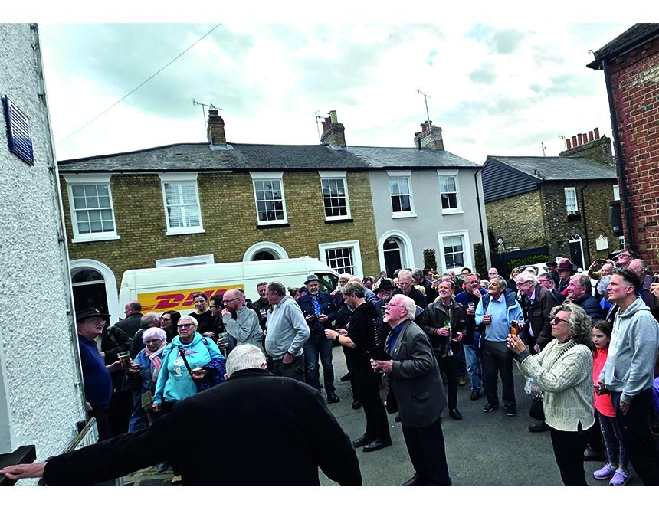

Pints of cask beer were raised in St Albans to celebrate the survival of the Farriers Arms, a pub that played a key role in the 55 year-history of CAMRA. A new plaque was unveiled and greeted by a large crowd to mark the fact that the Farriers is home to the longest surviving branch of the Campaign. Hertfordshire branch was formed in 1972 and was so influential in encouraging the growth of cask beer in the region that it was divided into North and South Herts, Herts Essex Borders and Watford and District branches. In recent years there were fears the Farriers might close but a spirited local campaign saved it. The building was originally a corner shop and then a butcher's in the 19th and early 20th centuries, but was turned into a pub in the 1920s by Hertford family brewer McMullen. Today the 50 pubs in St Albans offer a wide range of cask beers but in the 1970s the Farriers was a lone outlet for cask, serving McMullen’s AK Original Mild. McMullen sold it to the sitting tenants Tony and Jannine Passmore who decided to retire in 2021. They put the pub on the market and there were fears it could become a residential property. But Emily Ryans of South Herts CAMRA lobbied the council and it was agreed to make the Farriers an Asset of Community Value (ACV) which imposes a six-month moratorium on the sale of a property. The ACV was successful and the pub was bought by Frazer Snell, an experienced publican who had run a pub in neighbouring Harpenden. An original plaque on the Farriers’ wall had become difficult to read as a result of its age. The South Herts branch, working with the local historical society, invested in a new plaque that was cheered by the crowd in Lower Dagnall Street. Among the well-wishers were Susan Nowak and her husband Fran who lived for many years across the road from the pub. Sue edited CAMRA’s Good Pub Food Guide and was a regular contributor to BEER Magazine. Also present was John Green, the national Campaign’s first employee. When membership grew rapidly in the early 1970s CAMRA hired a room above a bicycle shop in Victoria Street where John worked before bigger premises were found in Alma Road. More staff were hired to cope with the clamour of beer drinkers to join the Campaign. Alma Road was also home to What’s Brewing and the Good Beer Guide. Office manager Iain Dobson, who was awarded an OBE for his work for the Campaign, was also present at the unveiling. South Herts branch chairman Ian Boyd told the crowd that the success of the Farriers had helped to grow CAMRA membership from a few thousand in the 1970s to over 140,000 today, with branches throughout the country. Beer writer and former Good Beer Guide editor Roger Protz, who drank in the Farriers from the late 1970s, said the landlord George Vardy sold impeccable pints of AK. But Roger added, George has no love for CAMRA members who, he thought wrongly, told him how to serve his beer. There were many legendary stories involving George. Roger recalled the occasion when a choirboy in St Albans Abbey, on his first date, suggested to his young lady they should go to the Farriers, the sole entry in the Good Beer Guide. They entered the pub, the young man clutching his copy of the Guide. “George went red in the face and his eyes bulged,” Roger said, “and he told the couple they could eff off with their effing beer guide. Not the best start to a romantic relationship!” But Roger stressed that George’s devotion to serving tip-top pints of cask beer played a key role in the area. Pub after pub went over to cask and a one-day festival showed local drinkers the wide choice of beers available from other parts of the country. Today the great majority of pubs in the city serve cask beer and the local festival, staged in late September, has been running for more than 25 years. Photo by Franciszek Nowak

