Welsh win double
05/05/2026 by Harri Knight-Davis
Campaign

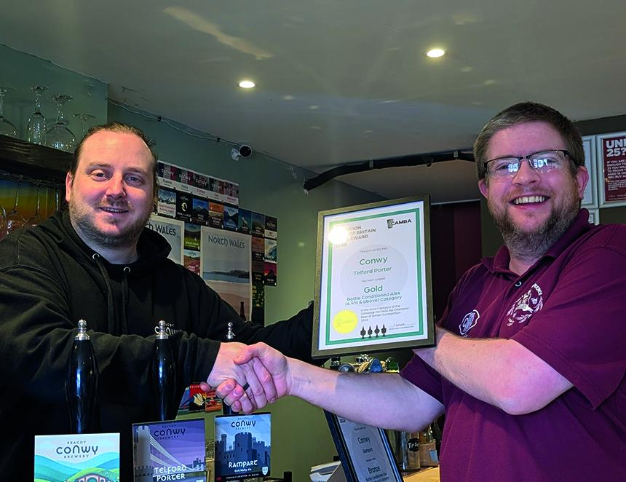

Llysfaen’s Conwy brewery doubled up in CAMRA’s Champion Bottled Beer of Wales competition, winning both gold and bronze medals in the 4.4 per cent and above category. The brewery’s Telford Porter (5.6 per cent ABV) was crowned overall winner after fighting off competition from beers across Wales. Silver went to the refreshing, hazy yellow smooth gold Hefeweizen (5.2 per cent) by Geipel Brewing, Denbighshire. Conwy took bronze for its nutty, sessionable Rampart Brown Ale (4.8 per cent). Telford Porter now has the chance to fight for the overall Champion Bottled Beer of Britain title. Judges described Telford Porter as a: “Ruby black, smooth porter with enticing aromas of coffee, chocolate and raisins. The flavour was well balanced with roasty notes, damsons, dark cherries and treacle. The aftertaste was dry with a roasty bitter character. A very drinkable porter.” Conwy head brewer Kane Upton, said: “Winning gold and bronze is a huge moment for us. It reflects the care, consistency, and craft our team puts into every beer we brew – and we’re incredibly proud to be representing Wales on this stage.” Pictured, from left, Kane Upton and CAMRA’s Steve Lamond

