Explore Belgian beers, breweries and bars with updated guide
04/05/2026 by WB Reporter
Campaign

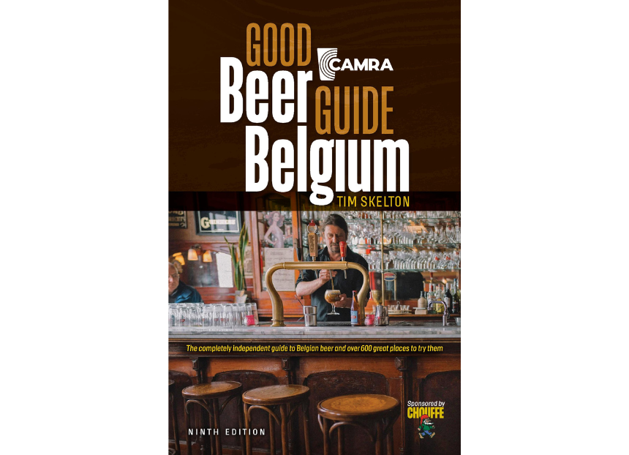

The new, fully revised and updated Good Beer Guide Belgium is the essential guide to one of the world’s greatest beer destinations. The latest edition of CAMRA’s guide by Tim Skelton showcases more than 1,500 beers and the 400 brewers and lambic blenders who make them, plus, most importantly, 650 of the best places to enjoy them. The book explores all regions of Belgium, including Brussels, Antwerp, Flanders, Brabant (Flemish and Wallonian), Luxembourg and Liege, with useful travel tips and recommendations on what to eat and where to stay. The beer industry in Belgium has changed significantly in recent years, with a large increase in breweries. The Good Beer Guide Belgium includes a list of breweries with useful rankings for these must-visit destinations. From blond ales and saisons to black beers and wild-fermented lambics, this is the perfect guide for any tourist keen to experience Belgium’s diverse beer culture. This ninth edition of the guide has been independently researched, featuring 650 of the best venues to enjoy these amazing beers, from cosy cafés and specialist beer bars to brewery taprooms and festivals. The book has two forewords – one by Tim Webb, the creator and long-time curator of the guide, and the other by Yvan De Baets, co-founder of the De La Senne brewery in Brussels. Written by beer and travel guide writer Tim Skelton, the guide is published on 14 May and can be pre-ordered from CAMRA’s online shop now. Skelton said: “I’ve lived in Benelux for more than 30 years, visited Belgium more than 100 times, and thought I knew everything about the country. But researching this new edition still led me to find undiscovered gems that I’d never previously been aware of.” Belgian brewer Chouffe, is sponsoring the publication. Duvel Moortgat UK general manager Steve Behan said: “It is a pleasure for Chouffe to be the headline sponsor. Belgian beer is renowned for its exceptional quality, traditional craftsmanship and broad variety and we are proud to help celebrate that through this guide. We are delighted to support a publication that champions the quality, diversity and rich heritage of Belgian beer.”

