Golden moments for birthday beer
01/05/2026 by Timothy Hampson
Industry

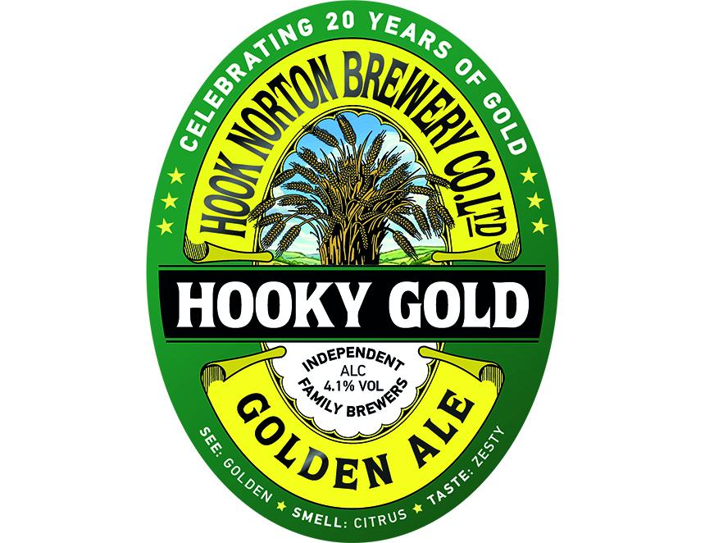

This year marks the 20th anniversary of Hooky Gold’s launch and the brewery is planning a series of “golden moments” to mark the milestone. Brewer Hook Norton will be celebrating throughout May and June with a series of “moments” including competitions and special events across its pubs and at the brewery. MD James Clarke is inviting anyone with any gold medal – from 10-metre swim to running across the Sahara – to bring it to the brewery and be rewarded with a glass of Hooky Gold. He said: “Hooky Gold has become a real modern classic for us over the past 20 years – an ale that perfectly balances tradition with a more contemporary, aromatic hop character. “It’s a beer that continues to win people over, whether they’re long-time Hook Norton drinkers or discovering us for the first time.” Hooky Gold, at 4.1 per cent ABV, combines traditional English hops Fuggles and Goldings with the American Willamette. It is available throughout May and June in cask at the brewery, in Hook Norton pubs, and selected free houses. It is also available year-round in bottle from the brewery shop, nearby retailers and online at hooky.co.uk

