Government urged to listen to cidermakers
28/04/2026 by Timothy Hampson
Industry

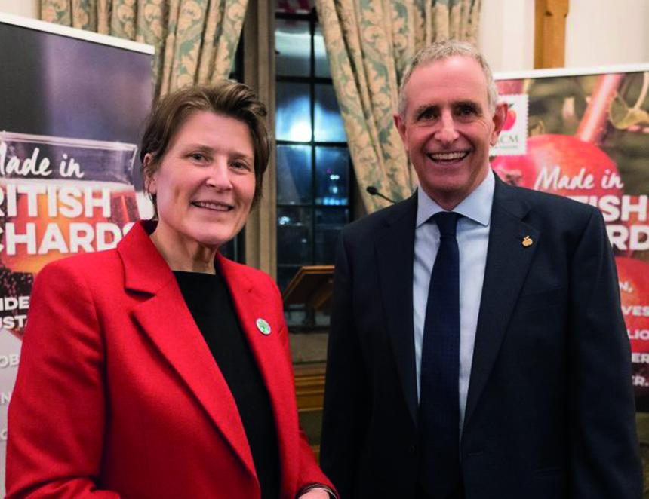

Thatcher’s Cider MD Martin Thatcher called on the government to listen to the industry to create the right environment for long-term success. Thatcher, who is also the National Association of Cider Makers chair, said at a Houses of Parliament reception for the industry: “Cider makers are not just producers; we are farmers and hospitality workers too. Our annual wassail held last month – a cherished tradition where communities come together to bless the orchards for a prosperous harvest – reminded us of the importance of caring for today’s resources to ensure tomorrow’s prosperity. “The administrative burden created by new taxes and policies, changes to inheritance tax, business rates, national insurance rises and on-going duty rises, are all placing significant pressure on our industry. These challenges extend to our supply chain, affecting our suppliers and customers. “With the government’s ambition for economic growth, our goals are aligned. We ask policymakers to listen to the cider industry, understand its needs and take meaningful action. By working together, we can create the right conditions for long‑term success.” The reception for the industry, which contributes £2.7bn to the economy and supports more than 65,000 jobs, was hosted by Sarah Dyke, MP for Glastonbury and Somerton. She said: “Cider is a proud part of our heritage in Somerset and across the UK. Events like this, when the industry can come together to honour the dedication and craftsmanship of British cider makers are such wonderful occasions. I’m delighted to raise a glass in parliament to recognise their vital contribution to our rural communities and economy.” Pictured Sarah Dyke and Martin Thatcher

