21 up for Harry
27/04/2026 by Timothy Hampson
Industry

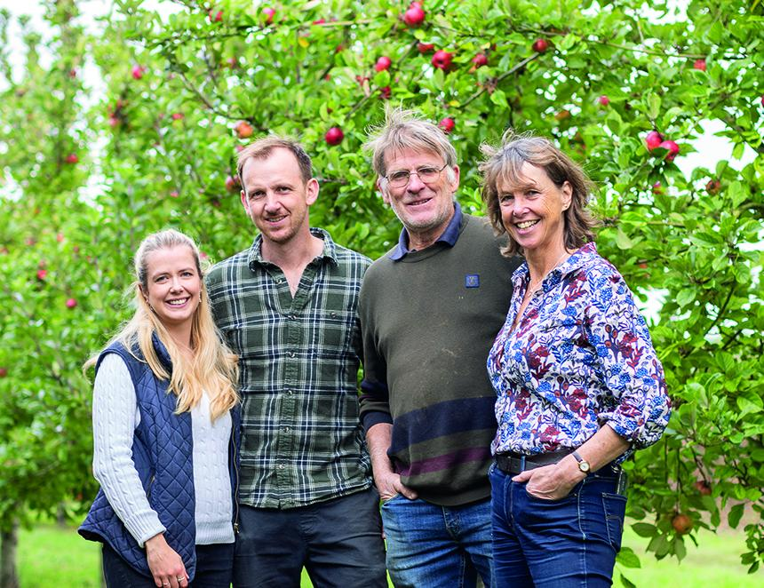

This spring marks a double celebration for one of Somerset’s best-loved independent producers, as Harry’s Cider toasts 21 years in business alongside the first anniversary of its popular shop and taproom. Founded in 2005 by Harry and his son Toby, the family run cidery has grown from a small farm diversification project into a nationally recognised name, known for its characterful, small-batch ciders made using 100 per cent cider apples and traditional methods. Using heritage varieties such as Harry Masters Jersey, Dabinett, Yarlington Mill and Browns Apple, Harry’s produces a range of traditional, sparkling, fruit and mulled ciders, all made to showcase the depth and flavour of proper cider. This commitment to quality has earned national acclaim, including the 2022 Reserve Supreme British Champion Cider award for Harry’s Dabinett. To mark the occasion, Harry’s is releasing its exclusive 2023 Vintage Fine Cider. Made using a traditional in-bottle fermentation method and aged for two years, this limited release offers a crisp, lively character with a refined natural sparkle. Carefully made for special moments, it is perfectly suited to accompany a delicious meal or to raise a glass in celebration. The anniversary also shines a spotlight on the cidery’s shop and taproom, which opened last year and has quickly become a destination for locals and visitors alike. Set just metres from the orchards where the apples are grown, picked and pressed, the space offers a uniquely close connection between land and glass. With the orchards now in full blossom — a fleeting spectacle that lasts only a few weeks each year — there’s no better time to visit. Visitors can enjoy a relaxed experience with a pint in hand, alongside a carefully curated selection of locally sourced food and drink. From tasting paddles showcasing the cider range to hearty farmhouse platters, cakes, and light lunches, everything is designed to complement the flavours of the cider and celebrate the best of the West Country. “We wanted to create a space where people could slow down, enjoy great cider, and really connect with where it comes from,” said Harry. “It’s about sharing not just the drink, but the whole story behind it.” Pictured, from left, Alison Chapman, Toby, Harry and Pippa Fry. Photo: Bill Bradshaw

