Chinese beer duck
25/04/2026 by Christian Gott
Opinion

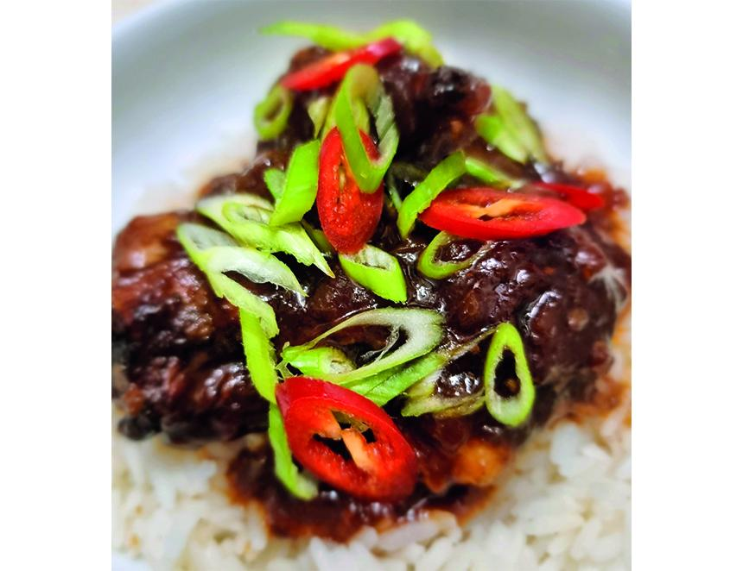

The one thing I want to do when writing this column is show beer’s virtuosity as an ingredient in cooking. When doing this I endeavour to use a beer that is available both in cask and bottle so that as many people as possible can recreate the recipe, but unfortunately that is not always possible. However, sometimes it seems the stars align and something special happens, like this month’s recipe for Chinese beer duck which is made using a cask beer from the Fuzzy Duck brewery named after an American breed called Golden Cascade (3.8 per cent ABV). Beer duck is a unique Chinese dish that originated in Sichuan. Sichuan cooking has layers of flavour that comes from using aromatics such as star anise, ginger, spring onions, and garlic. Umami from fermented bean paste, some heat from red chillies and the distinctive mouth-numbing citrusy taste from Sichuan peppercorns. If you have never tried Sichuan cooking before you are in for a real flavour explosion, but don’t add more of the peppercorns than the recipe states the first time you make the dish. Sichuan peppercorns are available from specialist Asian retailers and large supermarkets. The addition of beer adds a touch of sweetness and savoury complexity to the finished dish. It is thought that cooking with beer started in China as cooks started to use different ingredients than the traditional soy sauce and rice wine in slow braising. While everyone will know stir-frying, slow braising or red-cooking is a different style of Chinese cuisine that both tenderises the meat and allows the sauce ingredients to thicken, concentrating the flavours into a richly flavoured, caramelised glaze. Golden Cascade is brewed at the eight-barrel Fuzzy Duck microbrewery in Poulton-le-Fylde, Lancashire. Founded 20 years ago by Ben Croston, Fuzzy Duck has won a host of local SIBA awards for its range of beers that are supplied locally in cask. I chose Golden Cascade, a session pale ale, because the light colouring and slightly citrus flavour profile matches the light style of beers favoured in China. It also goes exceptionally well with the finished dish. Traditionally the dish is made by cutting up a whole duck carcass, but I used duck legs. You can prepare them on a solid chopping board using a large cook’s knife. First separate the drumstick and thigh portion then carefully cut the knuckle from the drumstick and discard. Cut through the meat half-way through the thigh, then chop down to cut in two. If you have a friendly butcher, you could ask them to do it for you. I like to serve the dish for special occasions with garlic fried beans and Chinese-style pickled vegetables. Beer duck 4 duck legs 1 bottle Fuzzy Duck Golden Cascade 6 large spring onions, trimmed and finely chopped 3tsp dark brown soy sauce 2tbs soft brown sugar 1tbs doubanjiang or fermented bean paste 1tbs Sichuan peppercorns 2 red chillies, sliced 6 cloves of garlic, peeled and finely chopped 4cm piece of ginger, peeled and grated 3 star anise pods 1tsp chilli flakes Garnish Finely sliced spring onion, red chilli pepper or fresh coriander Place the duck skin side down in a large, heavy-bottomed frying pan and place over a medium heat. As the pan gets hot it will start to melt the fat under the duck skin this is called rendering. Using this technique, you will not need any extra oil for frying. Regularly turn the pieces of duck over until they are evenly browned. Add the garlic, ginger and chilli slices and cook for a couple of minutes stirring all the time to prevent burning. Add the star anise, chilli flakes, soy, sugar, bean paste and beer and bring to a gentle simmer and cook for 30 minutes. Add the spring onion and a little water if the sauce is reducing too quickly and simmer for another 30 minutes. When the duck is tender and the sauce has the consistency of syrup remove from the heat and serve.

