Members’ Weekend 2026 round up
24/04/2026 by WB Reporter
Campaign

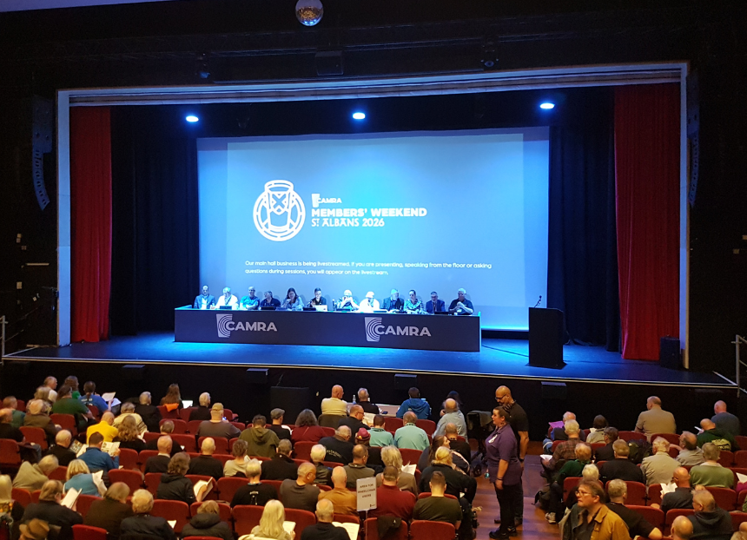

CAMRA’s Members’ Weekend took place in St Albans last weekend. Details of award winners and how the motions fared are below. AWARDS Chairman’s Award
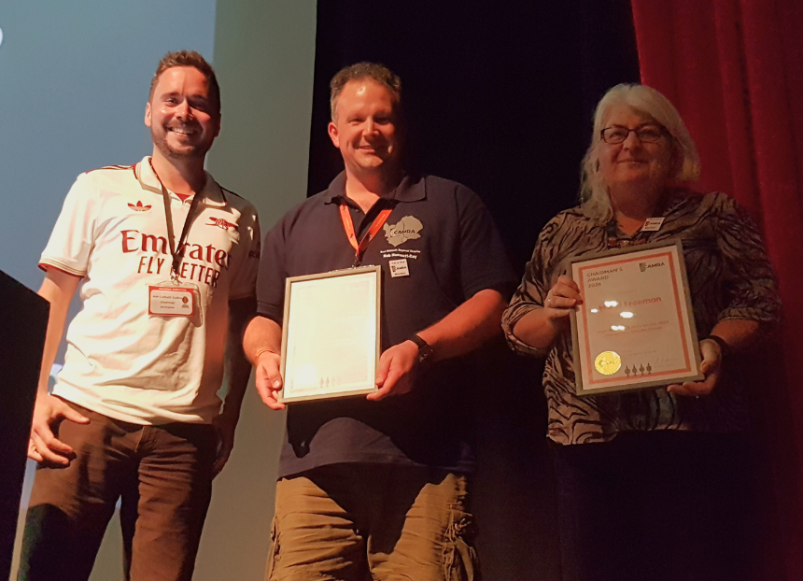
Winner: Disciplinary Review Group – Robert Hamnett-Day, John Perry, Maria Freeman, Adrian Zawierka, and Kate Ahern The Disciplinary Review Group took home the Chairman’s Award for its improvements to CAMRA’s Complaints and Disciplinary procedures, ensuring members are protected with a strong system. This has involved reviewing policies and procedures, putting forward a new national reporting approach and looking to implement easy-to-access training. Pictured above, from left, CAMRA chairman Ash Corbett-Collins, Robert Hamnett-Day and Maria Freeman
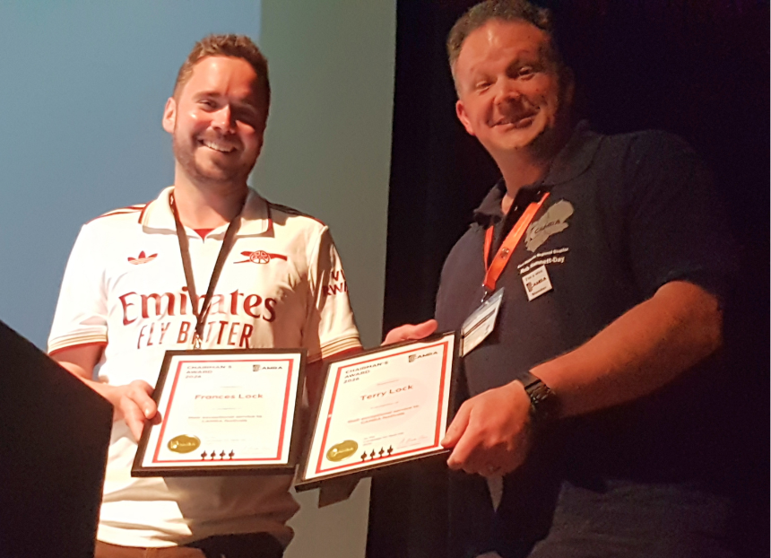
Winner: Terry and Frances Lock Terry and Frances Lock were awarded the Chairman’s Award for their exceptional service to CAMRA festivals, having been instrumental in how events are planned and approved. Working closely with Business Plan assessors, who sign off on all CAMRA festivals, Frances has dedicated well over a decade to her role and CAMRA festivals. She's done all this while also making other contributions to the Campaign. She was one of the instigators of the European Beer Consumers Union (EBCU) and served as its president. She’s also an active member of CAMRA’s Events and Finance Committees, working to continuously improve our festivals to make sure members and consumers get the best possible beer and experiences. Terry has committed to the development and deployment to CAMRA’s festival finance tool FOCUS. He continues to update it so festivals can submit their business plans as smoothly as possible. As well as serving on the National Executive, he’s also held the role of secretary for CAMRA’s Events Committee for a considerable length of time. Pictured above, from left, Ash Corbett-Collins, Robert Hamnett-Day accepting the award on behalf of Terry and Frances Magazine of the Year
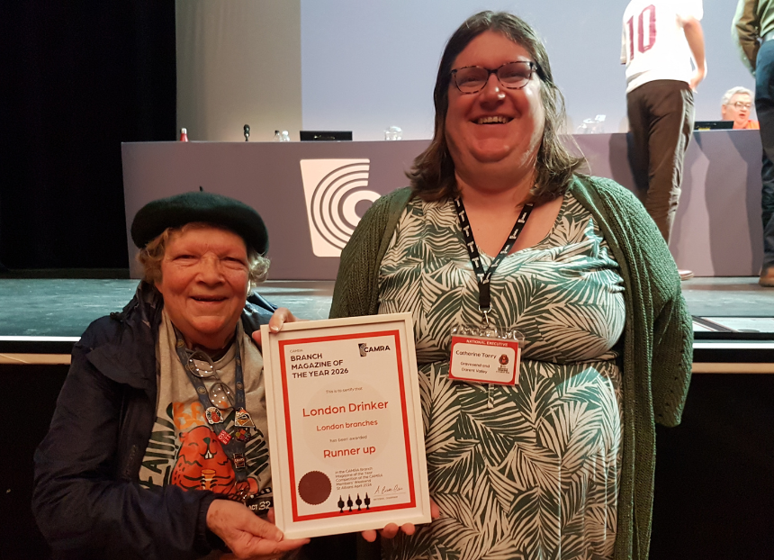
Runner up: London Drinker, London branches, edited by Tony Hedger Judges said the magazine had good images, featured a mixture of events, people and pubs with relevant descriptions. At 52 pages it is a giant CAMRA magazine, with judges commenting it must be a full-time job keeping it up to date. Pictured above, from left, regional director of Greater London Ellie Eames with Campaigns and Communications director Catherine Tonry
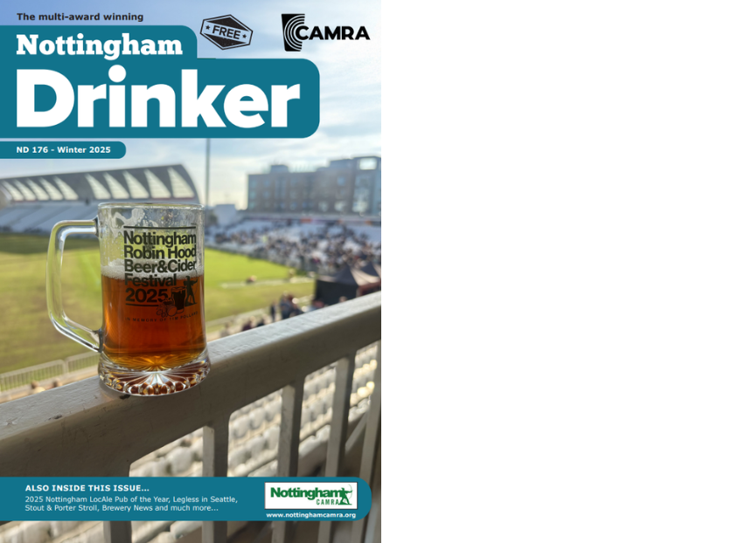
Bronze: Nottingham Drinker (above), Nottingham branch, edited by Danielle Jeffery Judges praised this magazine for mentions of all brewery liaison officers, its LocAle promotion and strong focus on stouts and porters. It’s a strong magazine with a mixture of articles detailing local and wider interest that engages the reader.
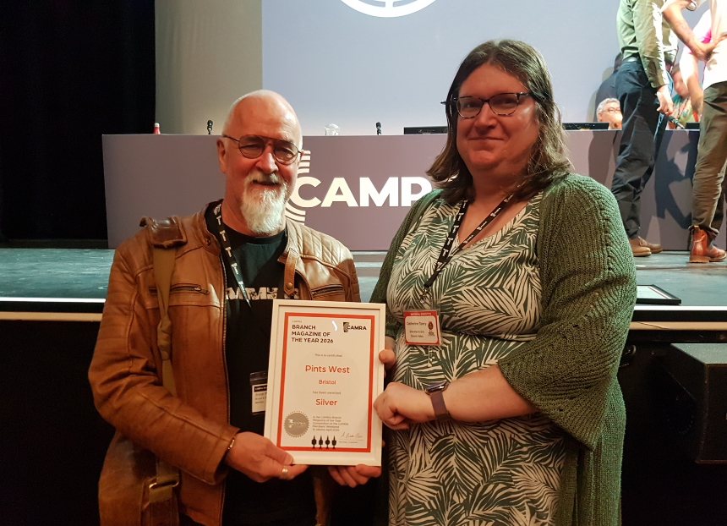
Silver: Pints West, Bristol and District branch, edited by Steve Plumridge Judges were impressed by this magazine’s comprehensive brewery section, good use of campaigning and attractive layout that’s enhanced by its A4 format. Being one of the most active CAMRA branches is clearly reflected in this magazine, showcasing an impressive list of more than 30 contributors. Pictured above Steve Plumridge with Catherine Tonry
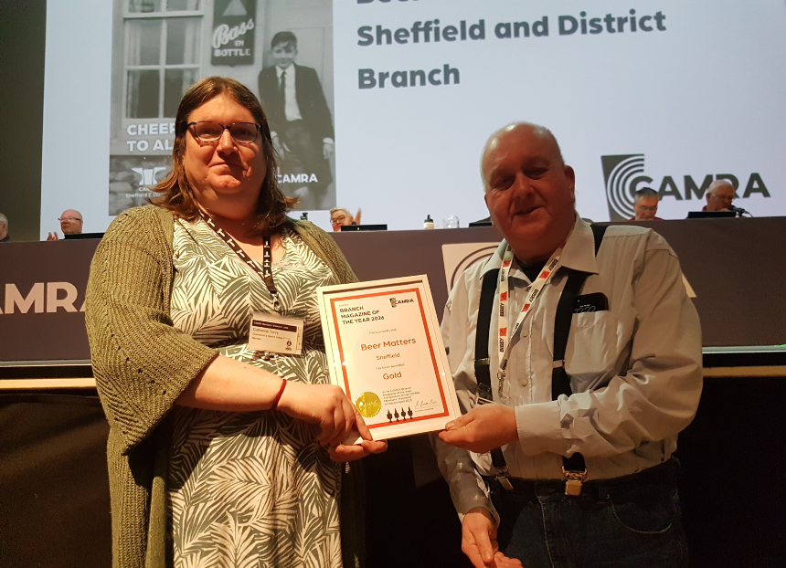
Gold: Beer Matters, Sheffield and District branch, edited by Andy Cullen Judges described the magazine as well-presented with an interesting colour layout and reflects a busy, successful branch. From its simple but effective use of images in its table of contents to its great mixture of local pub and brewery news, well-written articles and national campaign information, judges praised the branch for maintaining a high standard 11 times a year. Pictured above Yorkshire regional director Kevin Keaveny and Catherine Tonry Website of the Year
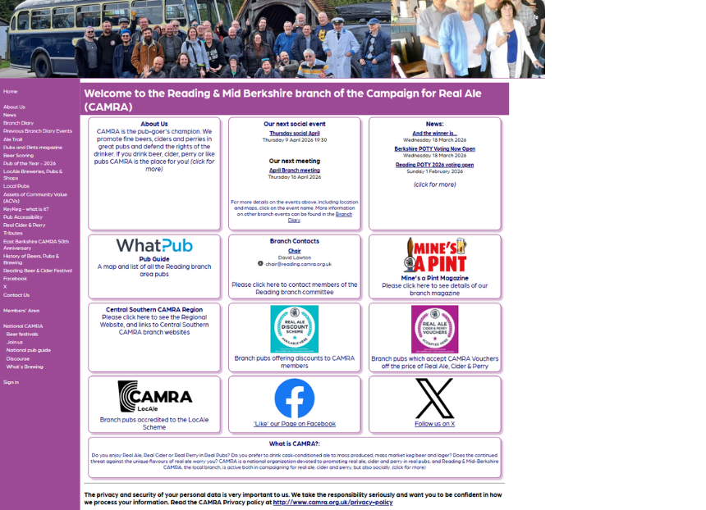
Runner up: Reading and Mid-Berks branch (above), website coordinator Timothy Hayward Judges were impressed with the website’s balance of text and images with no clutter and a clear use of its homepage, noting good use of photos in the top banner. It’s a great site with lots of features, including a comprehensive sidebar. The beer-scoring pages and explanations of keykeg were of particular note. The site portrays a very active branch, with informative articles on the history of pubs and brewing in Reading and surrounding areas.
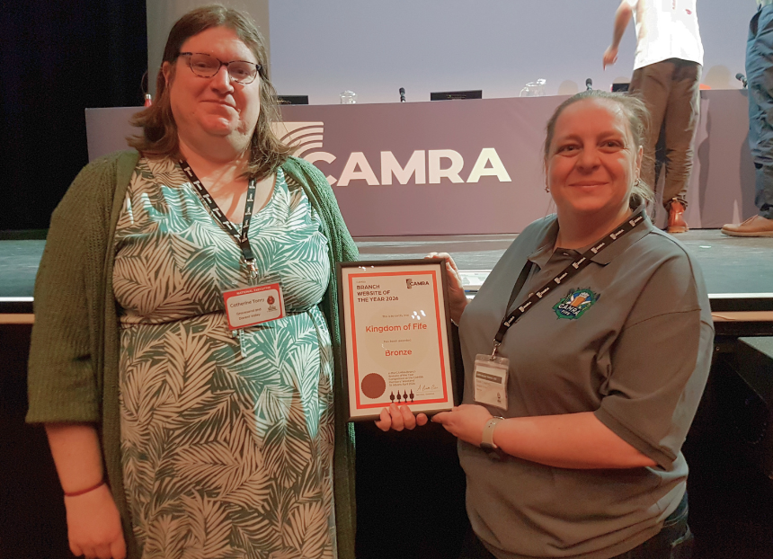
Bronze: Kingdom of Fife branch, website coordinator Dave Hollingsworth Judges described the professional-looking website as neat and well-structured with good photos and a logical menu. Judges praised how the site encouraged members to get involved in the Campaign. Pictured above, from left, Catherine Tonry and Kingdom of Fife branch chair and National Executive member Sarah Crawford
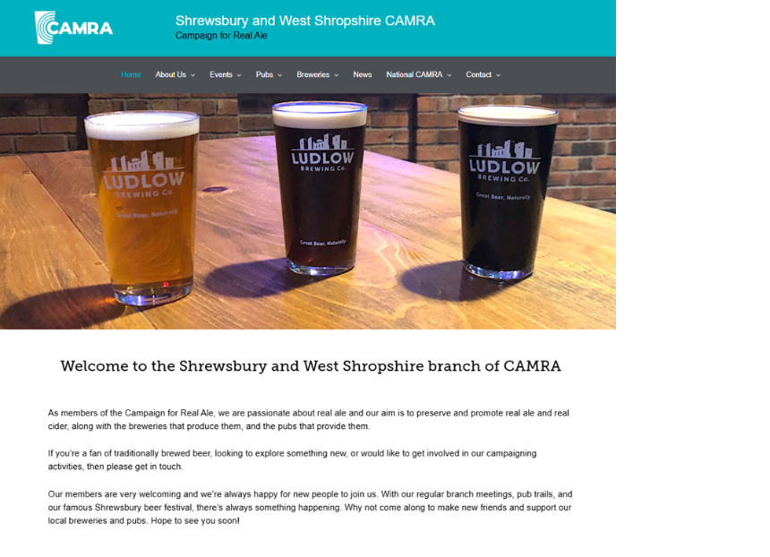
Silver: Shrewsbury and West Shropshire branch (above), website coordinator Nick Smith Judges praised the site’s attractive and modern design, good use and range of images and clear navigation. Its varied use of interesting content about how the branch works and how members and non-members can get involved made this branch website a clear winner.
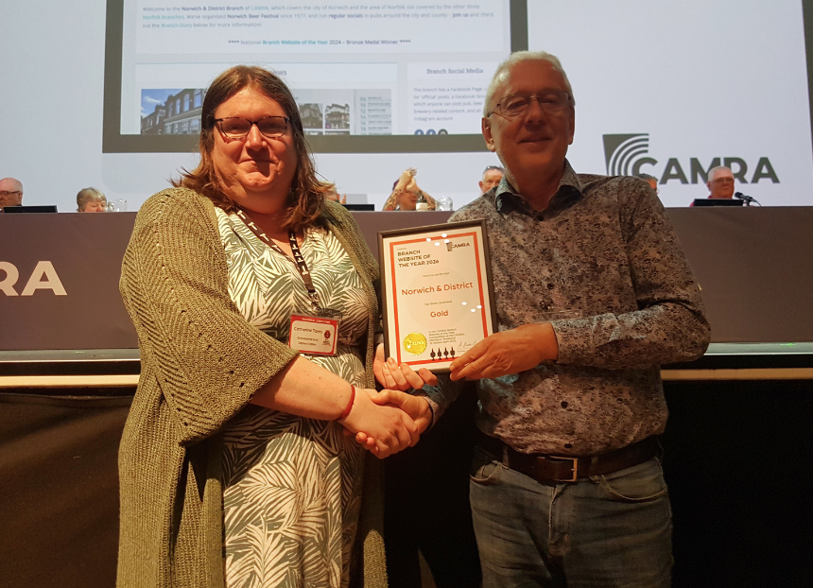
Gold: Norwich and District branch, website coordinator Ian Stamp Judges were impressed with this extremely well-structured and exceptionally well-organised website, describing it as one of the most feature packed sites around. Judges praised how welcoming the site was for users and commended the annual pub survey page. Pictured above Catherine Tonry and Ian Stamp Campaigner of the Year

Winner: Northern Ireland region of CAMRA CAMRA NI has been praised for its outstanding campaigning. It was rightly lauded for embedding a vigorous campaigning ethos in everything it does – whether that is putting on outstanding festivals, having a presence at events and with other organisations across the region, or shouting loud on social media and in the press and media about the importance of its, and CAMRA’s, work. Its engagement with politicians, political parties, civil servants and other organisations and stakeholders to build consensus for its campaign for desperately needed change has received widespread acclaim. CAMRA NI has punched well above its weight within the campaign, educating members and the public about the challenges pubgoers, brewers, cider makers and pubs face and about why its campaigning is so vital to achieve fairness for consumers, producers and publicans. Its expansion into new parts of its region and the setting up of a new branch covering the area with the most westerly pub in the UK serving cask has also been highlighted as one of its many achievements. CAMRA NI members are fighting to modernise the most outdated alcohol licensing laws across these islands so consumers can have a decent choice of pubs, social clubs and brewery taprooms selling great, local and independent beer and cider. Pictured above CAMRA NI director Ruth Sloan accepting the award on behalf of CAMAR NI via a video message. MOTIONS Motion 1 – passed Proposed by: National Executive This Conference agrees to adopt the Policy Documents presented for adoption at Conference 2026, subject to any amendments to policy decided at this Conference. Motion 2 – passed Proposed by: Bradford This Conference instructs the National Executive to prioritise motions for debate in the Members’ Weekend schedule, and wherever possible all motions shall be adequately debated on the Saturday of Conference. Motion 3 – failed Proposed by: Bradford This Conference instructs Conference Procedures Committee to amend section 6.1.5 of the Remit and Procedures to give, wherever feasible, higher precedence to motions, classified under sections 6.1.5.2 and 6.1.5.3, which have been submitted by two individual members or by regions or branches, over those submitted by National Committees and the National Executive. Motion 4 – failed Proposed by: South Herts This Conference instructs the National Executive to change the title of the National Pub of the Year to reflect the year that the award is presented, if that differs from the year that judging took place. Motion 5 – remitted Proposed by: South Herts This Conference instructs the National Executive to develop a financially sustainable business model for the printed version of BEER Magazine, working with the editors of CAMRA's cost-neutral branch magazines. Motion 6 – passed Proposed by: Wales This Conference instructs the National Executive to produce bilingual membership application forms and other promotional materials for use in Wales. Motion 7 – failed Proposed by: Roger Protz This Conference instructs the National Executive to bring proposals to the 2027 Members’ Weekend to restore the Great British Beer Festival at the earliest opportunity. Obituaries As always, as part of Members' Weekend we pay tribute and raise a glass to the campaigners and volunteers who we have sadly lost over the past year. The tribute which was shown over the weekend can be watched below:

