Below inflation rates rise
24/04/2026 by WB Reporter
Campaign

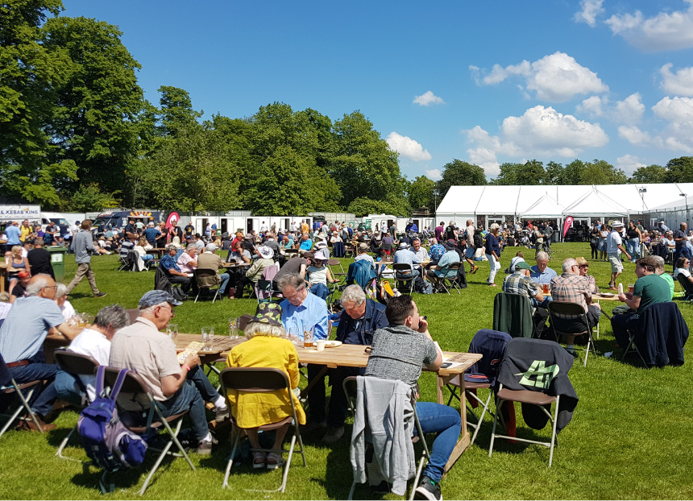

CAMRA subscription rates will rise by a below RPI increase of £1 from 24 Jun. The small rise comes as the Campaign increases the benefits of being a member including free entry to more than 100 CAMRA beer festivals (above). Other benefits include: real ale vouchers worth £30 for single membership every year and £40 for joint members discounts on CAMRA books and merchandise discounts on cask beer, cider and perry in participating pubs partner benefits and offers via our trusted third parties access to website tools to find the pints you want to drink and pubs you want to enjoy them in joining CAMRA campaigns and access to volunteering opportunities award-winning BEER magazine What’s Brewing online news service online learning and resources to expand your knowledge of the drinks you love. The new rates are:

Membership type

Payment method

Type

Old rate

New rate

Increase

Full / Overseas*

DD

Single

£34

£35

£1

Full / Overseas *

DD

Joint

£42

£43

£1

Full / Overseas*

Non-DD

Single

£36

£37

£1

Full / Overseas*

Non-DD

Joint

£44

£45

£1

Concession

DD

Single

£25.50

£26.50

£1

Concession

DD

Joint

£33.50

£34.50

£1

Concession

Non-DD

Single

£27.50

£28.50

£1

Concession

Non-DD

Joint

£35.50

£36.50

£1

Life

N/A

Single

£612

£630

£18

Life

N/A

Joint

£756

£774

£18

*Overseas members – Direct Debit is only possibly with a UK bank account. Overseas members, non UK, CI, NI, IOM are not automatically sent vouchers and cannot opt into paper copies of BEER.

