Campaign&#039;s Scottish wish list
23/04/2026 by Paul Edgeworth
Campaign

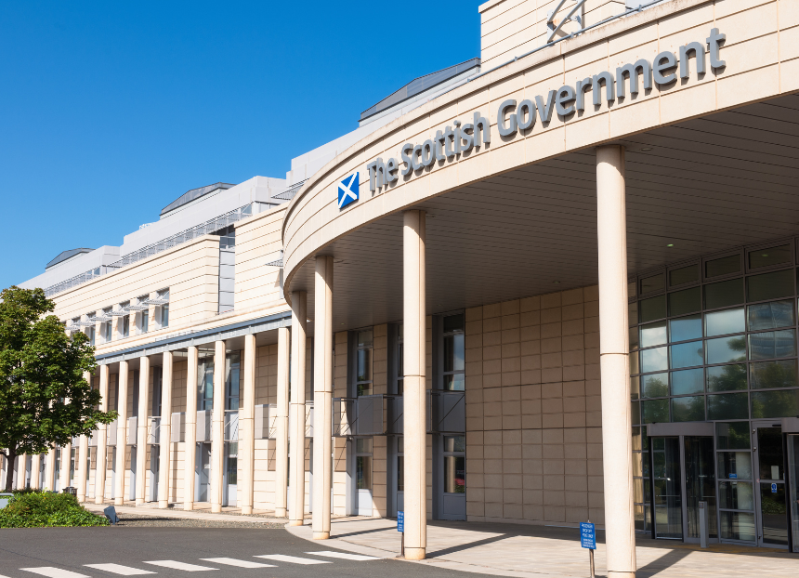

Ahead of the Scottish parliament election on 7 May, CAMRA’s Campaigns and Communications team has been taking a look at the main parties’ manifestos and picking out the policies and promises that affect consumers, pubs, beer and cider. What does CAMRA want to see from the next Scottish government and from MSPs in the next term? It wants them to speak up and take action to support, protect and promote pubs, social clubs, breweries, cider makers and consumers. CAMRA wants: – reform of the business rates system to permanently fix the unfair overpayment by pubs – changes to permitted development rights so planning permission is always required to demolish a pub or change its use – no reintroduction of restrictions on alcohol advertising and sponsorship that would harm community pubs, festivals, independent producers and consumer choice – a commitment to retaining and strengthening the Scottish Pubs Code and adjudicator – recognition of and respect for the role of pubs in combatting loneliness and social isolation and as a safe place to drink responsibly in a regulated setting. What are the parties offering? Reform UK Reform UK Scotland has published its manifesto, which promises to: – phase out business rates (as the economy recovers) to make them consistent, fair and proportionate – a review of all current planning laws – creation of a fast-track planning regime for 10 business clusters, including hospitality. Scottish Conservatives The party’s manifesto states it would: – provide 100 per cent relief for pubs and licensed hospitality businesses with rateable values of up to £100,000 – start by ending the cliff-edge tax hikes that are part of the business rates system by capping the maximum rise that can occur between revaluation cycles – support high streets by reducing taxes for retail, hospitality and leisure businesses. Scottish Greens The Scottish Greens’ manifesto commits the party to: – providing sustained, long-term funding for community organisations and intermediaries delivering essential local services, such as local housing projects and operating community shops, pubs and meeting spaces – strengthening compulsory purchase and compulsory sale powers so councils and communities can bring vacant and derelict land and buildings back into use, supporting local economies, employment and cultural spaces, and developing community wealth building capacity – supporting councils to revive town centres by repurposing empty commercial property into workspace, cultural and community uses – supporting small, Scotland-based businesses and high streets by shifting a greater share of the tax bill onto the likes of online retailer warehouses, out-of-town shopping centres and arms dealers – use the non-domestic rates system to add surcharges to businesses which cause harm to our environment and communities and raise funds to reinvest in public health measures and thriving local economies. These surcharges will include public health, ensuring that supermarkets and other large retailers selling alcohol and tobacco make a greater contribution towards the NHS and other services which deal with the harm caused by their products. The surcharges will also include out-of-town retail to support high-street businesses. Scottish Labour Scottish Labour pledges to: – champion the development of specialist hospitality qualifications, working with business schools and colleges to close critical skills gaps and build clear, respected career pathways across the industry – work with the business sector and local authorities to develop a business levy as a replacement for current unfair business rates. Changes would be revenue neutral but better balanced to support retail and hospitality in town centres and promote local economic growth – overhaul the planning system, reforming NPF4 so that decision makers can take account of the economic potential of projects, designating housing as critical infrastructure and expanding the use of zonal planning – speed up planning decisions, transforming the planning hub into a national planning agency, with expertise and specialist teams that local authorities can draw on for complex projects and guaranteeing timelines for decisions – simplify community right to buy, making the legal process easier for local people to buy and own land and assets for the benefit of communities. Scottish Liberal Democrats In their manifesto, the Scottish Liberal Democrats are proposing to: – reform business rates by: ensuring revaluations don’t produce unfair bills that condemn otherwise viable businesses; building on the £178m of relief won by the Scottish Liberal Democrats in the 2026/27 Budget which is providing a three-year package to help licensed pubs, restaurants, hotels, music venues, licensed clubs and nightclubs – linchpins of the high street; reviewing the functions of the assessors; working towards a new system of business rates with a land value element. This would avoid penalising businesses which refurbish properties or install renewables. It would reduce long-term vacant sites by raising more from under-used units and land banked by developers and help high streets develop and compete with online retailers using large warehouses in cheaper locations – giving local authorities levers to encourage innovation, support business development and foster new partnerships between councils and local business – linking the minimum unit price of alcohol to inflation – reforming planning to make it simpler to redevelop long-term derelict buildings. Scottish National Party The SNP’s manifesto includes policies on: – recognising the ongoing concerns raised by the licensed hospitality sector on the valuation methodology applied to non-domestic property in this sector. It will commission an independent review to report by the end of 2026 and consider any recommendations in advance of the 2029 revaluation cycle – among the steps it will take are to create a Safer Nights Design Champion to help improve how areas can have improved lighting, enhanced passive surveillance, and safe spaces – particularly near transport hubs – enhancing opportunities and support for community right to buy and ownership.

