Brewer aims for big score with Sir Geoff’s World Cup beer
20/04/2026 by Timothy Hampson
Industry

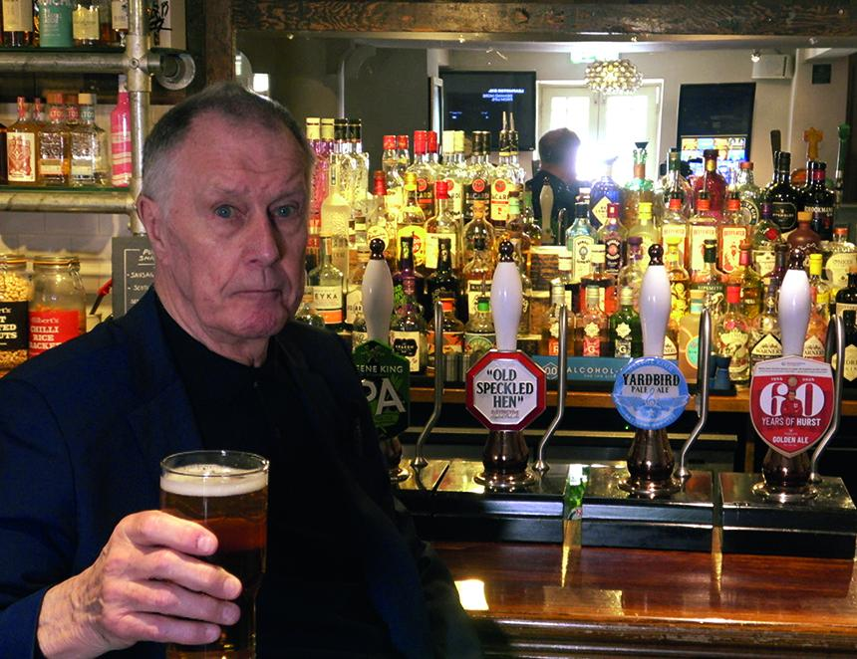

A football icon from 1966 is the face of a new cask beer. Greene King Pub Partners has launched 60 Years of Hurst, celebrating the World Cup-winning squad. Available exclusively to Greene King’s Pub Partners pubs, 60 Years of Hurst has been created to help them make the most of this summer’s football. Brewed by the Greene King brewery, 60 Years of Hurst is claimed to be refreshing four per cent ABV golden pale ale. The beer features a malty body balanced with juicy citrus and tropical fruit notes. As part of the collaboration with Hurst (above), five pence from every pint of the new beer sold will be donated to Diverse Abilities, Dorset’s charity that supports those with profound physical and learning disabilities across the county. The charity has existed since 1955 and is one that is close to Sir Geoff's heart. Hurst said: “60 Years of Hurst is a lovely, refreshing pint that’s perfect for watching the football with friends. I hope people enjoy raising a glass this summer and supporting a really important cause at the same time.” Hurst is the last surviving member of England’s World Cup-winning squad.

