Did BrewDog put cask beer back a decade?
18/04/2026 by Matthew Curtis
Opinion

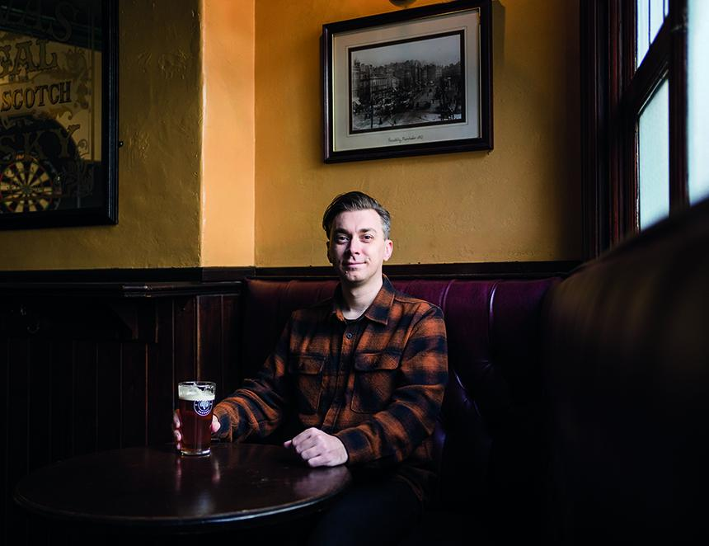

It genuinely does feel like cask beer is having its moment on the bar. Bass, Boddington’s, Landlord, it feels like they’re everywhere. Dare I say it; they’re actually even considered to be quite fashionable by younger drinkers. Don’t just take my word for it, there’s plenty of data to back this up. Bass is experiencing 23 per cent year on year growth and is now stocked in 60 per cent more outlets than it was 18 months ago. As for Landlord, it’s now the best-selling cask beer in the country by value, displacing Doom Bar, which held the top spot for almost 13 years. The success of smaller brewers backs up the growing popularity of the format. Thornbridge has continued to launch new bars across the country, including the Wild Swan in the City of London, which opened over the Easter weekend. In the North, brands like Kirkstall and Five Points seem to be thriving alongside beloved favourites like Theakston’s Old Peculier and Harvey’s Sussex Best. Simply put, it’s a great time to be a cask drinker. Fingers crossed, there will be further statistics released in a few months' time that back up this feeling that cask is having a long-overdue moment in the sun. But it wasn’t always this way, as until very recently cask beer was considered to be deeply unfashionable by many millennial-generation drinkers. One brewery that emerged in 2007 made a personal case of railing against it, ceasing its production, deliberately causing a ruckus around the Great British Beer Festival (GBBF), and at one point even vainly attempting to reinvent the format entirely. I am, of course, talking about BrewDog. Now that the dust has settled on its near two decades of unfortunate antics, hindsight has allowed me to consider if this often-reckless behaviour damaged the image of cask beer to the point where it actually held the category back a decade. Unlike cask beer, BrewDog is not having a good time of it lately. Following the exit of its founder and CEO James Watt in May 2024, the company has struggled to manage the excessive amount of debt accrued over an exponential period of expansion, both in terms of production and its chain of bars. In March 2026 it hit breaking point, crashing into administration, through which it was sold to New York-based cannabis and beer portfolio Tilray Brands for a measly £33m – a far cry from the £1bn valuation it bestowed on itself 10 years ago. In the immediate aftermath more than two-thirds of its bars were closed with immediate effect, leaving 484 workers unemployed and out of pocket. After a long string of blunders, it feels very BrewDog that it saved its biggest for last. But blunder has always been the name of BrewDog’s game. Back in 2011, when it could still genuinely be considered a small, independent brewery, there was controversy when the Scottish brewer claimed that CAMRA had cancelled the brewery's stand at GBBF, because it had decided to bring keg beer and no cask. Watt claimed that CAMRA had cancelled BrewDog’s stand because it was bringing keg beer to the event. However, a CAMRA spokesperson said the reason was because it was seven weeks late in paying the remainder of the deposit for its stand and refused to use the larger 50-litre containers required by an event of this size. Although Watt claimed BrewDog was bringing something “new and exciting” to GBBF, the irony is that there had been keg beer available for some time on the Bieres sans Frontiers bar, largely from Belgium, Germany and the Czech Republic. This didn’t matter to BrewDog, however, which continued to stage protests against cask beer at subsequent festivals, eventually ceasing all production of it themselves. BrewDog’s attitude towards cask beer was a deliberate rhetoric. Here was a brewery inspired wholly by then-current brewing trends in the United States and, as such, saw British brewing tradition as antithesis to its objectives. It was an attitude that inspired many other breweries to pursue a keg-only approach, including Camden Town and Beavertown breweries in London, neither of which invested in the format. In 2017 Manchester’s Cloudwater, which produced cask beer from its launch two years earlier, announced ceremoniously that it would no longer be investing in its production. It was around this time that cask hit a real low point. By now it was deeply unfashionable, and in double digit decline around the country. National cask quality adjudicators and publishers of the annual Cask Report, Cask Marque attempted to find solutions to the issue: cask was not being served cold enough, handpulls weren’t big enough, it needed to be premiumised so it was respected. But none of these solutions really took. Then things began to change. In September 2018 Cloudwater decided to return to producing cask beer, not just with a whisper, but with aplomb. I was there at the Wenlock Arms in Islington when it launched a range of six cask beers at an event that felt genuinely meaningful. Many smaller breweries who never abandoned cask saw it as a cynical move, but for me it was different. Here was a brewery which had decided to abandon the BrewDog-driven narrative of the past decade and start investing in British brewing tradition. Strangely enough, in the years that followed cask has continued to follow this path of revival, with an increasing number of modern breweries investing in its production including Verdant, Deya, and Kernel. There is an argument that cask perhaps needed a bit of a shake-up. Being in the thick of things during the BrewDog heyday, it was almost too easy to believe that it was right about which direction beer was heading in. Now, when a traditional mild beer brewed on an original Burton union system is more fussed over than the latest hazy IPA, it really does feel like the worm has finally turned. Yes, BrewDog stunted cask beer for 10 years or more, but all it really achieved in the long run is that it’s made the format more revered by younger drinkers than it has been for a quarter of a century. Cask is back, and I feel it will continue to experience a revival over the next few years. But the truth is that it never really went away, it was just held back by those who thought they knew better.

