Wherry good birthday bash
15/04/2026 by Timothy Hampson
Industry

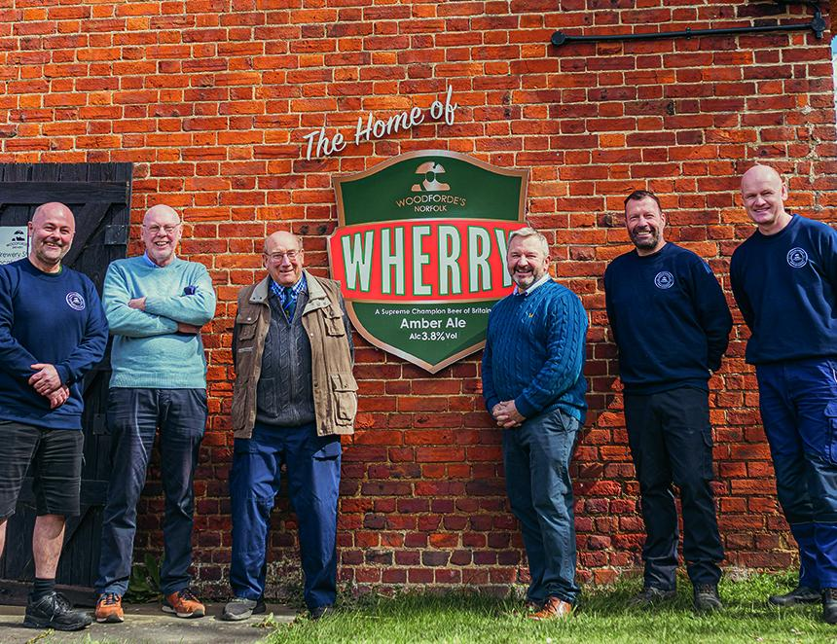

Norfolk’s largest brewery celebrated the 45th birthday of its award-winning Wherry by inviting the company’s founder to raise a glass at its brewery tap. Woodforde’s brewery, based in Woodbastwick, released the amber beer in 1981 and it has become a firm favourite ever since. The 3.8 per cent ABV brew has won a host of awards, including being crowned Champion Beer of Britain. Woodforde’s CEO Paul Sullivan said: “Wherry is the beer we are best known for and a brew we are particularly proud of. “Since the first pint was poured it has been a Woodforde’s favourite for good reason – it’s a beautiful, well-rounded ale with a crisp, clean finish that really hits the spot.” To celebrate the anniversary, Ray Ashworth, the brewery’s original owner, was invited for a pint and a pub lunch at the Fur and Feather, just yards from the brewery. His visit was made all the merrier with news that Wherry had won yet another award as Norfolk CAMRA’s best session bitter. Ashworth said it was “great” to take the walk down memory lane. “When Paul Sullivan invited me to the brewery to celebrate 45 years since the founding of Woodforde’s, and the very first pints of Wherry being brewed, I couldn’t quite believe that it was so far back in time. “I remember the brew day quite well and it was a testament to all the folk involved in setting the brewery up that it went so smoothly. “I never imagined that Wherry would be such the success that it is, having won two national awards and learning today that it has won yet another award as a best session bitter beer.” Wherry continues to be widely available on cask in pubs across Norfolk and further afield, with mini kegs, bottles and cans also available from the Woodforde’s online store. Pictured, from left, head brewer Craig Bennett, former director Mike Betts, Ray Ashworth, Paul Sullivan, brewing manager Bruce Ash and head of brewing Alec Williamson

