High-flying tribute to the last of the few
14/04/2026 by Timothy Hampson
Industry

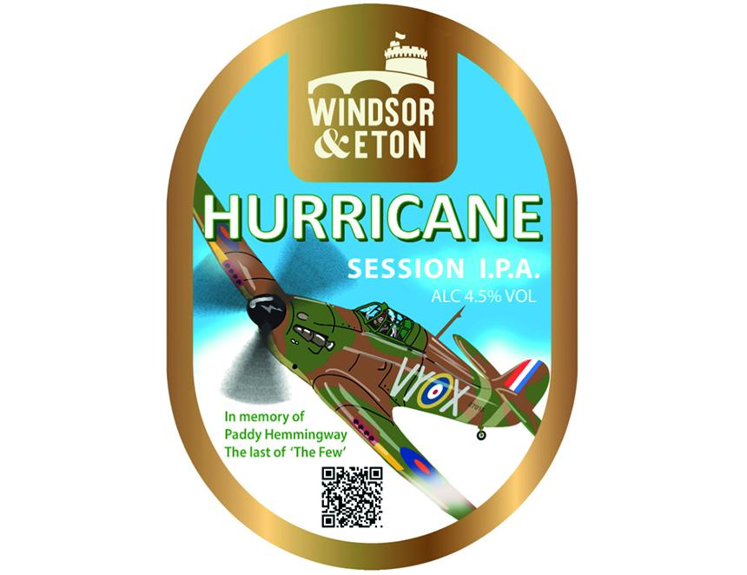

Windsor and Eton brewery is releasing Hurricane IPA to coincide with the reopening of its riverside bar in Kingston-upon-Thames. The beer is a well-balanced and quaffable 4.5 per cent IPA brewed with a blend of two hops, Chinook and Lemondrop, for a fruity aroma and big tangy taste. The pumpclip features a Hawker Hurricane in the markings of 85 Squadron flown by John “Paddy” Hemmingway. In August 1940, Paddy was shot down over the Thames Estuary during the Battle of Britain. Paddy parachuted to safety while his plane crashed at Fobbing Marshes in Essex. In March 2019, his Hurricane was recovered and is now under full restoration at Hawker Restorations in Suffolk. On the pumpclip is a QR code for a moving film tribute to Paddy created by his son, Mike Hemmingway. Windsor and Eton MD Bob Morrison said: “At the incredible age of 105, Paddy was the very last of the few. “Mike Hemmingway is a close friend of ours, so when his father passed away last year, we wanted to find a way to celebrate his life and the Hurricane. It's no exaggeration to say that, without the Hurricane, the Battle of Britain would not have been won. “The Hurricane was designed by Sir Sydney Camm, who was born in Windsor next door to our brewery, and nearly all UK-built Hurricanes were made in Kingston.” In September, a temporary exhibition called Born in Windsor, Built in Kingston will be held in the WEBREW Kingston bar at the Eagle Brewery Wharf, Kingston-upon Thames. Working with local historians, the brewery will be reaching out to the Kingston community asking for family stories, letters, and photos of the building of the legendary Hurricane.

