Tapps tops for branch
13/04/2026 by Timothy Hampson
Campaign

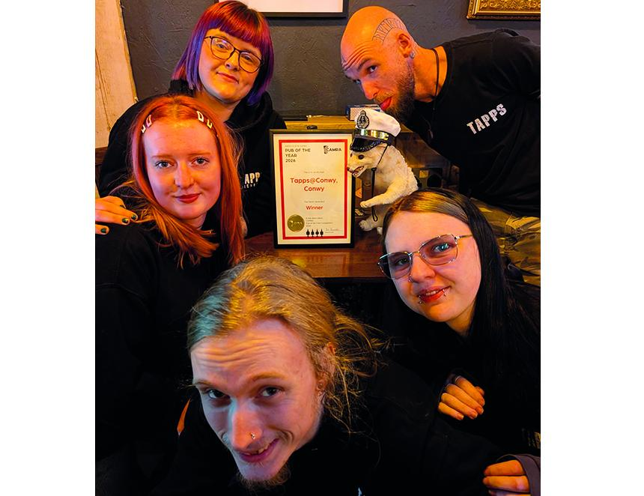

A Conwy bar is the Abercolwyn branch’s 2026 Pub of the Year. Tapps@Conwy, which opened its doors two years ago in what used to be an ice cream factory, has been selling a variety of cask beers and traditional ciders since day one. Presenting the award, branch chair Ian Saunders, commended the new enterprise saying that the bar was a great advert for cask and real cider in the area, and the taproom has become a hub for local beer lovers. Dave Guinn, owner of the group of four Tapps bars in the area (the others are in Llandudno, Craig-y-Don and Rhos-on-Sea), thanked the staff (above) for creating such a warm welcome, the customers for creating such a great atmosphere and CAMRA members for the award. On the night of the presentation there were six cask beers, four traditional ciders and a variety of craft keg beers to choose from.

