Swan flying high in heart of capital
12/04/2026 by Timothy Hampson
Industry

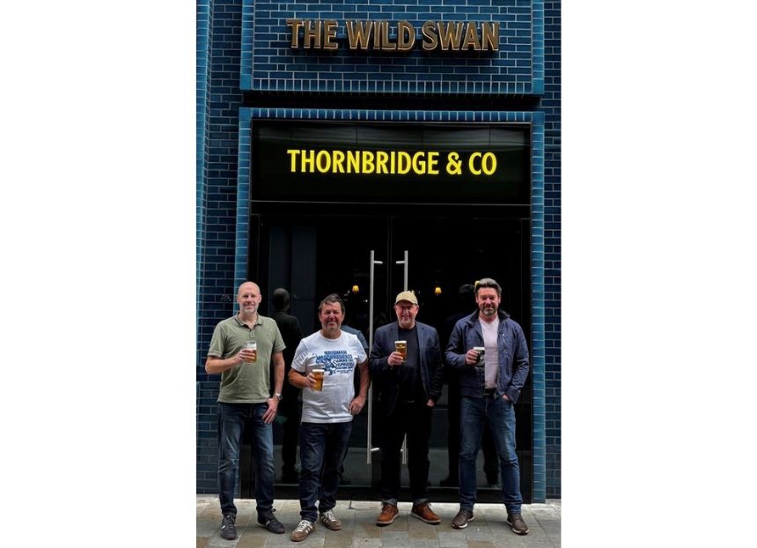

The brewer of Jaipur has officially opened the doors to the Wild Swan, its newest pub and first site in the capital. Located in the heart of bustling Holborn at 99 Fetter Lane, the Wild Swan becomes the fifth pub in Thornbridge’s portfolio, joining the operator’s successful sites in Birmingham, Leeds, Sheffield and York. A standout feature of the new pub is a bespoke stained-glass window adding a distinctive design element and character to the space. Thornbridge director Jamie Hawksworth said: “Establishing a site in the capital has long been an ambition for us, so it’s incredibly rewarding to see that vision come to life on Fetter Lane.” Fellow director Simon Webster added: “With the Wild Swan we wanted to create a pub that combines quality, character and a genuine sense of place. “From the drinks offer through to the design of the venue, every detail has been considered carefully, and we’re thrilled to now be welcoming guests through the doors.” Pictured, from left, Jonathon Holdsworth, Jamie Hawksworth, Simon Webster and Mike Cole

