New right to guest beer improving choice in Scotland
11/04/2026 by Timothy Hampson
Industry

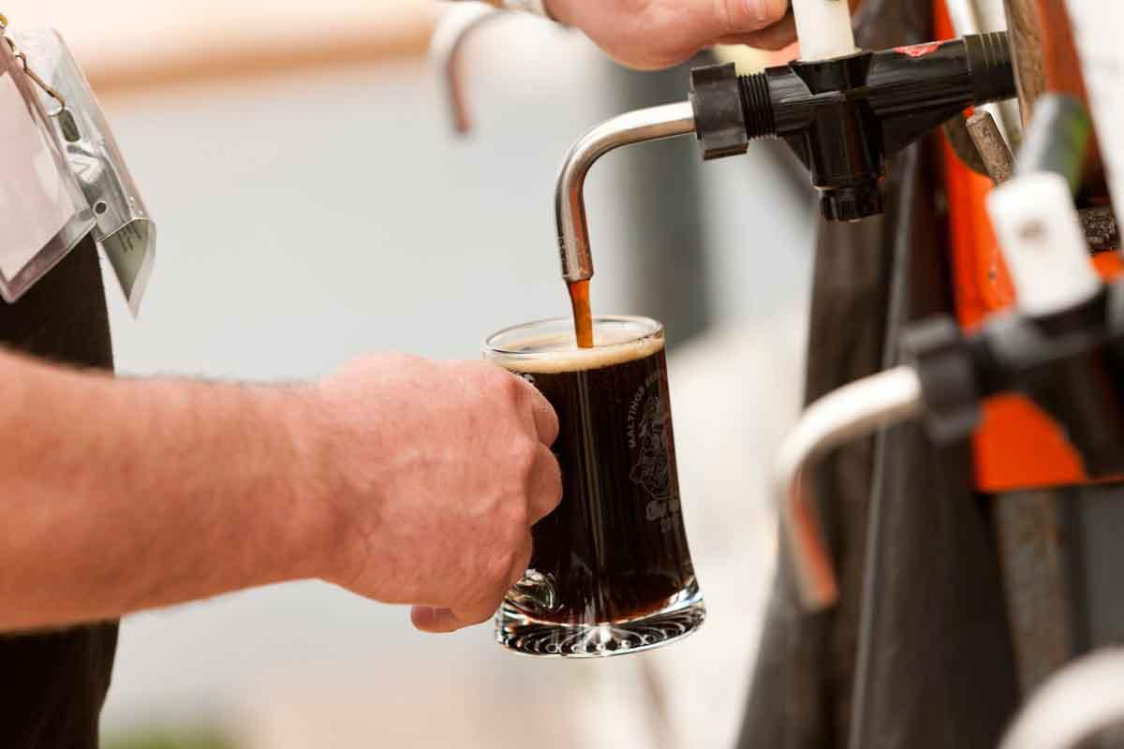

The new right to a guest beer is improving choice in pubs where tenants are aware of it, but others are being discouraged from applying, a new report has revealed. While Scottish pub tenants have a low awareness of their new right to stock a guest beer, those that are aware find it is improving trade and is useful to their businesses. However, some tenants are facing intimidation and have been discouraged from applying. This is the conclusion of a new report published by the Society of Independent Brewers (SIBA) into the Guest Beer Agreement on the first anniversary of its launch. Introduced in April last year, the scheme allows pub tenants in Scotland to directly source their beer from local breweries and sell it in any format they wish, including in both cask and keg draught beers. It aims to widen consumer choice, support local independent breweries and empower pub tenants. The research shows that fewer than half (45 per cent) of Scottish tenants were aware of their new right. However, for those that were aware of it, the vast majority (71 per cent) found it be useful for their pub businesses. This increased to 94 per cent for those who have applied for an agreement and 86 per cent of those that had an agreement in place said it was improving trade. While only a fifth had secured an agreement, the research showed significant interest with one in 10 having applied and a third saying they intend to apply. Disappointingly there were reports of pub companies dragging out the process and tenants receiving misleading advice about being required to renegotiate their tenancy. A small, but not insignificant, number highlighted instances of intimidation and discouragement. One said that “it wouldn’t look good when it came to renewing their tenancy” and another that “the owner of our pub has strongly discouraged it”. The report’s recommendations include having the Pubs Code adjudicator, who is responsible for enforcing the scheme, and pub companies do more to highlight the scheme and improve the information available to tenants. SIBA chief executive Andy Slee said: “The new right to a guest beer is a trailblazer initiative in Scotland. For the first time, it allows pub tenants to have a direct relationship with local breweries and respond directly to consumer demand by serving a local independent beer. “This in-depth research demonstrates that awareness of the scheme is still too low, but once a tenant is aware, its usefulness to their businesses, to trade and to consumers is crystal clear. There is more that pub companies and the Pubs Code adjudicator can do to ensure tenants are better aware of the benefits of the scheme.” SIBA Scottish regional director and Fyne Ales MD Jamie Delap said: “Where it’s been implemented, the Guest Beer Agreement is a win-win for Scottish brewers, pub tenants and beer drinkers. However this report highlights wrongful assertions and barriers that prevent more tenants from accessing the scheme. “These need urgently addressing so that all Scottish tenants are fully aware of their rights under the Pubs Code.” The Guest Beer Agreement is part of the Scottish Pubs Code. More information can be found here https://www.gov.scot/publications/scottish-pubs-code-adjudicator-guest-beer-arrangements/

