The drinks are on the Telegraph!
09/04/2026 by WB Reporter
Industry

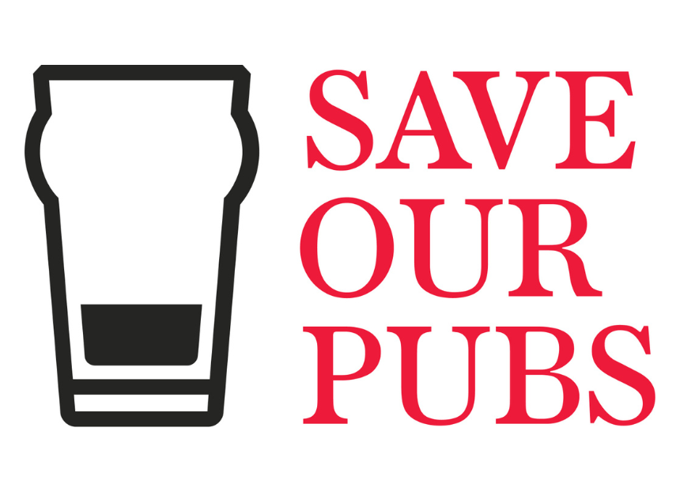

Do you want to help your pub win a £5,000 round? Then enter it into the Telegraph’s Save Our Pubs competition and give it a chance of being one of five that will get a £5,000 drinks tab for its customers to enjoy on National Pub Day – 16 May. In 250 words, explain why your local is the cornerstone of your community and what the money would mean for the licensee and their patrons. The Telegraph's Save Our Pubs competition aims to support the industry against rates relief cuts and high taxes plus stop the government from “calling last orders” on Britain’s locals. Nominations close on Saturday 11 April and the winners will be revealed on 25 April. Enter your pub here: telegraph.co.uk/news/2026/03/21/help-your-local-pub-win-a-5000-round

