Swan flies again
03/04/2026 by Timothy Hampson
Pub

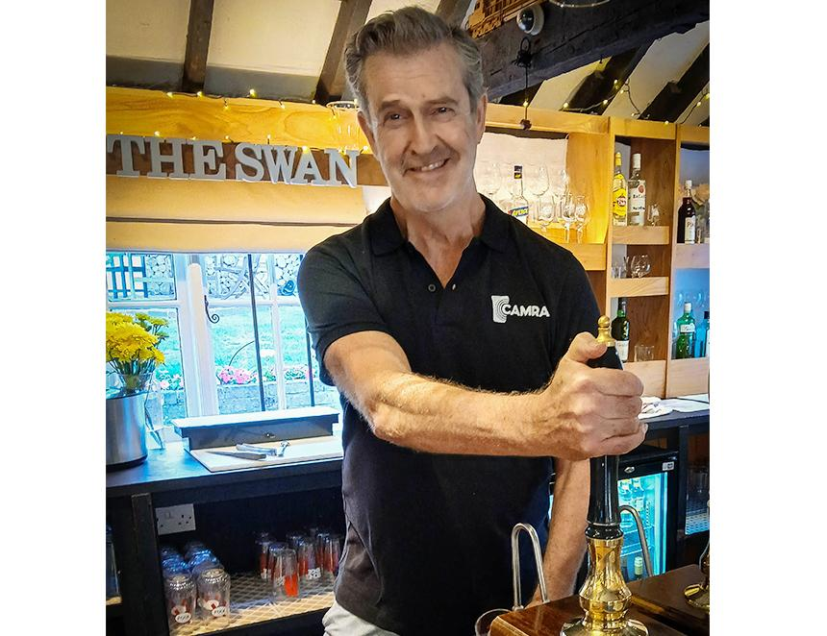

The Swan at Enford, Wiltshire has reopened thanks to a new investment and campaigners who have pitched in to ensure that the only pub in the village remains a vital community asset. Combined with the ongoing hard work of a team of volunteers who ran the pub for five months until January, the Swan now has a secure future. The volunteers included film star Rupert Everett (above) whose shifts pulling pints made headlines around the world. Investors Sophie Cooper and Andy Wiggins, who moved to Enford last year, realised the need within the community for a thriving pub to be available to all. “We chose Enford because of the amazing location and its charming rural pub – we didn’t know we were going to meet so many wonderful people and those people were our motivation to buy the pub,” said Cooper. Wiggins said: “When the volunteers ran the pub it really changed the dynamic, everyone was happy to work and made the pub a genuine community hub, we couldn’t let that change so we stepped in to keep it owned by locals and focused on being a real community asset.” The Swan made national and international news last year when star of stage and screen Rupert Everett, who lives nearby, joined CAMRA and then was seen pulling pints in the pub. Rupert described the thatched 16th-century building as the beating heart of the community. He may soon be seen behind the bar again, filming schedules allowing. “I am so excited for the future of the Swan, our pub tradition must be saved”, he said. The Swan caters for all but is renowned for supporting local breweries and the quality of its cask beer. South Wiltshire CAMRA branch secretary Steve Stringer is running the cellar and is in charge of the cask beer.

