County calls out government over missing support
02/04/2026 by Timothy Hampson
Industry

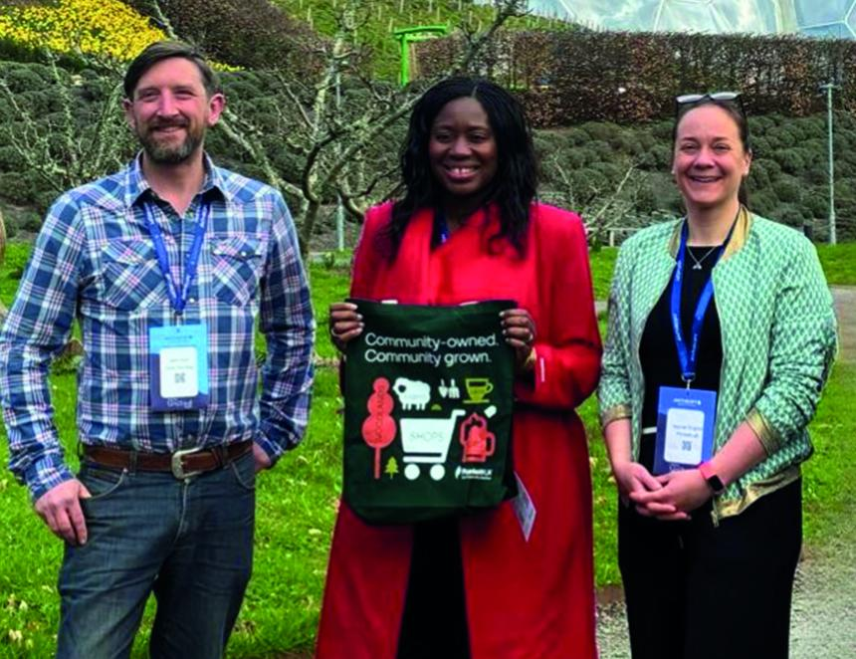

Plunkett UK and campaigners in Cornwall have called on the government to provide stronger support for rural communities during an event at the Eden Project. Speaking at Anthropy 2026’s session, How to build happier, healthier and wealthier places, Miatta Fahnbulleh MP emphasised her commitment to provide more support for neighbourhoods across the UK and shift greater power into community hands. The parliamentary under-secretary of state at the Ministry of Housing, Communities and Local Government highlighted plans to invest in 300 areas over the next decade through the Pride in Place scheme. However, in the panel discussion, representatives from rural Cornwall made clear that its communities feel overlooked and left behind. Sam Fitch, from the Save the Stag community group in Ponsanooth where the last remaining pub is under threat, shared how vital a community’s local assets are. He said: “A pub is so much more than a place to drink – it’s the heart of the village. There’s nowhere else where all ages and backgrounds can come together.” “As we look to save the Stag, everyone is doing what we can and coming together – if we do that, we can move mountains. The support we have had from Plunkett has been amazing too.” He warned that government programmes are not reaching the places most in need: “Pride in Place is not delivering in Cornwall. None of the 300 communities are here. The impact on rural communities would be huge if they were to receive support.” In response, Fahnbulleh said she was a strong advocate for rural communities and pointed to the government’s plans to strengthen the community right to buy powers within the forthcoming English Devolution and Community Empowerment Bill. Deputy chief executive of Plunkett UK Harriet English highlighted the proven success of community-owned businesses in reviving rural places: “Rural community businesses are incredibly resilient with a 98 per cent survival rate after five years and 94 per cent still thriving after 20. They bring people together, create warm and welcoming spaces, tackle loneliness and provide jobs and volunteering opportunities. They’re very special places.” Plunkett is urging the government to invest £10m over 10 years in a dedicated rural community ownership fund, to establish more than 500 community-owned businesses including 300 pubs with an estimated gross value added (GVA) of £264m. Pictured, from left, Sam Fitch, Miatta Fahnbulleh, Harriet English

