CAMRA award nominations open
01/04/2026 by WB Reporter
Campaign

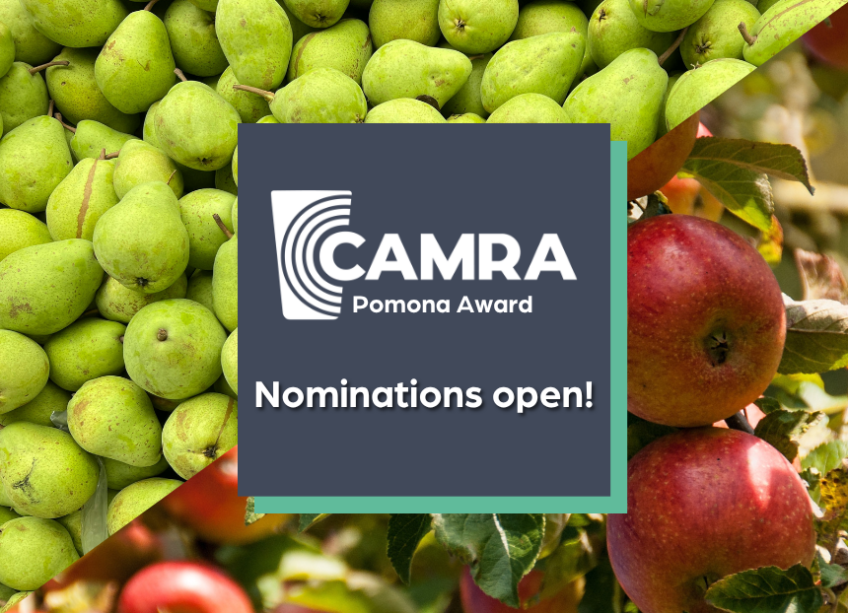

Nominations are now open for CAMRA’s 2026 Pomona Award, which recognises people who have gone above and beyond to promote real cider and perry across the UK. All forms of cider and perry activity will be considered with primary consideration given to activities over the previous 12 months. Where there is no outstanding contender in this category, consideration is then given to ongoing work in this field. The nomination form, eligibility criteria and more information are here: camra.org.uk/awards/pomona-awards Nominations close 1 August 2026, but submissions received after this date may be considered for an award in May 2027. Individuals will not be eligible if their contribution is for or within CAMRA, as this is covered by the Campaigner of the Year award. The national Cider and Perry Pub of the Year award is also there for licensees. Last year’s winner was the Hartpury Heritage Trust in Gloucestershire, which was celebrated for its work in preventing the extinction of a wide variety of perry pears, playing a vital role in preserving the UK’s perry heritage. Other previous winners of the Pomona Award include: Adam Wells, author of CAMRA’s groundbreaking Perry: A Drinkers’ Guide; Elizabeth Pimblett, director of the Cider Museum in Hereford, the late Susanna Forbes, co-founder of Little Pomona Cider in Herefordshire and Cider Critic James Finch. Pomona co-ordinator Andrea Briers said: “The cider and perry community is full of amazing people across the UK who go above and beyond to protect these incredible drinks. From educating the public about orchards and fruit to promoting traditional production techniques, these unsung champions deserve to be given the spotlight and inspire the next generation of cider and perry lovers. “The Pomona Award is flexible in terms of the type of work that is considered. From volunteers who campaign for better access to market for independent producers to cider and perry makers fighting for the industry, let us know who deserves recognition for this prestigious award!”

