K ‘Devastating loss’ of Scottish brewer
31/03/2026 by Roger Protz
Industry

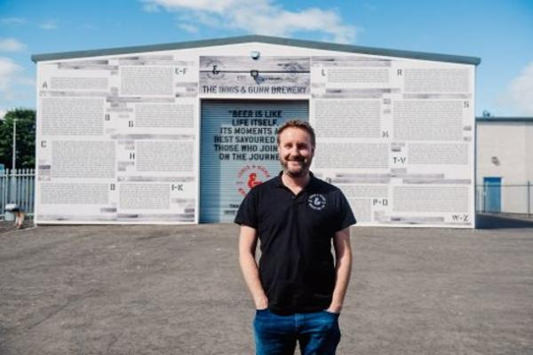

The lurid headlines and bizarre reports surrounding the collapse and takeover of BrewDog by an American manufacturer of cannabis have diverted attention from the loss of Perth’s cask beer brewer Inveralmond. It was bought by oak-aged beer maker Innis & Gunn in 2016 and continued to produce a range of cask ales, including Ossian Golden Ale (4.1 per cent ABV), winner of CAMRA’s Champion Beer of Scotland in 2017. Inveralmond opened in 1997 and was the first new brewery in Perth for 30 years. Production grew to 12,000 barrels a year. Innis & Gunn took over as the result of a Beer Bond crowdfunding scheme that raised £3.1m. This enabled the Edinburgh-based company to build a giant warehouse for oak barrels where I&G beers were aged in wood. I&G founder Dougal Sharp (above) said he was committed to the cask ales brewed at Imveralmond and he featured some of them in taprooms and restaurants he opened in Edinburgh, Glasgow and Dundee. In 2021 the major Irish beverage company C&C bought an 8 per cent stake in I&G and in March this led to a total takeover the brewer and its brands for £4.5m. C&C owns Bulmer’s and Magners ciders and Tennent’s Lager, the biggest breweing brand in Scotland, accounting for 60 per cent of all the beer sold in the country. It brewed some of the I&G beers, including lager, and brews destined for wood-ageing were then trunked to Perth. But now Inveralmond and the I&G taprooms have all closed, with around 100 people made redundant. Dougal Sharp owned 35m shares in I&G and, in common with James Watt and Martin Dickie at BrewDog, can walk away with a sizeable fortune. CAMRA’s Scotland director Stewart Campbell said: “The loss of Inveralmond after producing quality cask ales for the past 30 years is another devastating blow for Scottish brewing. “The loss of availability of Scottish beer on bars of our pubs is also regrettable. Cask production needs to be championed across Scotland and our pubs should be able to offer regional beers to their customers.” C&C marketing director Stewart Mackenzie said the group is keen to brew Ossian but he doesn’t yet know where this will take place. The fact that Ossian is the fastest-growing bottled beer in Scotland explains why C&C wants to continue to produce it. As well as Tennent’s Wellpark plant, the group also owns the neighbouring Drygate brewery that specialises in craft beer and would seem to offer the ideal base for Ossian. Drygate was set up as a collaboration between C&C and Heather Ales, a subsidiary of Williams Brothers in Alloa, famous for its Fraoch Heather Ale. But in 2025 C&C bought Heather’s 51 per cent share and is now the sole owner. C&C said at the time that Drygate would “enhance the group’s range of fast-growing premium and craft beers”. Ossian may survive the turmoil but the other Inveralmond beers will become a footnote to Scottish brewing. Those beers include Lai Fail (4.7 per cent), which with grim irony means Stone of Destiny.

