MPs to debate protecting cask beer
30/03/2026 by Timothy Hampson
Campaign

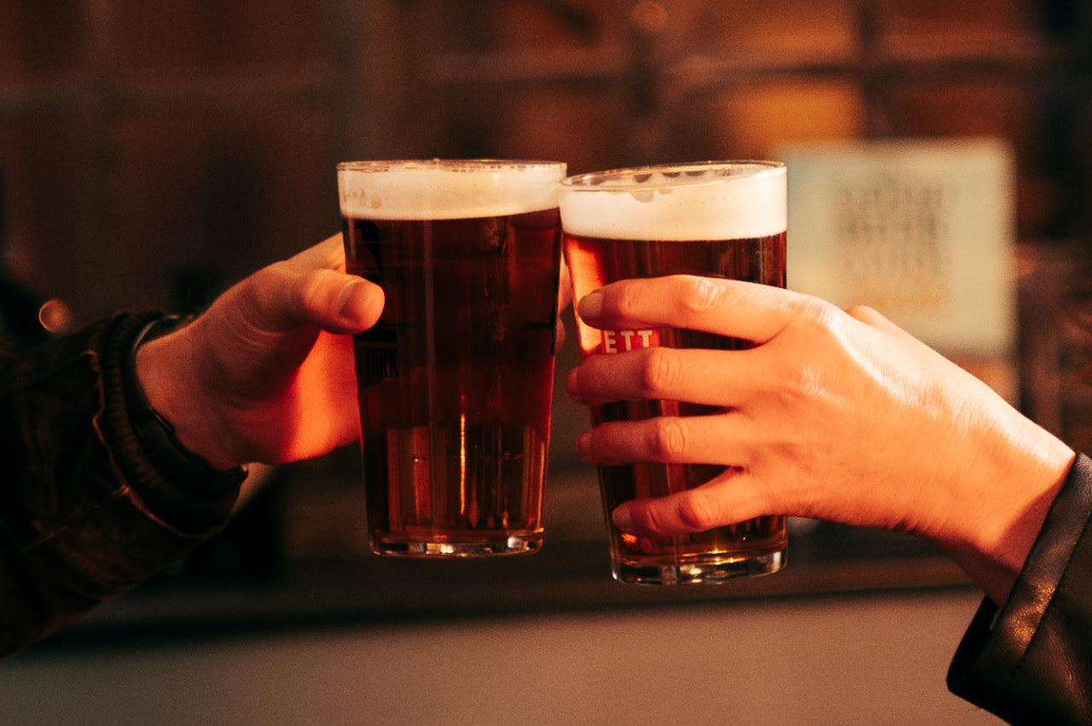

Derby South MP Baggy Shanker has secured a parliamentary debate on protecting cask ale and recognising its production and serving as Intangible Cultural Heritage, after working with CAMRA. Shanker has been working with the Campaign to support efforts to give cask beer greater recognition and protection, amid concern over the long-term decline in production and sales plus the growing pressure facing pubs, clubs and taprooms across the country. The debate will allow MPs to discuss the importance of cask beer to Britain’s brewing tradition, the traditional skills involved in making and serving it, and the role pubs play in local economies and community life. Shanker said: “Cask ale is part of our British heritage, and something we should be proud of. It is not just about what is in the glass. It is about the tradition, skill and care that goes into brewing it and serving it properly, and about the pubs that keep that tradition alive in communities across the country. “I know how much our locals mean to people, so I’m proud to have secured this debate to make the case for our pubs, our brewers, the skilled workforce behind them and a great British tradition that deserves to be recognised.” CAMRA chairman Ash Corbett-Collins said: “CAMRA is proud to have worked with Baggy Shanker to help bring this debate to parliament. Cask ale is a living part of Britain’s brewing tradition, still brewed, still served and still enjoyed in pubs across the UK. “It reflects generations of skill and care, from the brewery to the cellar, but without stronger recognition that tradition is at risk. The long-term decline in production and sales should concern anyone who cares about consumer choice, brewing heritage and the future of our pubs. “Parliament now has the chance to act. Recognising the production and serving of cask ale as Intangible Cultural Heritage would raise its profile, celebrate the expertise behind it, and strengthen the case for protecting and promoting it before more of this proud tradition is lost. Cask ale has earned its place in our national story. Now it is time to protect it.” CAMRA Derby branch campaigns officer Alan Pickersgill said: “It’s great to see we, through working with Baggy, have spearheaded this campaign for this vital issue to be debated in parliament. This is a proud day for myself and the Derby branch." The debate marks an important next step in the campaign to protect cask beer, support the pubs and brewers behind it and give greater recognition to a tradition that remains part of Britain’s national story. The debate application has been approved by the Backbench Business Committee, with a date now to be confirmed by parliamentary clerks. The full debate title is: that this House has considered protecting consumers and promoting cask ale by recognising its production and serving as Intangible Cultural Heritage.

