PUBlic Affairs round up – March
28/03/2026 by Tori Wood
Campaign

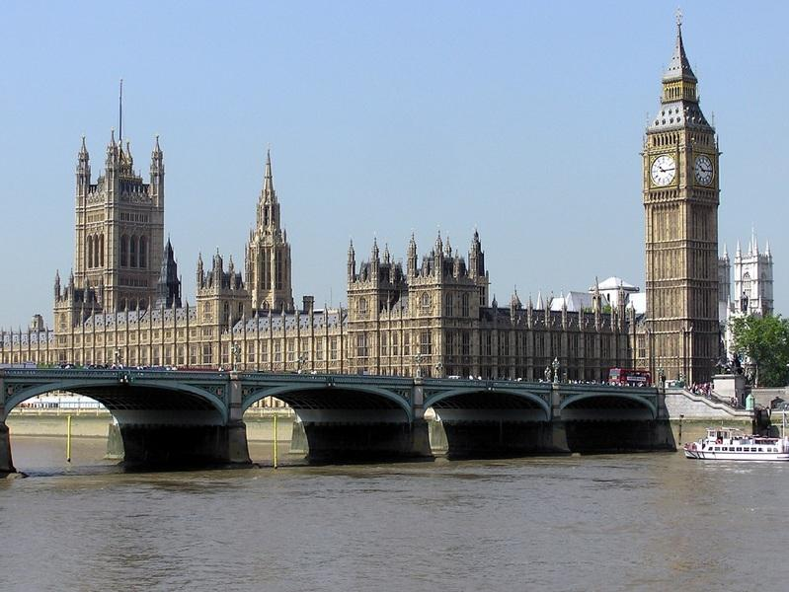

This regular series brings you up-to-date details on the Campaigns and Communications team’s campaigning for pubs, pints and people across Westminster, devolved parliaments and local government. CAMRA is continuing to ask everyone living in England to take part in our e-lobby campaign to make sure the government’s new planning proposals don’t weaken pub protections. Email your MP here. Westminster Access to Market review At the 2024 Budget, the chancellor promised an Access to Market review for independent brewers against the stranglehold global giants have over the beer and pub market. The government has “conducted a review of the beer market to determine whether there are any structural barriers preventing small breweries, the findings of which are currently being considered by ministers”. The team is keeping an eye out for published findings. Business rates [England only] The UK government U-turned on its disastrous business rates bombshell that removed a 40 per cent discount at the same time as revaluation for pubs in England. The U-turn means pubs will now get 15 per cent off their bills in April. More guidance to help councils manage the new discount has been published by the government. Read here. Planning [England only] CAMRA launched an MP e-lobby after the government announced planning proposals that could see only the last pub in an area protected by law. More than 3,000 people have taken part so far. On the back of this, a series of parliamentary questions have been asked by MPs and CAMRA’s campaign got front page coverage in the Telegraph. The team has submitted a central response to the consultation about the changes, but CAMRA needs to keep the pressure on the government to think again. Email your MP here. Pubs Code [England and Wales] The government is reviewing the Pubs Code for England and Wales. Tom Stainer (CAMRA chief executive) and Paul Edgeworth (CAMRA campaigns and communications manager) met with business minister Kate Dearden MP to discuss it. They emphasised keeping and strengthening the code, extending it to include hybrid, franchise and retail agreements, safeguards needed if investments related to the market rent only exemption is introduced, as well as a guest beer right for tied tenants. Cider Our Beer and Cider Campaigns Committee met with civil servants in the Department for Environment, Food and Rural Affairs in February. Discussions were had on CAMRA’s campaign to increase minimum juice content in cider with useful conversations on consumer and producer attitudes. As the European Union is making a proposal on defining cider, there might be an opportunity to align with EU definition as part of upcoming EU-UK trade agreements. Sharp’s brewery closure In February, Molson Coors announced it will close Sharp’s brewery in Rock, Cornwall. CAMRA’s response is here. Many media outlets like ITV News, BBC News and BBC Radio Cornwall used it in their stories. The team has been working with the North Cornwall MP, Ben Maguire, who has asked several parliamentary questions: to ask the secretary of state for business and trade, if he will take steps to ensure that details of (a) the geographical location of production and (b) ownership of brands is included on (i) labels and (ii) point of sale materials for (1) beer and (2) other food and drink products.

to ask the secretary of state for culture, media and sport, what assessment her department has made of the potential impact of local and regional (a) breweries and (b) beer brands on the tourism economy in (i) Cornwall and (ii) England.

to ask the secretary of state for environment, food and rural affairs, what assessment she has made of the potential merits of introducing a geographic indication scheme for beers traditionally brewed in a specific location.

to ask the state for environment, food and rural affairs, what assessment she has made of the potential impact of the proposed closure of Sharp's brewery in Rock, North Cornwall on (a) jobs, (b) the local economy and (c) consumer choice.

to ask the secretary of state for business and trade, whether his department has made an assessment of the level of prevalence of multinational companies marketing (a) beers and (b) brewery brands as being from (i) small and independent brewers and (ii) from a specific geographical location.

to ask the secretary of state for business and trade, what assessment he has made of the potential impact on consumers of breweries (a) stating and (b) implying that their products are being brewed in one location when they are produced in another location. Scottish government and parliament Business rates [Scotland only] The Scottish Budget was announced on 13 January. The Scottish parliament voted to pass it on 12 February after coming to an agreement with the Scottish Liberal Democrats since the SNP Scottish government didn’t have a majority. The 40 per cent business rates discount for hospitality business was reinstated for the next three years. It was going to be reduced to 15 per cent. More information here. Northern Ireland executive and assembly Licensing review After the University of Stirling carried out an independent review of Northern Ireland’s alcohol licensing system last year, the NI minister for communities published his response rejecting all substantive recommendations, including reforms of the surrender principle. The outdated principle forces one business, like pubs, to surrender their licence so another can open. Now Belfast charity Free the Night is pursuing legal action against the minister over his decision not to implement recommendations in the review. A letter has been issued which gives the minister a chance to review his original decision. If he does not, a full judicial review of legal proceedings will begin. CAMRA is supporting Free the Night where appropriate. More information here.

