New beer aims to kickstart cask ale market
27/03/2026 by Timothy Hampson
Industry

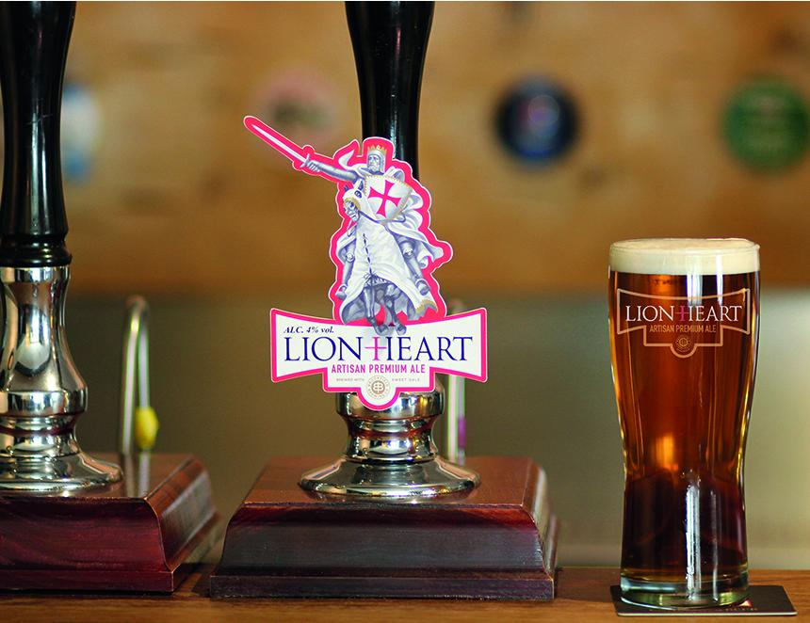

LionHeart arrives on the bar with a roar in time for St George’s Day on 23 April, aiming to revitalise the cask beer market. The newcomer is a well-balanced, 4 per cent ABV beer made with traditional English ingredients and is the result of a collaboration between brand owner Brookfield Drinks and Norfolk brewer Woodforde’s. The launch is backed by a £2m investment that sets out to kickstart the cask category. Brookfield MD Nigel McNally said: “Cask ale can only be enjoyed in pubs, clubs and bars and the trade needs well-supported, strong national and regional cask brands to give both operators and beer drinkers confidence in the category. “Our aim with LionHeart is to restore the pride in England’s signature beer style and give pubs the support they need to stock cask ale with confidence. With the World Cup taking place this summer, the LionHeart brand is an opportunity to see football fans roaring with pride as they follow the England team’s progress in their local.” The beer has a font in the red and white colours of King Richard the Lionheart, as well as POS support including drip mats, bar runners and posters. The brand will also be supported with broadsheet advertising. Ingredients include sweet gale, also known as bog myrtle, which was traditionally used as a bittering plant by English brewers before hops were grown commercially. McNally added: “Many beer aficionados have heard of sweet gale, but very few have actually tried a cask beer brewed using it. It adds an interesting flavour note to this classic English cask ale, which will appeal to established ale drinkers as well as the increasing number of younger consumers looking for the confidence to try cask or order it more often.”

