Seasonal springs into life
26/03/2026 by Timothy Hampson
Industry

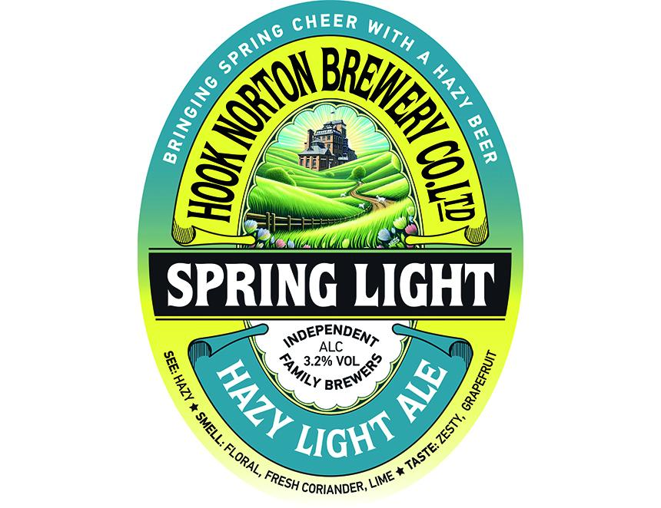

Hook Norton has unveiled its April seasonal cask beer – Spring Light at 3.2 per cent ABV. The brewery said the beer is hazy, zesty, and “effortlessly refreshing”, bringing bright grapefruit notes with a hint of coriander spice. Despite its low strength, Hook Norton said the beer is full of flavour. “Spring Light will be available for a limited time at the brewery, across Hook Norton pubs and in free houses,” said a spokesman.

