Writer scoops Forbes prize
25/03/2026 by Timothy Hampson
Campaign

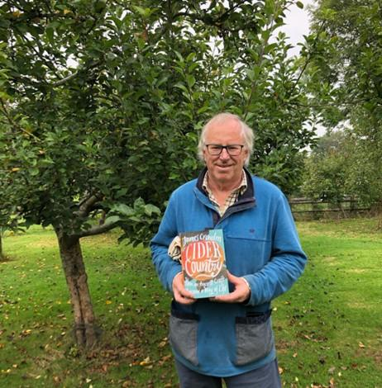

The Susanna Forbes Outstanding Contribution to Cider Culture Award for 2026 has been won by James Crowden (pictured). The award was renamed in 2024 in memory of BEER Magazine contributor Susanna Forbes who was influential in raising the profile of cider and perry. The award is open to written, audio, video or photography work about cider and cider making, that informs and entertains. The winner was revealed at Craft Con 2026, organised by the 3CCPA, the UK’s only national conference bringing together cider and perry makers, supporters and enthusiasts. With a career spanning decades and a wealth of experience in agriculture, orchards and fermentation, Crowden has interwoven the culture of cider throughout his life and work as an author and poet. His works portray his heritage in the South West of the UK, with poems and biographies penned in recognition of local traditions and interpersonal tales of ancient crafts and rural life. His books on the history, craft and culture of orchard drinks – Cider; the forgotten miracle, Cider Land, and Cider Country; how an ancient craft became a way of life (winner of the André Simon Food and Drink Awards in 2008) have been instrumental in educating makers and enthusiasts across the globe. Crowden coordinates and sits on the judging panel for the British Cider Championships at the Royal Bath and West Show, where he shares his knowledge and expertise in the promotion of real cider and perry.

